Holiday Theme

www.shac.org/holiday-theme

If you find these resources helpful, or have comments or additional resources we can add, please let us know by sending us a message to our Facebook page at www.facebook.com/shac.bsa.
Content  (Source: Baloo’s Bugle December Themes)  Gathering Activities  Opening Ceremonies  Leader Recognition  Advancement Ceremony  Skits  Songs  Cheers  Runons  Audience Participation  Games  Cubmaster Minute  Closing Ceremonies  Pack Meeting Ideas  Pack Meeting - 1  Pack Meeting – 2 (Lights)  Pack Meeting – 3 (Gifts)  Pack Meeting – 4 (Around the World)  Pack Meeting – 5 (Traditions)  Pack Meeting – 6 (Winter Wonderland) | Free, customizable placemats are available for packs to use to help promote day camp. Download placemats at  www.shac.org/holiday-theme

Sources: BSA and Baloo’s Bugle: Let's Celebrate (Dec ’98), Holiday Magic (Dec ’99), What Do You Do at Holiday Time? (Dec 02), Winter Wonderland (Dec ’02), A Cub Scout Gives Goodwill (Dec ’03), Holiday Food Fare Dec ’04), Faith, Hope and Charity (Dec ’05), Holiday Lights (Dec ’03), Celebrations around the World (Dec ’07), Holiday Lights, Holiday Lights (Dec ’08), Holiday Lights, Holiday Lights (Dec ’12), A Cub Scout Gives Goodwill (Dec ’14), Winter Wonderland, Winter Wonderland (Dec ’15), Celebrate, Celebrate (Dec ’16)

SHAC Pinterest page: www.pinterest.com/samhoustonbsa/christmas-theme/

A Cub Scout looks for the bright side of things. They try to make others happy. December is a big month for all sorts of celebrations and opportunities to make others happy.

A Scout is cheerful. How does celebrate relate to this point of the Scout Law?

As winter comes, it brings with it a wonderland of snow, peace, beauty, and holidays. All of us come from different backgrounds and celebrate many traditions; each of our traditions gives us an identity and a sense of belonging. When we share those traditions and accept others’ traditions, we expand our circle so everyone feels like they belong. Whether we celebrate Christmas, Hanukkah, Kwanzaa, or none of these, sharing valued traditions and holding true to what they stand for will help us understand others. But no matter who we are or how we celebrate, we are all part of a great organization that has taught us to show reverence for others and their beliefs.

GATHERING ACTIVITIES

Backward and Forward
Can you fill these blanks with words that are spelled the same backward as forward?
- The night before Christmas. __ __ __
- What you do with a whistle. __ __ __ __
- A little child __ __ __
- Father __ __ __
- Twelve o’clock __ __ __ __
- A chin apron __ __ __
- A live Christmas gift __ __ __
- Silent __ __ __
- A good thing you did __ __ __ __
- What a noisemaker does __ __ __
Answers – eve, toot, tot, dad, noon, bib, pup, mum, deed, pop)

Celebrations Around the World Word Search
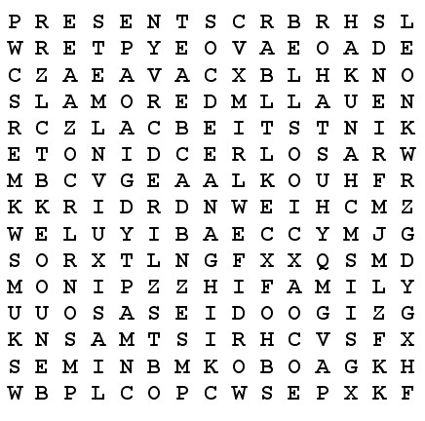
BELLS CELEBRATE CHANUKAH
CHRISTMAS DECEMBER FAMILY
FRIENDS GOODIES HOLIDAY
KWANZAA LOVE MUSIC
NOEL PEACE PRESENTS
RAMADAN ROHATSU SERVICE
SNOW TRADITIONS YULE

Christmas Card Puzzle
This game makes a good gathering activity. Cut an old Christmas card into irregular pieces to form a puzzle for each player and place in an envelope. As each Cub Scout arrives, give them a puzzle. If playing as a regular game, the first player to put their puzzle together is the winner.

Christmas Carol Scramble
Materials: Choose several well-known Christmas carols. For each selected song, write each line on a separate piece of paper.
Directions: Give a slip of paper to everyone as they come in. Tell them to find the people who have the other lines to their song and arrange them in order. The first song team to find all the right people and sing the song is the winning team.

Christmas Cheer Song Match
Directions: Match the phrase with the song title.
Lyrical Phrase
- Was a happy jolly soul
- Are you listening?
- In a one horse, open sleigh
- No crib for his bed
- Let Earth receive her King
- As they shouted out with glee
- The lights are brightly shining
- Now you say there’s no such thing as Santa
- Like the ones I used to know
- Bring us some figgie pudding
- Sing, choirs of angels
- All is bright
- She didn’t see me creep
- He knows when you’re awake
- Dancing and prancing in Jingle Bell Square
Song Title
- I saw Mommy Kissing Santa Claus
- Grandma Got Run Over by a Reindeer
- Frosty the Snowman
- Joy to the World
- Jingle Bell Rock
- Santa Claus Is Coming to Town
- Oh Come, All Ye Faithful
- Away in a Manger
- Silent Night
- Jingle Bells
- O Holy Night
- We Wish You a Merry Christmas
- White Christmas
- Winter Wonderland
- Rudolph
Answers: 1-C, 2-N, 3-J, 4-H, 5-D, 6-O, 7-K,
8-B, 9-M, 10-L, 11-G, 12-I, 13-A, 15-F, 15-E

Christmas Greeting Match Up
Below are holiday greetings from 6 different countries. See if you can match each greeting with the country where that greeting is used. You can work with your parents.
- Feliz Navidad a. Italy
- Joyeux Noel b. Spain
- Frohliche Weinachten c. France
- Glaedelig Jul d. Germany
- Buon Natale e. Poland
- Wesolych Swiat Bozego Narodzenia f. Denmark

Answers: 1-b, 2-c, 3-d, 4-f, 5-a, 6-e

Christmas Handshake
  - Give each Cub Scout five Christmas cards or seals.
  - On signal, each Cub Scout introduces themselves to five parents other than their own.
  - Each time they must leave a card or seal with them.
(Parents should not accept the card or seal until the introduction is complete and the Cub Scout can repeat their name.)
  - The first den to finish assembles as a den and raises their hands in the Cub Scout sign or gives their den yell.

Christmas Map
Make a Christmas map. Find cities with names associated with Christmas. Place names on flag pins and poke in the map. Can you find Christmas Island? There are two, one in the Indian Ocean between Australia and Indonesia and the other just south of Hawaii in the Line Islands. Here are some:
North Pole, Alaska Joseph City, Arizona
Bethlehem, New Hampshire Noel, Missouri
Snowflake, Arizona "Carroll”, New Hampshire
Santa Claus, Indiana Mt. Angel, Oregon
"Carroll", Tennessee Evergreen, Alabama
Nicholas, Kentucky Bell, Kentucky
Helper, Utah Holly Green, Arkansas
Snowhill, Maryland "Holladay", Utah
Berry, Alabama Merryville, Louisiana
Berryville, Arkansas Bow, New Hampshire
Star, Idaho Bethlehem, Pennsylvania

Christmas Sayings and Songs Puzzle
- Move thitherward the entire assembly of those who are loyal in their belief.
- Listen, the celestial messengers produce harmonious sounds.
- Nocturnal time span of unbroken quietness.
- An emotion excited by the acquisition or expectation of good given to the terrestrial sphere.
- Embellish the interior passageways.
- Exalted heavenly beings to whom harkened.
- Twelve o'clock on a clement night witnessed its arrival.
- The Christmas preceding all others.
- Small municipality in Judea southeast of Jerusalem.
- Diminutive masculine master of skin covered percussionistic cylinders.
- Omnipotent Supreme Being who elicits respite to ecstatic distinguished males.
- Tranquility upon the terrestrial sphere.
- Obese personification fabricated of compressed mounds of minute crystals.
- Expectation of arrival to populated area by mythical, masculine perennial gift-giver.
- Natal Celebration devoid of color, rather albino, as a hallucinatory phenomenon for me.
- In awe of the nocturnal time span characterized by religiosity.
- Geographic state of fantasy during the season of Mother Nature's dormancy.
- The first person nominative plural of a triumvirate of Far Eastern heads of state.
- Tintinnabulation of vacillating pendulums in inverted, metallic, resonant cups.
- In a distant location, the existence of an improvised unit of newborn children's slumber furniture.
- Proceed forth declaring upon a specific geological alpine formation.
- Jovial Yuletide desired for the second person singular or plural by us.

Answers:
- Oh, Come All Ye Faithful
- Hark the Herald, Angels Sing
- Silent Night
- Joy to The World
- Deck the Halls
- Angels We Have Heard on High
- It Came Upon a Midnight Clear
- The First Noel
- Oh, Little Town of Bethlehem
- Little Drummer Boy
- God Rest Ye Merry Gentlemen
- Peace on Earth
- Frosty the Snowman
- Santa Claus Is Coming to Town
- I'm Dreaming of a White Christmas
- Oh, Holy Night
- Winter Wonderland
- We Three Kings of Orient Are
- Jingle Bells
- Away in The Manger
- Go Tell It on The Mountain
- We Wish You a Merry Christmas

Cub Scout Spirit
Personnel: 5 Cub Scouts, Den Chief (DC), Den Leader (DL) or Cubmaster (CM)
Equipment: 5 index cards with script written on each, US flag, Pack flag
Setting: Flags are already in place in the front and each Cub Scout enters from the side one at a time and reads their script.
#1: December is a fun time of the year. It is a time for giving and sharing.
#2: As we gather for the last pack meeting of 2012 let us remember the good times.
#3: Let us end this year with new determination to keep the Cub Scout Spirit going.
#4: As we begin our program tonight, let us keep in mind the true holiday spirit.
#5: Remember, to give of yourself is more important than any gift you can buy.
DC: Please stand for the Pledge of Allegiance.

December Number Rhyme
Fill in the right number at the end of each line. After you have completed one through six, add up the numbers to get the answer for number seven.
- Take the number of letters in SANTA
- Count a half dozen candy canes.
- Check the number of ears on a panda bear.
- Count the wings on two shiny toy planes.
- Count the points on a treetop star.
- Count the number of kings in a favorite Christmas carol
- They add up to a date in December- -It’s our merriest day, by far!
(1) 5, (2) 6, (3) 2, (4) 4, (5) 5, (6) 3, (7) 25

Decorate a Christmas Tree
Materials: Small Christmas Tree, paper, stickers, markers, glitter, etc. to make decorations
Directions:
As they arrive have the Cub Scouts and their families make decorations to place on the Christmas Tree to be given to a family in need. During the pack meeting announce and talk about the purpose of the tree. That it is to be donated to a family in need with all your lovely, handmade ornaments adorning it.

Find Your Caroling Partners
Prepare “sets” of cards that each contains a verse of popular carol. Hand these out to people as they arrive, instructing them to find others who have the same song/verse. Tell them they need to practice their song for a special presentation immediately following the opening. After the opening ceremony, have each group of carolers stand and sing its song.

Gathering Snowballs
As the families gather, present each with a nametag, on which you have left room to write a number. The set-up for this game is a table on which you have placed cotton balls (be sure to have quite a few). You also need either wooden or good-sized plastic spoons all the same size. As players enter room have them see how many cotton balls they can gather in an allotted time (10 or 15 seconds) and write their total on their nametag. Remember, with the spoon only; no hands allowed. At the end of the game, award a small prize for the one who collected the most balls.

Gift-Wrapping Station
The Cub Scouts are getting to an age where they can begin to help with the wrapping of gifts (and they probably really want to do it themselves as well). Get one or two parents to set up a gift-wrapping station so that the Cub Scouts can either bring in gifts they want to wrap or they can use empty containers to practice wrapping. You might want to set this up starting in the beginning of the month and make it available for each December Den Meeting.

Holiday Word Search
P | I | N | E | W | R | E | A | T | H | S | B | A | L
R | O | O | B | I | E | A | N | G | E | L | P | N | O
E | S | S | U | N | D | V | T | M | R | A | C | T | F
S | Z | L | N | T | L | M | L | O | C | Y | O | L | R
E | V | R | X | E | I | O | E | O | U | D | Z | B | L
N | P | D | S | R | B | Y | R | S | P | K | Y | U | P
T | I | N | S | E | L | B | U | E | I | O | X | B | O
N | O | R | T | H | P | O | L | E | D | B | O | A | T

Sled | Pine | Wreath | Tinsel
Red | Presents | Winter | Angel
Antler | Eve | Moose | North Pole
Cupid | Cozy.

How Many?
Fill a clear container filled with red, green and white jellybeans, holiday M&Ms, counting as you fill. Everyone makes a guess on a slip a paper (be sure they include their first and last name) as to how many treats are in the jar. The winner gets the container & candy.
Icicle Hunt
Cut pieces of colored yarn or string into different lengths. Hide the icicles (yarn) around the room and have the Cub Scouts search for them. The winner is the one whose strings forms the longest icicle when laid end to end, not the Cub Scout who collects the most.

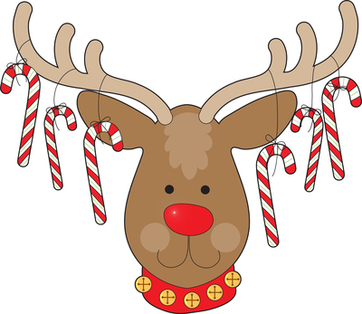
Kwanzaa Word Search
BENDERA KARAMU KUJICHAGULIA KWANZAA MAZAO MUHINDI
NIA SWAHILI UJAMAA
UJIMA IMANI TAMBIKO
KUUMBA UMOJA MKEKA

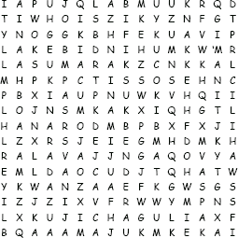

Marshmallow Snowmen
If you have the right supplies, you can put this craft together in minutes! Here’s what you’ll need:
- Glue—white frosting
- Optional base—cookie
- Body—large marshmallows
- Arms—pretzel sticks
- Hat—chocolate mint patty and chocolate kiss
- Face and buttons—candy-coated chocolates and/or mini chocolate chips
- Scarf—pull-and-peel licorice or a strip of fruit leather
- Toothpicks
- Plastic knives

Directions:
- Place materials on individual plates and have each Cub Scout build their own marshmallow snowman.
- Spread frosting over the bottom of the cookie, and press the cookie onto a plate.
- Spread frosting on the bottom of marshmallows and stack them on top of the cookie. As an option, poke a toothpick through the marshmallows for added stability.
- Tie on a scarf.
- Add the hat (a chocolate mint patty) and then the chocolate kiss on top of that, then eyes, the nose, and buttons.
- Slide a pretzel stick through the body for arms.
- Put snowmen in the refrigerator or freezer while the frosting hardens.

Meet Your Match
Materials – pictures of things that belong in pairs, one picture for each participant.
Ideas - marshmallows and hot cocoa, logs and fireplace,
wrapping paper and bows, flames and candles.
Set Up: –
In a room away from the main area,
Lay the pictures out and stick a piece of tape at the top of each.
(Maybe have the pictures face down and not in their pairs or it could be real obvious CD)
Invite the Scouts to take one picture at a time and tape it on the back of another Scout,
Then reverse, the second Scout tapes a picture on the back of the first Scout.
They have to be careful so Scout #2 doesn't see which picture Scout #1 placed on their back, and vice versa.
Warn everyone (not just the kids) not to talk about the other pictures.
Directions –
Everyone asks each other yes or no answer questions to figure out what's on their own back. (Examples: Is it something you can eat? Is it an animal, vegetable, or mineral? Is it bigger than a toaster?) Limit the number of questions one Scout can ask another before moving on. Make sure the youngest Scouts understand that they're not supposed to tell people what picture is on their back until that person figures it out for themselves.
Once you discover what you are, you have to find your match.
e.g. If you're a cookie, look for glass of milk; if you're a stocking, look for hook, and so on.

Santa's Bag
Number 10 brown paper bags from 1 to 10. Put a familiar item in each bag (preferably related to Christmas), fold and staple the bag shut. Each Cub Scout is given a pencil and paper with 1 through 10 listed. Then they try to guess what is in each bag by touching and shaking the bag. They write their guess on the paper by number. The Cub Scout with the most correct answers wins.

Santa Maze
Baltimore Area Council
This has a suggested time limit of 4 minutes. Start at the “in” arrow at Santa’s boot and exit at the “out” on his pack.
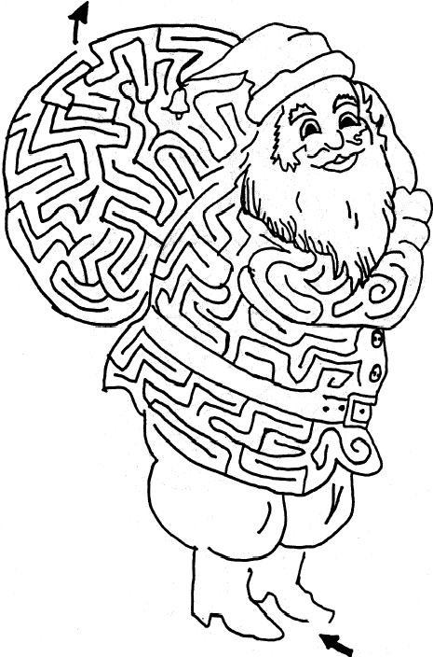
Star Tracing
Duplicate a number of double stars, the outer one being about 6 inches from point to point, and the inner one smaller, as illustrated. The Object is to draw a third star between the lines of the inner and outer stars while shielding the stars from direct vision and using a mirror. Place mirror about 1” from point of star.

Visit from Saint Nicholas
Prepare sets of four cards.
  - On each card, write one of the first four lines of the famous Christmas poem: 'Twas the night before Christmas when all through the house Not a creature was stirring, Not even a mouse. The stockings were hung by the chimney with care In hopes that St. Nicholas soon would be there.
  - Suspend the cards with a string around the necks of all the players.
  - On signal, everyone is to scramble about seeking the other three lines of the poem.
  - The first four to line up in the proper sequence are the winners.

What Am I?
Materials: Index cards with the names of objects related to the Winter Wonderland or December Holidays written on them, tape.
As Cub Scouts and families arrive, tape a card on each person's back. Make sure the people don't see their own cards. They walk around the room and ask others questions that will help them guess the name of the object. They may ask each person only one question at a time.
Questions must require a "yes" or "no" answer.

Winter Wonderland Words
Hand out sheets of paper with the words “WINTER WONDERLAND” at the top. Ask everyone to find as many words as they can in that single phrase.

12 Days of Cub Scouting
Have the Cub Scouts work together on their own carol based on the 12 Days of Christmas, but titled “The 12 Days of Cub Scouting.” Start them with a sheet that lists out the basic lyrics, such as:
On the first day of Cub Scouting, my CUBMASTER gave to me, a BOBCAT BADGE FOR ALL TO SEE.
On the second day of Cub Scouting, my ___ gave to me, a

OPENING CEREMONIES

Building A Better World
11 Cub Scouts, each holding a card with a letter on the front and their line on the back in BIG print.
Each speaker holds up their letter as they say their line. Last line delivered by all.
Cub # 1: B for BROTHERHOOD, boosting for each other's good
Cub # 2: E for EVERY LAND to share in earth's riches everywhere
Cub # 3: T for TRUSTFULNESS, trusting more and fearing less
Cub # 4: T for TEAMWORK, for joining hands to put things through
Cub # 5: E for EQUAL CHANCE for each nation to advance
Cub # 6: R for REAL RESPECT in spite of race, creed, or sect.
Cub # 7: W for WILL TO WORK for peace with faith and skill
Cub # 8: O is for OPPORTUNITY to keep our speech and action free
Cub # 9: R for REVERENCE for a guiding providence
Cub # 10: L for LOVE TO SPREAD around when need and bitterness are found
Cub # 11: D for DIGNITY of man devoted to a better plan.
(All hold up letters)
ALL There you have it - that is how you build A BETTER WORLD.
Candle Opening
Dim or turn off room lights except for an electric candle or flashlight. The paragraph is read by the Cubmaster or other adult.
This is the season of lights and stars, when days are short and nights are long with beautiful stars. Lord Baden Powell, the founder of Scouting, once said this to Scouts: “I often think when the sun goes down, the world is hidden by a big blanket from the light of heaven. But the stars are little holds pierced in that blanket by those who have done good deeds in this world. The stars are not all the same size, some a big, some are little. So some men have done great deeds, and some men have done small deeds, but they have all made their hole in the blanket by doing good before they went to heaven.”
Let's remember when we look at the starry sky to make our own hole in the blanket, by doing good deeds and helping other people.
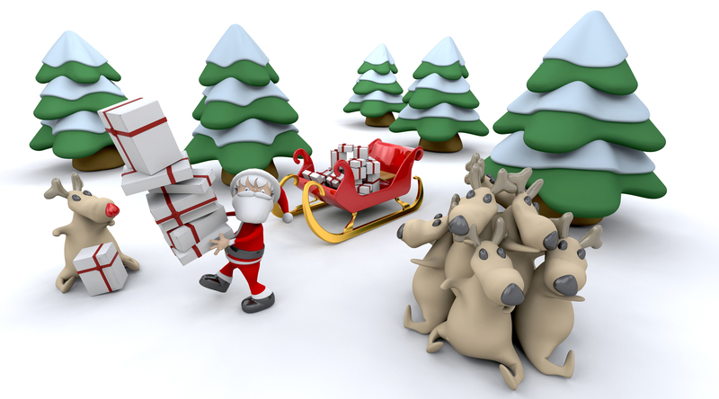
Christmas Around the World
Each Cub Scout holds an article representing the country, they have chosen, while they read the lines. Or instead, have each Cub Scout hold a cardboard cutout of the country they represent, with the words written on the back of the cutout for easy reading. Cub Scout can be in uniform or in costumes for countries.
- Ireland – The building of a grotto for the Nativity scene is a family project in Ireland. A Dublin fruitcake, covered with thick almond-flavored icing and decorated with green gumdrop shamrocks is the popular food.
- Scandinavia – Children, parents and even grandparents all join in making interesting straw and balsa wood ornaments in shapes of stars, angels, reindeer, and other animals. They begin making these holiday decorations on Little Christmas, the last Sunday in November.
- Poland – Here the Christmas tree is a symbol of friendship and peace, and is heavily laden with pretty ornaments. Poppy-seed rolls filled with ground poppy seed and honey paste are prepared the night before Christmas.
- Austria – Greens and apples signify hope for the coming spring and are used in the twilight tree with candles to celebrate the holidays. Linzer cakes and nut butter rounds are their Christmas delicacies.
- England – Punch and Judy shows are very much a part of the British Christmas. Plum pudding, spicy ginger cookies, shaped like cornucopias and filled with whipped cream are delightful foods.
- Italy – Instead of a Christmas tree, Italy has the pyramid-shaped Ceppo. The manger scene of hand-carved figures is placed on the lower shelf of the ceppo and small gifts for the children are put on the next shelf. Golden bread of Verona and Sicilian torrone, a multi-colored candy loaf are special pastries.
- Greece – St. Basil, who distributes Christmas toys, makes his rounds in a boat instead of a sled. New Year’s bread with a coin baked inside is served at the stroke of midnight on New Year’s Eve. Father cuts a portion of bread for each member of the family in the order of their ages. Whoever gets the piece with the coin will enjoy a year of coed luck.
- Mexico – In Mexico, the piñata filled with candy is always a favorite at Christmas time. The children strike it until it cracks and the goodies spill cut for all to enjoy.
Christmas Flag
Personnel 6 Cub Scouts
Equipment taped music, American flag
Setting Play "Joy to the World" softly in the background as Cub Scouts recite lines.
- I pledge Allegiance, at this joyous time of year.
- To the flag, a symbol of unity as Christ is a symbol of peace.
- Of the United States of America, a land chosen above all others.
- And to the republic, to the people who care and share for which it stands.
- One nation under God, who shared His Son with us.
- Indivisible, a nation united through love with liberty and justice for all.
- Please stand and repeat the Pledge of Allegiance.

Christmas Spelling
Arrangement: Nine Cub Scouts come onstage, one by one. Each carrying a large cardboard letter. Hint: glue red tinsel garland on poster board. Cub Scouts could wear Santa hats. As they speak their lines, they hold up their letter, each ultimately spell out the word Christmas. The script is on the back of letters in LARGE PRINT. Make sure the Scouts practice reading their script and speaking loud and looking up at the audience and projecting their voice to the back of the room.

- C is for carols and Christmas cheer.
- H is for holly that’s hanging here.
- R is for the reindeer I’ve never seen.
- I is for ivy of Christmas green.
- S is for stockings, Santa and skis.
- T is for tinsel on Christmas trees
- M is for a message to you from me.
- A is for angel atop a tree.
- S is for the secrets of every size. All wrapped and waiting for eager eyes.

Cub Scout Spirit
Personnel: 5 Cub Scouts, Den Chief (DC), Den Leader (DL) or Cubmaster (CM)
Equipment: 5 index card with script written on each, US flag, Pack flag
Setting: Flags are already in place in the front and each Cub Scout enters from the side one at a time and reads the script.
- December is a fun time of the year. It is a time for giving and sharing.
- As we gather for the last pack meeting of <insert year> let us remember the good times.
- Let us end this year with new determination to keep the Cub Scout Spirit going.
- As we begin our program tonight, let us keep in mind the true holiday spirit.
- Remember, to give of yourself is more important than any gift you can buy.
DC: Please stand for the Pledge of Allegiance.
December Gift Opening Ceremony
Props: Box wrapped with holiday paper and tied with a bow. In the box are a menorah, small Christmas tree, invitation, Kwanzaa candelabra, and other symbols of December Holidays appropriate for your unit, Instant Recognition patch and beads, small wrapped gift, small felt stocking, and card saying "Do Your Best."
Cubmaster: (Opens box and looks inside.) December is one of the most exciting months of the year, and certainly one of the busiest. This month we have: Christmas (Takes out tree.); Hanukkah (Removes menorah.); Kwanzaa (Removes candle holder.), (Does other symbols), and Holiday parties (Takes out invitation.).
What a great time for all of us! Our pack has had lots of fun this month working on advancements (Takes patch and beads from box.).
One of the best things was our special service project/Good Turn (Takes stocking or other symbol for the project from box.)
We've been busy, and all the time we have followed the Cub Scout Motto: (takes paper out of box and shows it while saying motto) "Do Your Best". And we have learned to Respect the traditions of other people from around the world. We are also learning to show Respect for our flag. Now Den ___ will present the colors.

December Opening
Personnel: 5 Cub Scouts and Cubmaster (CM)
Equipment: 5 Index cards with script written on each, US flag and pack flag. Flags are already in the front and each Cub Scout enters from the side one at a time and reads script.
- December is a fun time of the year. It is a time for giving and sharing.
- As we gather for the last Pack meeting for 2015, let us remember the good times.
- Let us end this year with new determination to keep the Cub Scout Spirit going.
- As we begin our program tonight, let us keep in mind the true Holiday Spirit.
- Remember, to give of yourself is more important than any gift you can buy.
CM: Please stand for the Pledge of Allegiance.

Do unto Others
Cub # 1: The holidays are a time for Giving!
Cub # 2: The holidays are a time for sharing!
Cub # 3: The holidays are a time to think of other!
Cub # 4: All year we should remember to do a good turn, give good will.
ALL: AND DO UNTO OTHERS!

Four Gifts
Cubmaster: Christmas is a wonderful time to show love to others through giving gifts. It is also a time we can look at the many gifts we have already been given and enjoy each day. I have four gifts wrapped up that represent some of the gifts that each of us receives by living in a free country.
Four Cub Scouts unwrap the gifts and read, in turn, the statements found inside.
Cub # 1: The gift of freedom--Freedom to worship as we choose and to express ourselves and our ideas without fear.
Cub # 2: The gift of beauty--We live in a country full of beauty and wonders. From mountains to plains, from valleys to seas, it is ours to enjoy as we freely travel its width.
Cub # 3: The gift of opportunity--We are free to become whatever our ambitions and desires lead us to. Our limits lie only within ourselves.
Cub # 4: The gift of pride--We can be proud of a country where we are blessed with freedom and justice. We can be proud each time we see “Old Glory,” our country’s flag, unfurled. We can be proud to be an American.
Cubmaster: With these gifts in mind, will you please stand and pledge your allegiance to our country and our flag.

Gift of Goodwill
Arrangement: A group of 8 Cub Scouts are gathered around Christmas gifts. Each Cub Scout is wrapping a gift, Den Chief enters.
Den Chief: Hey guys, let me see what each one of you is wrapping.
Cub 1: Gloves for my Dad.
Cub 2: An owl plaque for my Mom.
Cub 3: Oreo cookies for my little brother...maybe he will quit eating mine.
Cub 4: A doll for my sister.
Cub 5: Wind chimes for my Mom.
Cub 6: Ink pens for my big brother...maybe mine will quit disappearing.
Cub 7: A lamp for my Mom.
Cub 8: A lacy handkerchief for my grandma. She likes to wave them good-bye.
Den Chief: Hey you guys are really giving Goodwill
(laughs).
All Cubs: We hope so. Aren't we supposed to do that year-round?
Den Chief: Yes, but let me show you something that's quite unusual. (They take a large piece of poster board and marking pen. They call on each Cub Scout in order to name the gift they are wrapping, and the den chief writes the first letter on the
board...such as G for gloves. O for owl, etc. The result spells out Goodwill, which they hold up for the audience to see.)
Cub 1: Hey, that's all right! We're giving Goodwill separately together!

G*I*V*E*S
Equipment: Five Cub Scouts with 5 large cards each with a letter forming the word G*I*V*E*S. Each one has the sayings written on back in large print.
Arrangement: Each Cub Scout holds up their card and says the following:
# 1: G stands for Giving, It's always good to give.
# 2: I stands for Intentions, May mine always be right.
# 3: V stands for Valiant, A trait of great might
# 4: E stands for Earnest, From beginning to end.
# 5: S stands for Sharing, This makes me a friend.

Holiday Opening
Props: Box wrapped with holiday paper and tied with a bow. In the box are a menorah, small Christmas tree, invitation, (Kwanzaa candelabra if appropriate), Instant Recognition patch and beads, small wrapped gift, small felt stocking, and card saying "Do Your Best." Cubmaster: (Opens box and looks inside.) December is one of the most exciting months of the year, and certainly one of the busiest. This month we have: Christmas (Takes out tree); Hanukkah (Removes menorah); Kwanzaa (Removes candle holder); and Holiday parties (Takes out invitation). What a great time for all of us! Our pack has had lots of fun this month working on advancements (Takes patch and beads from box), but one of the best things was our special service project/Good Turn (Takes stocking from box). We've been busy, and all the time we have followed the Cub Scout Motto: (takes paper out of box and shows it while saying motto) "Do Your Best".
Now Den ___ will present the colors.

Holidays Lights Around the World
- In India and Thailand, they celebrate the Festival of Lights, with little lamps or lotus boats that float into the night. [Cub Scout carries a Lotus Boat of foil]
- In Sweden, too, they honor Santa Lucia, Queen of Light, the oldest girl will wear a crown with candles warm and bright. [St. Lucia crown or candle and greens.]
- In Mexico, the children gather goodies from the floor, for they’ve broken the piñata filled with candy treats galore! [Piñata]
- In Poland, on the table, under dishes they put straw, aAnd they leave a chair that’s empty for the Holiest child of all. [Hand full of straw or a small chair.]
- In Ireland, each window holds a very special light, A candle that will welcome all who wander in the night, Just as Mary came with Joseph seeking shelter long ago, The candle still will welcome those who wander to and fro. [Artificial battery candle]
- In Holland, children fill their shoes with carrots and with straw ~ In hopes “Black Pete” will substitute a gift for one and all. [Wooden shoes and/or carrots]
- In Israel, the children play with a special top for a special day. [Dreidel]
- In England, children hang a sock - one that doesn’t have a hole! They hope it will hold presents and not a lump of coal! [Christmas stocking]
- Let’s Celebrate! Let’s Celebrate! and learn of special ways that people all around the world celebrate their holidays! [Globe]

Holiday Pledge of Allegiance
Personnel: A Cub Scout (or several Cub Scouts) , den chief, or adult leader reads the lines for narrator (NAR) and the audience (AUD) reads the other lines together. Either print the lines in the Program or Distribute the ceremony beforehand.
NAR: I pledge allegiance
AUD: At this joyous time of the year
NAR: To the flag
AUD: A symbol of unity
NAR: Of the United States of America
AUD: Where we join together in peace
NAR: And to the republic for which it stands
AUD: Where people do their best to help each other
NAR: One nation under God
AUD: Where we have freedom to worship in our own way
NAR: Indivisible
AUD: We will stand strong, giving respect to others.
NAR: With liberty and justice for all.
AUD: Where people of all races and faiths can experience true fairness
NAR: Let us remember all our blessings as we pledge our allegiance to the flag.

Holiday Lights
Personnel: 5 Cubs, Den Leader (DL) and Cubmaster (CM)
Materials: Log candle holder with 3 candles (12")
Multipurpose lighter

- The theme of this month is “Holiday Lights” and we have been busy getting ready for the Holiday season.
- This month there are three major holidays celebrated by a different Religions, Hanukkah, Christmas and Kwanzaa. And each uses light in a special way.
- Hanukkah is the Jewish Feast of Lights or Feast of Dedication. The Hebrew word Hanukkah means dedication. It is a celebration of God's deliverance of the Jews in 165 BC.
DL: The Hanukkah holiday begins on the eve of the 25th day of the Hebrew month of Kislev, and lasts eight days. It usually falls in the month of December and is celebrated by lighting of candles in a special Hanukkah menorah. I light the first candle for Hanukkah. [Lights the first candle]
- Christmas is the celebration of the birth of Jesus Christ. Advent is the season of preparation for Christmas.
DL: In preparing for Christmas, Christians use an Advent wreath with four candles in the wreath and one in the center. They light one candle in the wreath each week and the center, or Christ, candle on Christmas, for Jesus is the Light of the World. The word Christmas is taken from old English, Christes maesse or Christ's Mass. I light the second candle for Christmas. [Lights the second candle]
- Kwanzaa is an African American holiday based on the traditional African festival of the first harvest crops.
DL: The word Kwanzaa comes from the phrase Matunda ya Kwanzaa, which means “first fruits” in Swahili. The holiday was developed in the United States in 1966 by M. Ron Karenga, a professor of Pan African studies and a black cultural leader. It begins on December 26th and lasts for seven days. Each day of Kwanzaa, another candle is lit on the Kinara. The candles stand for the seven principles of black culture developed by Karenga. The principles are: Unity, Self-determination, Collective Work and Responsibility, Cooperative Economics, Purpose, Creativity, and Faith. I light the third candle for Kwanzaa. [Lights the third candle]
- With the spirit of the holiday candles now burning, let us begin our own celebration of our accomplishments this month.
CM: All rise for the Pledge of Allegiance. [Perform proper flag protocols.]

Holiday Openings
Scene: CM comes out followed by several scouts, each holding a large card with one letter from either Christmas Joy or Chanukah on it. Words can be on back of card with letter in LARGE print or the CM or Den Chiefs or other scouts can read the text associated with each letter. Have Scouts hold cards above their heads when finished.
Cub # 1: C: Caroling, candies, chimes a-ringing
Cub # 2: H: Holiday wreaths with berries climbing
Cub # 3: R: Reindeer - fast but oh so tiny
Cub # 4: I: Icicles bright and silvery shiny
Cub # 5: S: Stars and stockings, shoppers streaming
Cub # 6: T: Through the town with tinsel gleaming
Cub # 7: M: Mistletoe in its waxen glory
Cub # 8: A: Angels from the Christmas story
Cub # 9: S: Santa with his sack to carry
Cub # 10: J: Journeys on his sled so merry
Cub # 11: O: O'er the world to each girl and boy
Cub # 12: Y: Yes! It's time for Christmas Joy!

Cub # 1: C: Stands for candles golden and bright that Father with blessings will light every night
Cub # 2: H: Stands for Hannah, courageous and true, who would not yield, so her sons they slew
Cub # 3: A: Stands for Antioch, Syrian king, who tried with his power, Greek worship to bring
Cub # 4: N: Stands for "nes," that wonder so great, when oil lasted not one day, but eight
Cub # 5: U: Is for unfurling the Maccabee banner by Judah who fought in so valiant a manner
Cub # 6: K: Is for the kindling of candles each night, reminding us all of great deeds of might
Cub # 7: A: Stands for all, living far and wide, who tonight are glowing with a true sense of pride
Cub # 8: H: Stands for Hebrew, the language so old, in which the story of Chanukah is told

Light of Scouting
Scene: Have four Cub Scouts each light a candle (or turn on a flashlight inside/behind a construction paper candle) in turn. Have another (or others) read the ceremony.
Cub # 1: This is the light of Scouting - it radiates enthusiasm. As light brings out the sparkle in diamonds, enthusiasm brings out the sparkle in scouting.
Cub # 2: This is the light of Scouting - its energy gives us the strength to do our best.
Cub # 3: This is the light of Scouting - it touches everyone. Remember the brotherhood we share together in Scouting.
Cub # 4: This is the light of Scouting - it brightens the way of the path we will follow.
All: Feel the warmth from the glow of the light.
May it warm your heart.

Traditions at Christmas
Equipment: Each Cub Scout could have the object they talk about on display or a large picture of the object. Make sure each Cub Scout’s script is in LARGE print.
Cub # 1: The Christmas Tree. The custom of decorating a small evergreen tree at Christmas time began in Germany. However, it reached America before it arrived in England. The German settlers in Pennsylvania decorated trees with lights, sweets, and colored paper. That is how the Christmas tree became part of our traditional Christmas.
Cub # 2: The Mistletoe. Ancient Celtic priests believed mistletoe had medicinal powers and was sacred. They thought it brought good fortune. Mistletoe was also considered the plant of peace and, under it; enemies met and reconciled their differences. From this ceremony came the English custom of kissing beneath the mistletoe.
Cub # 3: The Christmas Wreath. During the 16th century in Germany, branches of fir or spruce were intertwined in a circular shape. This symbolized the love of God, which had no beginning and no end. One legend tells of a young girl of Bethlehem who wept because she had nothing to bring to the Christ child but a crown of holly leaves. The babe touched the crown and the leaves gleamed and scarlet berries appeared where her tears had fallen.
Cub # 4: The Christmas Candle. Medieval Christians believed that on Christmas Eve the Christ child wandered through town and countryside in search of those who believed in Him. On that night, they place candles at their windows to guide Him.
Cub # 5: The Poinsettia. This Christmas flower was discovered in Mexico in 1828 by Dr. Joel
Poinsett. The people of Mexico and Central America call it "Flor do la noche buena" or flower of the Holy Night because it reaches full bloom at Christmas.
Cub # 6: The Christmas Card. At Christmas in 1843, in London, "A Christmas Carol" by Charles Dickens had just been published. A friend, Sir Henry Cole, had an artist friend design a Christmas greeting to send to his friends. This was to be the first Christmas card. It took more than 30 years for them to become popular. They were first introduced in the United States in the late 1870s.
Asst CM The ___ den will perform the flag ceremony.

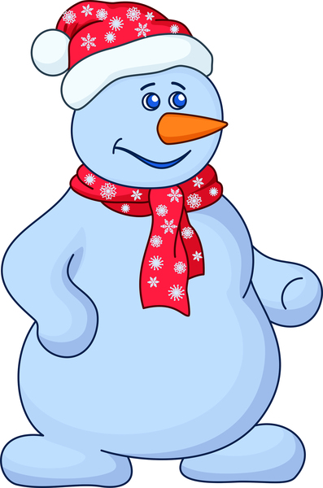

Many Ways
CM: It is the season that is full of so many wonders and so many thoughts. Each of us understands, celebrates, and remembers this special season in their own way. If it were only "my way" or only "your way" though, it would be so small, so limited. One of the beauties of the season is that it is so full, so complete.

And just as the season is made special by so many different ideas, cultures, and beliefs coming together, so is our country made special. We are not a single type of people, a single religion, or a single race, but we do have a single focus—to be and become the greatest, most full and complete country we can imagine.

As a melting pot of cultures and nationalities, we come together as one and that also makes us special. Let's join together in the Pledge of Allegiance and renew our single- mindedness

Opening (Christmas)
Five to nine uniformed Cub Scouts line up at the front of the room and hold up cards spelling out the word CHRISTMAS. Each Cub Scout shows their card as they speaks:
C – was the child in the manger asleep
H – was the herder that guarded the sheep
R – was the room in the stable that day
I - was the Innkeeper letting them stay
S – was the star that led three by its light
T - was the tiding of joy brought that night
M - was the mother, whom Joseph stood near
A - was the angel, whose message was clear
S - was the song that the angels sang then, of peace on earth and good will toward men.
Please join together in singing “Silent Night.”

Opening (Around the World)
CUBMASTER: This month we shine holiday light on our own traditions and culture and the customs of others. As we learn more about one another, we respect the different ways each of us celebrates this time of year around the world.

The preassigned den enters, each member carrying a battery-operated candle. As each Cub Scout lights their candle, they say:

#1: This is the season of lights.
#2: The days are shorter, the nights are longer, brightened by our holiday lights.
#3: Many homes light candles to honor the birth of Jesus at Christmas time.
#4: Many homes light Hanukkah candles to celebrate the festival of lights.
#5: Many homes light the kinara to celebrate Kwanzaa.
#6: The most brilliant light comes from the spirit of goodwill and peace toward all.
#7: Cub Scouts light up the lives of others by respecting the traditions of all faiths and traditions.
#8: Please stand and join us in the Scout Oath and Law
Peace and Friendship
Each Cub Scout holds a letter. The letters spell PEACE.
On the back of each piece of posterboard have their lines written in large print.
Sometimes during the holidays
As the days go rushing by.
Take time to see the holiday lights
Mist-halloed against the sky.
Sometime during the holidays,
Breathe deep the holiday smell. The bayberry and the piney scents
What welcome they foretell.
Sometime during the holidays
When carolers are singing.
Retell the age-old story.
For which the bells are ringing.
Sometime during the holidays
Midst the gaiety and noise.
Take time to hear the quietness
Of simple Christmas joys.
Sometime during the holidays Remember friends are near. And feel the warmth of knowing Your friendship's very dear!

Starry Night
Dim or turn off room lights except for an electric candle or flashlight
This can be either an opening read by one person or divided up into parts. Or it works well as a Cubmaster’s Minute.
This is the season of lights and stars, when days are short and nights are long with beautiful stars.
Lord Baden-Powell, the founder of Scouting, once said this to his Scouts, “I often think when the sun goes down, and the world is hidden by a big blanket from the light of heaven.
But the stars are little holes pierced in that blanket by those who have done good deeds in this world. The stars are not all the same size; some are big, and some are little. So some men have done great deeds, and some men have done small deeds, but they have all made their hole in the blanket by doing good before they went to heaven.”
Let’s remember when we look at the starry sky, to make our own hole in the blanket, by doing good deeds and helping other people.

Tree Opening (Traditions)
HINT: Use tree decorating as a Gathering Activity
Directions: Cubmaster uses Cub Scout sign to get everyone's attention, then Assistant Cubmaster lights the Christmas tree.
Cubmaster: “Cub Scouts, isn’t that a beautiful tree? It’s full of Holiday Lights making it bright and colorful, like the joyous seasons we celebrate this month.” (Name seasons celebrated by pack members, such as Christmas, Hanukkah, Kwanzaa, and any others.)
Assistant Cubmaster: “And we all had a part in making it so beautiful. When all Cub Scouts work together and do their best, the result is always something fine like this tree. Let’s remember that as we repeat the Scout Oath.” (Leads Oath)
Cubmaster: "Now let us repeat the Pledge of Allegiance"

Wishes
Set Up:
Cubmaster (CM), 3 Cub Scouts (Tiger Cubs, Cub Scouts and/or Webelos Scouts),
Display of 4 or more candles; one lit (to allow more Scouts to participate, continue to add wishes and candles);
Be sure the location where you are celebrating this meeting allows the use of lit candles.
Scene:
Scouts enter and light a candle from the one lit candle as each says their wish.
Cubmaster: With all the festivities of this busy season, our Cubs have designed some wishes they would like to share with you, to help brighten your spirit and light a path to their achievements.
Cub Scout #1: (lights candle) This wish is for everyone to work hard to follow their dreams.
Cub Scout #2: (lights candle) This wish is for peace for all the children of the world.
Cub Scout #3: (lights candle) This wish is for a year where everything goes well for those we hold dear.
Cub Scout #4: (lights candle) This wish is for (Add as many more wishes as you have Cub Scouts in your Den or who wish to participate in the ceremony)
Cubmaster: As our room is now lit with the spirit of good will and the spirit of Cub Scouting, I invite you to stand and join our Cub Scouts in the Pledge of Allegiance.

With Apologies to Charles Dickens (Traditions)
Reader: This is a special time of year for people all around the world. It is a time of Joy and Light, of Hope and Peace, and of the comforts of Home, Family, and Tradition. It is a time of Spirit in all things, and although there are many different types of Spirit and Spirits among us, tonight we are going to be visited by four of them.
Spirit of Christmas: "I am the Spirit of Christmas" (Lights Advent candles, using appropriate prayer(s) and a brief statement as to what the candles and the holiday represent.)
Spirit of Chanukah: "I am the Spirit of Chanukah" (Lights the Chanukah candles using the appropriate prayer(s) and a brief statement as to what the candles and the holiday represent.)
Spirit of Kwanzaa: "I am the Spirit of Kwanzaa" (Lights the Kwanzaa candles and gives a brief statement as to what the candles and the holiday represent.)
Spirit of Scouting: "I am the Spirit of Scouting, and here I light the twelve candles which the twelve points of the Scout Law, and three candles which represent the three points of the Scout Oath. I will also light one additional candle of the purest white, which represents not only the Spirit of Scouting, but also all the other Spirits of Goodness which exist throughout this old world of ours no matter what they may be called. Now, I call upon my Fellow Spirits, and all of you here in this room, to join with me in reciting the Scout Oath or Law or both.
All: (Scout Oath or Law or both)
Reader: Thank you all. Please be seated.
All Spirits: "Happy Holidays!"

Winter Wonderland
Setup: Have the Cub Scouts who are presenting the opening prepare cards that describe what “Winter Wonderland” means to them. They will read these before the Pack, so you will want to review them to make sure they’re sensible and appropriate.
Leader: Tonight, we gather to celebrate the theme, Winter Wonderland. What does that mean, Winter Wonderland? To each of us it means something different, but to all of us something special. Let’s close our eyes and think about “Winter Wonderland” and let our thoughts paint pictures of what it means to us. As we do this, let’s hear from the Cub Scouts in Den ___ who have already given some thought to what this means.
(Cub Scouts read off “To me, Winter Wonderland means…”)
Leader: So many different ideas all from the same two words. It’s no different than when we say “United States.” Again, two small words that mean many different things to many different people. But there is one way in which all of us are united—let’s stand and recite the Pledge of Allegiance followed by the Scout Oath — thoughts that bind us all together.

Poem: The ABC's of Christmas
A is for Angels with halos so bright, whose carols were
heard on that first Christmas night.
B is for Bells so merrily ringing, joy to the world is the message they're bringing.
C is for Candles that so brightly shine to give a warm welcome, to your friends and mine.
D is for Doorway with garlands of green, to make Christmas merry as far as they're seen.
E is for Evergreens, with fragrance so rare, so plentiful at Christmas, their scent fills the air.
F is for Fun the whole season long, from trimming the tree to singing a song.
G is for Greetings - a merry "hello" - with a heart full of love for people we know.
H is for Holly, with berries so red, to make into wreaths to hang overhead,
I is for Ice on snow covered hills, where sledding is fun along with the spills.
J is for Jesus, the Christ child so dear. We honor his birth on Christmas each year.
K is for Kris Kringle - so merrily he stands. He is who they call Santa in so many lands.
L is for Lanterns. I am sure that their light helped Mary and Joseph that first Christmas night.
M is for Mary, her heart full of love, for her little son Jesus, who came from above.
N is for Noel, the angels did sing, to herald the birth of Jesus, our King.
O is for Ornaments, so shining and bright, with lights on the tree to sparkle at night.
P is for Packages with ribbons so gay, all 'round the tree for our Christmas Day.
Q is for Quiet, Christmas Eve night, with snow covered hills glistening so bright.
R is for Reindeer who pull Santa's sleigh, to your house, to my house, they know the way.
S is for Shepherds who first saw the star over Bethlehem's manger and followed it far.
T is for Trees we decorate so gay; then wait for ole Santa to hurry our way.
U is for Universe, where Christmas brings joy to all in the world - to each girl and each boy.
V is for Visiting friends near and far. We travel by plane or by bus or by car.
W is for Wise Men, who brought gifts so rare, and knelt down and worshiped the child they found there.
X is for Xmas, or Christmas by full name. No matter the language, it all means the same.
Y is for Yule Logs, whose bright sparks fly high, to give a warm welcome to friends passing by.
Z is for Zeal we show at this time, in giving to others and loving mankind.

INVOCATION

Holiday Lights Prayer
Please prepare yourselves for prayer as is your custom. We give thanks for all who are here with us tonight, and wish those around the world who are celebrating in their own way, a happy, safe, and secure holiday season. May the light of the season lighten our hearts and theirs throughout this year and the next. Amen.

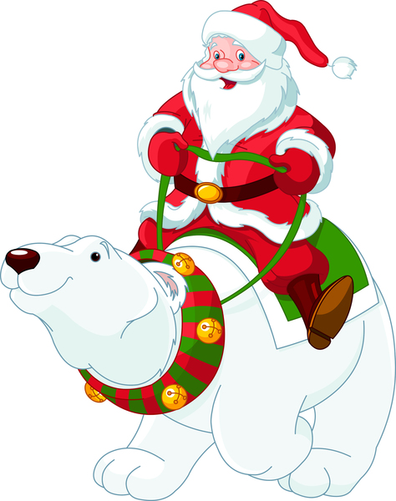

AUDIENCE PARTICIPATION

Camping in the Woods on Christmas Eve
T'was the night before Christmas
And all through the woods,
Not a Scout was stirring, they were all being good.
Their sneakers were hung by the camp fire with care.
In hopes the delivery guy, soon would be there…
And I in my Neckerchief,
And Mr._______ in his Cub-Cap,
Had just settled down for a short camping nap,
When deep in the woods there arose such a clatter,
I sprang from my sleeping bag,
To see what was the matter.
Away to the tent, I flew, I was scared,
I grabbed a hammer and shovel,
In case it was a bear.
Then what to my wondering eyes should appear,
But Scouter Clause, with some pizza and root beer.
He was a little old Scout, so lively and quick,
I knew in a moment, He was scared of ticks.
More rapid than an Eagle Scout the pizzas they came,
and he whistled and shouted and called them by name,
Now sausage, now peppers, now onions and pepperoni,
On meatball, on, ham. On, hold the anchovies.
To the top of the tents, to the top of the trees,
Dash away, Dash away, with extra cheese.
As I got to my feet and was turning around,
Into the campsite, he came with a bound.
He was dressed all in uniform from his head to his toes.
His shirt was garnished with badges and bows.
A bundle of pizzas he had flung on his back,
And he looked like a new Scout,
doing the opening ceremony, for his pack,
His eyes, how they twinkled, His dimples so merry,
His cheeks were like roses, his nose like a berry.
He had a broad face and a little round belly,
That shook when he laughed like a bowl full of jelly.
He was chubby and plump, a right jolly old Scout,
And I laughed when I saw him, in spite of myself.
He spoke not a word, but went straight to work,
Gave out the pizza and then turned with a jerk,
And laying a finger onside of his nose,
and checking his compass, Down the trail he goes,
I sprang to my feet, to the Cub Scouts gave a whistle
And up they all flew, like the down of a thistle.
We ate all the pizza and drank all the soda,
Our stomachs, all felt like they would explode.
And we heard him exclaim, as he drove out of sight,
Merry Christmas Pack ____, & to all a good night!

Christmas with the Wright Family
The Cub Scouts are seated in a circle and they start with their own present. As the story is read and a direction is given, they pass their gift that way.
Mrs. WRIGHT eyed her Christmas list carefully. “There won’t be anything LEFT of our budget after Christmas! Dear me!” she sighed.
Mr. WRIGHT looked up from his paper. “That’s all RIGHT, my dear, there isn’t anything LEFT of it anyway at the end of the month. I’ll be happy if it just sees the WRIGHT family through the holidays.”
As Mr. WRIGHT turned to his paper, he said, “Have you the RIGHT gift for Aunt Hattie WRIGHT this Christmas? She’s been pretty lonely since her daughter married and LEFT home. Uncle Harry WRIGHT LEFT her a lot of money, but she doesn’t know how to enjoy it.”
Eddie WRIGHT was studying in the corner LEFT of the fireplace. “I wish Aunt Hattie WRIGHT would ask me the RIGHT way to spend it,” he said.
Eugenia WRIGHT sniffed, “She wouldn’t have much LEFT if she did. Your allowance is almost gone before you get it.”
“And I suppose you have all of yours LEFT, Miss Miser!” returned Eddie WRIGHT.
“I don’t have all of it LEFT, but I’ve enough LEFT to buy presents, all RIGHT, without having to borrow from Mother,” she snapped.
Eddie WRIGHT looked downcast. “That’s RIGHT. Christmas is mighty near, only two more shopping days LEFT.”
“Have you a present for Rose, Eddie WRIGHT?” asked Mrs. WRIGHT. “She gave you a nice tie last year, remember?”
Eddie WRIGHT groaned, “That’s RIGHT! Gosh, a fellow can’t do RIGHT by his family and a girl, too, and have anything LEFT on two dollars a week. What shall I do?”
Just then the doorbell rang. Eugenia WRIGHT ran to answer it and the postman LEFT a special delivery letter for the WRIGHT family. She took it to Father WRIGHT and he opened it. Inside was a letter, along with four RIGHT new ten dollar bills!
Mrs WRIGHT whistled, “It’s from Aunt Hattie WRIGHT! She LEFT town and has gone to her daughter’s for Christmas and wished us who are LEFT here to spend it on each other.”
“Say, she’s RIGHT!” Eddie WRIGHT shouted.
“Bless her heart,” said Mother WRIGHT.
“It has made her RIGHT happy to give it to use before she LEFT,” declared Father WRIGHT. So, I guess it’s all RIGHT with everybody LEFT here.”
Once the story has ended, each child may open the present he/she ends up with.
(Personal experience has shown you will have to stop several times during the story, because some Cub Scouts will be holding two presents, and some Cub Scouts will have none. The best arrangement is to station the parents around the circle behind their child/children to keep the flow of presents going.)

Cub Scout Holiday
Break audience into four parts. Assign each part one word and its response. Practice as you make assignments
CUB SCOUT: stand, make a halo, say “Yes, Mother’
HOLIDAY PRESENTS: stand, put hands out, say “Oh, just what I needed”
DEN LEADER: stand, shake finger, say “Now Cub Scouts!”
CUBMASTER: stand; give Chinese Cheer “Phooey, Phooey, Phooey!”

Once upon a time, long, long ago a CUB SCOUT was shopping for HOLIDAY PRESENTS. They wanted something really nice for his DEN LEADER and his CUBMASTER. Unfortunately, the CUB SCOUT had only $1 to spend. As they walked down the snow-covered street in the cold winter air, the CUB SCOUT sang this song… JINGLE BELLS… Looking through store window, the CUB SCOUT saw the perfect HOLIDAY PRESENT for his DEN LEADER...a bottle of Excedrin. However, the price was too high; so the CUB SCOUT moved to the next store, singing this song… RUDOLPH THE RED-NOSED REINDEER…
Darkness was falling and still the CUB SCOUT had not found a HOLIDAY PRESENT for his DEN LEADER and his CUBMASTER. Frantically they ran from store to store. Knowing his DEN LEADER needed energy for the den meetings, the Cub Scout bought their favorite candy for his DEN LEADER. They found a small bag of marbles for his CUBMASTER, for they had heard people say that the CUBMASTER had lost his. The CUB SCOUT rushed to the Pack Meeting with his HOLIDAY PRESENTS which was presented to the DEN LEADER and CUBMASTER, who both said “Oh, just what I needed” and then sang… We Wish You A Merry Holiday!

Great Holiday
Divide the audience into 9 groups. Assign each group one of the words listed below. When their item is mentioned in the story, the assigned group should shout the designated saying. Have a practice session before starting the story.
MOM AND DAD: Remember your manners!
I: I’m soooo excited!
SNOW: Sprinkle with fingers and say
‘Flakes, flakes, flakes.”
PRESENTS: Spread arms and
shout “A new bike!”
GREETING CARDS: Hang them on the wall!
HOLIDAY DINNER: Rub stomach and
say “Yum, yum.”
DECORATIONS: Sing “Deck the halls
with boughs of holly.”
LIGHTS: Sparkle, sparkle
HOLIDAYS: All sounds and parts
at the same time.
Note -
There are 11 I's and only 4 or 5 of each of the others. CD
My favorite time of year is winter. MOM AND DAD and I love the HOLIDAYS! I enjoy sending GREETING CARDS and eating a big HOLIDAY DINNER. I enjoy colder weather and the SNOW. But most of all I enjoy seeing all the LIGHTS and exchanging lots of PRESENTS! Our house is filled with DECORATIONS.
My favorite DECORATIONS are the candles and the LIGHTS. I help MOM AND DAD send GREETING CARDS, prepare the HOLIDAY DINNER, shovel SNOW, wrap PRESENTS, put up DECORATIONS and set out the candles and the LIGHTS. After we are finished, I read stories about the HOLIDAYS. There are so many different celebrations around the world!
Our family and friends visit during the HOLIDAYS. We exchange PRESENTS with little GREETING CARDS on them. MOM AND DAD tell me I must be patient and wait to open them. Sometimes our friends bring us new DECORATIONS. We burn the candles and turn on all the special LIGHTS. I look out the window to see if there is SNOW.
Finally, we all sit down to eat our HOLIDAY DINNER. MOM AND DAD say grace and thank our guests for joining us for the HOLIDAYS. We eat our HOLIDAY DINNER while the DECORATIONS and LIGHTS sparkle all over the house.
After dinner we look at the GREETING CARDS one more time. As everyone leaves, we thank them for the PRESENTS. When I open the door and go outside, you’ll never guess what I see. SNOW!

Helping Others
Divide audience up into six parts.
Assign each part an action to do and say when their key word is read. Practice as you assign parts.
Lights: “Blink, blink, blink”
Cub Scout: "Do Your Best"
Helping Other People: "Warm Fuzzy"
Pack: Yell the Pack Number
Old Lady: "No, I Don't Want To Go"
Tree: "Ahhhhhhhhh"
Once upon a time, in a CUB SCOUT PACK a CUB SCOUT was learning about HELPING OTHER PEOPLE. The CUB SCOUT helped an OLD LADY across the street. But the OLD LADY did not want the CUB SCOUT to help her. The OLD LADY did not care that the CUB SCOUT had been learning about HELPING OTHER PEOPLE or that the CUB SCOUT and his PACK had set out to do good deeds. The OLD LADY just wanted to get a TREE. But the CUB SCOUT and his PACK were learning about HELPING OTHER PEOPLE and really wanted to HELP OTHER PEOPLE and so the CUB SCOUT helped the OLD LADY across the street. The OLD LADY thought what kind of a PACK is this?
The OLD LADY just wanted her TREE and pretty
LIGHTS. The CUB SCOUT said, "Nice OLD LADY, my
CUB SCOUT PACK and I are learning about HELPING OTHER PEOPLE. I'll help you get your TREE and put your pretty LIGHTS on, if you will just let me learn about HELPING OTHER PEOPLE by getting you across this busy street.” The OLD LADY sighed and smiled and said "Thank you.”

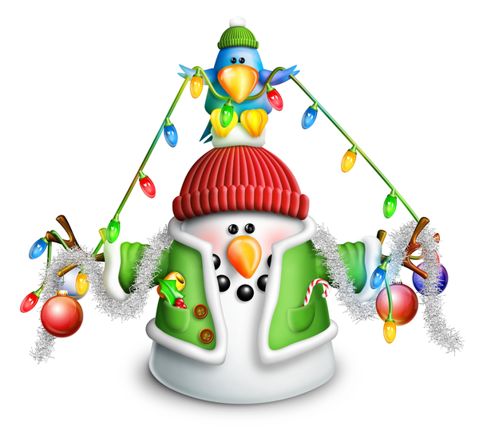

Holiday Masterpiece
Divide the audience into 6 groups. Assign each group one of the words listed below. When their item is mentioned in the story, the assigned group should shout the designated saying. Have a practice session before starting the story.
CANDLE(S): "Flicker, Flicker"
TREE(S): "Standing Tall!"
GIFT(S): "Thank You!"
FAMILY: "I love them!"
FOOD: "Yum, Yum"
HOME: "Home Sweet Home"
DRAW(ING): Everyone says “Work of Art!”
Let’s imagine you are each DRAWING a picture of a holiday scene. Let’s start with your HOME, a place to come in from the cold. Add some TREES outside with a bit of frost on the branches. Because the lights are lit inside your HOME, you can see your FAMILY through the windows. Who will you have in your DRAWING of your FAMILY? And what is your FAMILY doing on this chilly night at HOME? Will you DRAW them playing games together or wrapping GIFTS or sharing their favorite FOOD?
Let’s imagine more.
Add some CANDLES to your drawing. Make them shiny and bright. Are the CANDLES lit for Hanukkah or for Kwanzaa? Or will you draw a Christmas TREE with CANDLE lights for your FAMILY in your HOME?
Draw some GIFTS under the TREE or near a Menorah lit with CANDLES. You might draw some homemade GIFTS made for Kwanzaa. These GIFTS will be for your FAMILY that you drew inside your HOME.
We can’t forget the FOOD in this picture! Preparing and eating FOOD is an important part of a FAMILY’S holiday fun! What kinds of FOOD will you DRAW? The FOOD for Kwanzaa might be corn and fruit and vegetables. You might DRAW a turkey all shiny and brown for Christmas dinner. Or maybe your FOOD will be crispy latkes, with applesauce on top. You can each imagine your favorite FOOD in your DRAWING – something yummy that you can share.
When you finish with all the details, your DRAWING may have CANDLES, it may have TREES, and it may have FOOD and GIFTS and HOME and other things your FAMILY enjoys. Make it your masterpiece.
Now that you’ve imagined your DRAWING and created it in your mind, you might be ready to put your special DRAWING on an actual piece of paper. DRAW the picture that you imagined for your FAMILY. It could even be your GIFT to them for the holidays.
In closing, use this opportunity to send each Cub Scout home with “special” piece of drawing paper that they can use to draw their masterpiece for their family at home.

The House Where Santa Claus Lives
Have everybody stand and do the appropriate motion when the item is called.
- HOUSE: Hands over head in an inverted V.
- SHED: Hands in front of chest in an inverted V.
- SLED: Hands together in a waving motion from left to right.
- REINDEER: Hands on sides of head, palms out.
- PACK: Both hands over a shoulder as if carrying a pack.
- LITTLE GIRLS: Females, young and old, stand.
- LITTLE BOYS: Males, young and old, stand.
- DOLL: Hands with palms together on cheek, with head slightly bent.
- BOX: Both hands outline the three dimensions of a box.
- LION: Extend both hands and give a deep growl.
- SOLDIER: Stand at attention; give the Cub Scout salute.
- TRAIN: Make a figure 8 with a hand.
- SANTA CLAUS: Pat stomach with both hands and say “Ho, Ho, Ho.”
NARRATOR say the whole thing. This will not work if Narrator must read it. Occasional checks are all right. I usually have a sheet with the objects listed in large print where I can see it to check.
This is the HOUSE where SANTA CLAUS lives.
This is the SHED behind the HOUSE where SANTA CLAUS lives.
This is the SLED that is kept in the SHED behind the HOUSE where SANTA CLAUS lives.
These are the REINDEER that pull the SLED that is kept in the SHED behind the HOUSE where SANTA CLAUS lives.
This is SANTA CLAUS who guides the REINDEER that pull the SLED that’s kept in the SHED behind the HOUSE where SANTA CLAUS lives.
This is the PACK all filled with toys for good LITTLE GIRLS and good LITTLE BOYS that is carried by old SANTA CLAUS who guides the REINDEER that pull the SLED that is kept in the SHED behind the HOUSE where SANTA CLAUS lives.
This is the BOX that is kept in the PACK all filled with toys for good LITTLE GIRLS and good LITTLE BOYS that is carried by SANTA CLAUS who guides the REINDEER that pull the SLED that is kept in the SHED behind the HOUSE where SANTA CLAUS lives.
This is the DOLL that is in the BOX that is in the PACK all filled with toys for good LITTLE GIRLS and good LITTLE BOYS that is carried by SANTA CLAUS who guides the REINDEER that pull the SLED that is kept in the SHED behind the HOUSE where SANTA CLAUS lives.
This is the LION that frightened the DOLL that is in the BOX that is in the PACK all filled with toys for good LITTLE GIRLS and good LITTLE BOYS that is carried by SANTA CLAUS who guides the REINDEER that pull the SLED that is kept in the SHED behind the HOUSE where SANTA CLAUS lives.
This is the SOLDIER that captured the LION that frightened the DOLL that is in the BOX that is in the PACK all filled with toys for good LITTLE GIRLS and good LITTLE BOYS that is carried by SANTA CLAUS who guides the REINDEER that pull the SLED that is kept in the SHED behind the HOUSE where SANTA CLAUS lives.
This is the TRAIN that runs on the track and carries the SOLDIER forward and back, who captured the LION that frightened the DOLL that is in the BOX that is in the PACK all filled with toys for good LITTLE GIRLS and good LITTLE BOYS that is carried by SANTA CLAUS who guides the REINDEER that pull the SLED that is kept in the SHED behind the HOUSE where SANTA CLAUS lives.

How to Build a Snowman
Pass out the index cards you prepared ahead of time to members of the audience, and have them pick a word from their card to fill in the blank in the story below to create a fun winter story.

First, wait for the perfect snow. Once you have ________ (color), ________ (adjective) snow, you should make sure you’re dressed warmly enough. Make sure to put on your ________ (article of clothing) and ________ (noun). Once you get outside, make ________ (number) snowballs and then start rolling. It’s best to make them different sizes. Make a really big one, a ________ (adjective) one, and a smaller one for the head. Then add two pieces of ________ (noun) for the eyes and three pieces of ________ (noun) for the buttons.
________ (noun) will work just fine if you can’t find any coal. Some people like to add a ________ (noun) around the snowman’s ________ (body part). Add a ________ (noun) on top of its head. And don’t forget the ________ (vegetable) nose! When you’re done, you should reward yourself for all your ________ (adjective) work with a big ________ (noun) of steaming ________ (liquid).

Audience Participation cards: Prepare the following sets of three words on index cards or pick your own three words to fit the parts in parentheses:

Card 1: Itchy, fluffy, beautiful (adjective)
Card 2: Yellow, white, purple (color)
Card 3: Coat, socks, pants (article of clothing)
Card 4: Gloves, dress, spoon (noun)
Card 5: 3, 7, 10 (number between 1 and 10)
Card 6: Colorful, medium, muddy (adjective)
Card 7: Chalk, cake, coal (noun)
Card 8: Candy, coal, sticks (noun)
Card 9: Nuts, rocks, buttons (noun)
Card 10: Popsicle, scarf, plate (noun)
Card 11: Hand, neck, leg (body part)
Card 12: Skunk, hat, doughnut (noun)
Card 13: Carrot, potato, beet (vegetable)
Card 14: Lazy, hard, fantastic (adjective)
Card 15: Cup, cone, straw (noun)
Card 16: Hot chocolate, soda, water (liquid)

Old-Fashioned Christmas
Divide audience into three parts. Assign each part a word and a response. Instruct them they are to say the response whenever they hear the word. Practice as you make assignments.
Old Fashioned Christmas: "Peace on Earth"
Toys: "Buzz, bang, whiz
Gifts: "From the heart"
Please note when reading this that it is a poem.

What is an Old-Fashioned Christmas? a Cub Scout said to their parents one day.
They thought for a while before they would venture to say.
After talking it through and pondering a while,
They tried to portray to him the Old-Fashioned Christmas style.
You see the holiday season we all know of today,
Often seems a far cry from what this season should portray.
People crowd in the stores buying meaningless Gifts and Toys,
In far too large a quantity for all the girls and boys.
In the Old-Fashioned Christmas, things were different you see,
Far fewer Gifts than there seem to be.
So they were all given with love beyond measure,
Making the giving a wonderful treasure.
In the Old-Fashioned Christmas the best Gifts of all,
Were those of goodwill or perhaps a token so small.
Toys were not given in excess by the score,
And many Gifts were homemade, not bought from a store.
So if an Old-Fashioned Christmas you wish now to see,
Remember the quantity of Gifts is immaterial as can be.
For an Old-Fashioned Christmas let's all now start,
By remembering, my friend, it begins in the heart!
Through the giving of kindness and goodwill to all mankind,
An Old-Fashioned Christmas we certainly can find.
The Gifts with a meaning in this season play a part,
With an Old-Fashioned Christmas begun in the heart!

Santa Decorates the Tree
Divide the audience into seven groups. Assign each group a word and its response. Practice as you make assignments:
SANTA: Ho-ho-ho
STAR: Twinkle, twinkle
ICICLES: Drip, drip
ELF/ELVES: Tee, hee, hee
SNOW: Flaky, flaky
REINDEER: Clip, clop
WHITE: As snow
Once upon a time, long, long ago, SANTA was decorating his first Christmas tree. SANTA hung ICICLES on some branches and SNOW balls on others. In between, he hung SNOW flakes. On top, SANTA placed a STAR.
SANTA stood back to admire his tree. Something was missing! The STAR twinkled and the SNOW flakes glistened. The SNOW balls and ICICLES hung beautifully. The problem was that everything was WHITE!
SANTA called his REINDEER and asked them what to do. The REINDEER thought and thought. REINDEER are very good at flying, but Christmas trees were too hard. They just couldn't figure out how to fix SANTA'S WHITE tree. SANTA called his ELVES. "What can I do with this WHITE tree?" he asked. The ELVES thought and thought. Even though these ELVES were the very smartest of ELVES, they just couldn't figure out what to do with SANTA'S WHITE tree. SANTA, the REINDEER, and the ELVES stood looking at the WHITE tree with the STAR
on top, the ICICLES, the SNOW balls and the SNOW
flakes. They thought and thought.
While they were thinking, a very young ELF came in carrying several buckets of paint from the storeroom. This young ELF had never seen a tree with a STAR on top and decorated with SNOW balls, ICICLES, and SNOW flakes. The young ELF thought it was the most beautiful thing he had ever seen! The young ELF was fascinated by the STAR, the SNOW balls, the SNOW flakes and the ICICLES. Just then, he tripped over his paint buckets.
The paint buckets went flying through the air and spilled all over the tree. The ELVES were embarrassed by the clumsy young ELF and began to scold him. The REINDEER were frightened by the clatter and hid in the corner. The young ELF began to cry because he ruined SANTA'S beautiful tree. SANTA looked at the tree. It wasn't WHITE anymore! The ICICLES were silver, the SNOW flakes and SNOW balls were red, blue and green and the STAR on top glistened with gold.
SANTA was delighted with the beautiful colors on the tree. He picked up the young ELF, gave him a big hug and made him head ELF in charge of Christmas trees!

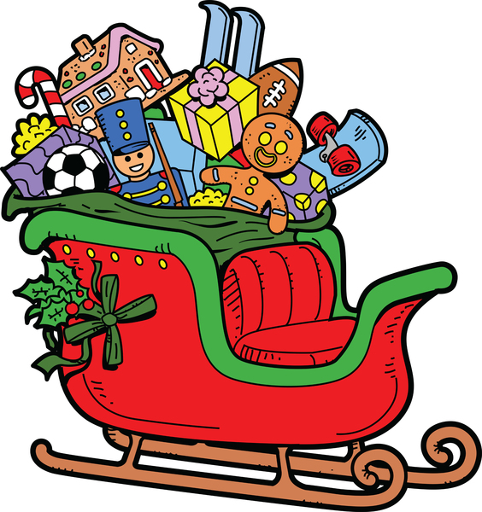

Santa's Workshop
Narrator: Say Cub Scouts, we've had a special invitation from old Santa himself to come up and visit his toy shop at the North Pole. However, he told me that we must make out trip through as quietly as possible so as not to disturb the elves or the toys, but the toys really come to life when they see visitors so if any of them spot us, we may have to pretend we're one of them and also the elves get very nervous when they see people around, so when I tell you to do something so as not to give our visit away to the elves or toys you just follow me and do as I do and we'll make it through without too much disturbance. So, listen and watch closely.
Come, let's follow Santa:
(Narrator motions for everyone to do as he does. Everyone pretends to be walking while standing still.) On a trip through his toy shop. But since the hour's late, we can't take time to stop.
(Everyone holds finger to lips and hump over pretending to sneak by)
SHHHHH, the jack-in-the-box, in his box is sound asleep. So come on quietly, and past him we will creep.
Look there's the dancing ballerina (points with finger ahead) Standing on one toe.
Oh, no, she saw us, so around and around we must go (Hold one hand over head and go around and around several times)
Boy, now that ordeal is over, let's continue on our way. (Start walking in place)
We want to see some more, but very long we cannot stay . Look over there to the right,
(Shade eyes with hand, point to right)
Back in that corner dark, I think that I can see ever so small a spark.
(Pretends to quietly sneak up on something). Oh, it's an elf I see, building a Rudolph toy, Oh, oh, he sees us! Pretend you're not a boy.
(Cup hand over nose to simulate Rudolph's large nose while saying blink, blink, blink)
Whew, that was a close call, (Wipes brow with hand)
But we fooled him I guess, we'd better follow Santa (Start walking in place)
Before we get into a mess. (continue walking)
Oh, Santa has stopped again,
(Stop walking and hold up hand in halt sign) I wonder what he sees,
Oh, no, I thing I'm going to sneeze!
(hold finger across under nose while saying AAAAACHOOOOO!)
Oh, my goodness, that did it,
Come we had better run (All start running in place) We better get out of here, Or it won't be such fun!
Come on and blink your nose
(all do as before while running in place) As past the Rudolophs we run,
Just to make the elf, Think that we are one. There's the ballerina, Dancing on her toe,
Let's twirl around once
(all twirl as before only once around then continue running)
So past here we can go.
Oh, oh, here's the Jack-in-the-box,
Let's get down low and crouch
(get down low and sneak quietly by) Here he comes out with a B-O-I-N-G!
(All shout B-O-I-N-G! as they spring up high in air and then back down in chair)
Now we're back home on the couch!
(Sit exhausted with hands at sides of chair)

Traveling Treats
Pass out a few small treats to the audience. Each time they hear a word that indicates a direction, they
move the treat to the person closest to them in that direction. A few treats could be bigger or wrapped to appear more special.
Listen for these words:
- Right
- Left
- In front
- Behind

CM: “The Cub Scout year is filled with such fun. Right at the end of the summer, the pack had a great Join Scouting night to invite new Cub Scouts into the pack. After the Webelos Scouts have left to join the troop, there will be more room for all the new Lions and Tigers.
“In January, all the Cub Scouts left door hangers for the neighbors to donate food for Scouting for Food.
“The Scouts from the troop helped run the district pushmobile race. Looking to the right and the left, they found the pack’s pushmobile right in front.
“At the pinewood derby, the excited Cub Scouts stood in front to see the racing. Did you see the one that left the others behind in the dust?
“In front of the pack at the blue and gold banquet, the Cubmaster was careful to give the Cub Scouts their right awards.
“The fun continued with Scout Fair with displays and activities jam-packed right in a row. What Cub Scout in their right mind could forget the fantastic time at day camp?
“Den meetings, field trips, pack meetings, outings galore! You had better write it all down because you would certainly feel sad if you were left behind.
“The End”
Note: See where the treats have ended up. You could number them and ask the beginning person to remember his or her number to see how far the treat has traveled.

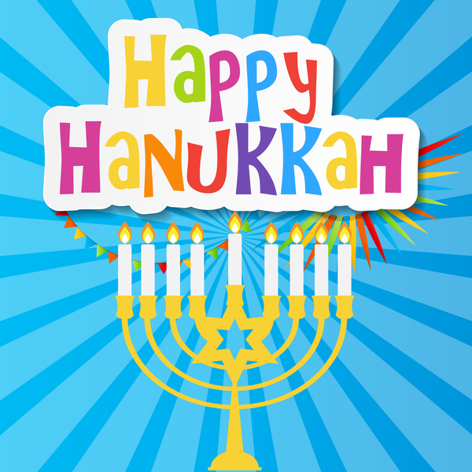
Wintry Mix-Up
Directions: Print the following phrases, one per card. Number the cards. Distribute to the audience. The Narrator reads the story aloud, pausing at each blank space. The person with the next card fills in the blank. You might want to number the cards and your script in case someone is not paying attention. Make sure order is random for maximum fun.
Cards Needed -
A quart of eggnog A Little Lamb A Snowman
A pound of butter A broken TV A pair of dirty socks
A fluffy pillow A dog' s bone Chicken feathers
A snow shovel A Stocking cap An old innertube
14 cookies Lipstick Frozen fingers
Snow boots Furniture Polish Bubble Gum
It was a cold winter night. The icicles on the eaves of the cozy house hung down like _____, and the snowflakes were falling as fast as ______. Inside, Mrs. Woolley sat in her old rocker that creaked like _____. She was knitting a pair of mittens the color of ______.
Story -
"Where can my husband be?" she wondered as she went to the stove. She lifted up the lid and stirred a bubbling pan of stew. The stew smelled delicious, just like ______. Just then, two little children burst into the room. Their frightened faces were the color of ______.
"Mommy, come with us!" they cried. "Something is happening in the garage." Mrs. Woolley tossed her knitting into______ and ran out the door so fast that she almost tripped over ______. With a noise like ______, the three quietly crept to the garage. In the frosty sky overhead, the stars twinkled like ______, and the snow lay on the ground as deep as ______. Through the window of the garage, they could see a figure pulling tools off the shelf and stuffing them into a sack that was as lumpy as ______.
"A robber," Mrs. Woolley whispered to the children. "You grab ______, and you grab ______, and I'll make a noise like______ to scare him away."
But just then, the door opened, and the person inside quietly crept out. "Stop, thief", Mrs. Woolley tried to shout, but she was so frightened, her voice sounded like ______. The figure with the sack stopped short. Then there was a jolly laugh, and a voice said, "What are you doing out here so late?"
It was daddy, himself! He said he was just gathering some tools to fix the broken sled, which had lost ______. Daddy had the day off tomorrow, and wanted the whole family to go sledding. He took each child by the hand. "Your hands are so cold, they feel like ______," he said.
They all hurried into the house for a bowl of stew, which tasted better than ______on that cold night. Then he gathered the family around the fire, which was crackling like ______, and read them all a story about ______. How wonderful it was to be together again.

Winter Songs
Divide audience into four parts. Assign each part a song and a response. As each part comes along, the group stands and sings the first line of their song. Instruct them as each part comes along, the group stands and sings the first line of their song. Practice as you make assignments.
Winter: "Dashing Through The Snow"
Santa: "Jolly Old Saint Nicholas"
Sleigh: "Sleigh bells ring, are you listening"
Reindeer: "Rudolph the Red Nosed Reindeer
Once upon a tune, on a cold, dark Winter night, Santa sat in his workshop trying to decide what to do. His Sleigh had a broken runner, his elves were behind schedule on toy production, his Reindeer were suffering from lack of exercise and they were weak, and he, Santa, had a cold. With Christmas only days away, and the Winter weather cold, and snowy, Santa was so depressed. Rudolph, his most famous Reindeer, was unable to get his nose recharged, so that it barely glowed at all.
In a practice run, the Sleigh with the broken runner scarcely got off the ground. With the toys to make, the elves were stopping early to watch the Power Rangers. "Goodness me!" cried SANTA. "How will I ever get everything complete by Christmas Eve?"
Out of the cold Winter night, trudged a cold, hungry old man. "Santa," cried the cold, old, hungry man. "If you will give me a hot meal and a warm place to sleep, I'll fix your Sleigh, cure your Reindeer, fix Rudolph's nose and get the elves to work faster." Santa quickly agreed. After they had eaten and a nice night's sleep, the old man went to work.
First, he plugged the nose of Rudolph, the red-nosed Reindeer into the television set. This charged Rudolph's nose so that it glowed more brightly than ever, and it also blew a fuse on the TV set. This enabled the elves to work later, since they couldn't watch the Power Rangers. They quickly caught up to schedule. In the meantime, the old man used parts of the TV set chassis to fix the runner on the Sleigh. The Reindeer, not able to watch TV, began to run in the snow, and quickly regained their strength. Santa slept better and got rid of his cold.
Because an old man knew the true value of the TV, everything was ready and on December 24th Santa hitched his Reindeer to the Sleigh and rode off into the Winter sky!

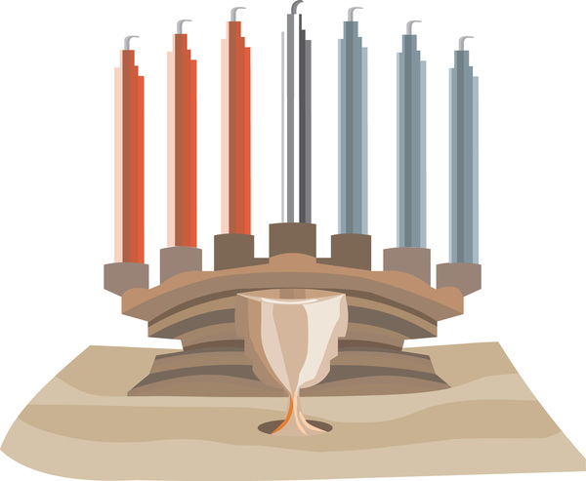

ADVANCEMENT CEREMONIES

Note: Be careful when doing advancement ceremonies in December. The awards should never be presented as gifts. The Scouts have earned them. Gifts are often undeserved. Don’t confuse our Scouts. Make sure the Scouts and the audience knows all awards were earned.

Christmas Awards
CHARACTERS:
SANTA - with long list & empty sack,
HELPER X with green cap,
6 HELPERS with red caps, working tools & toys,
Cubmaster (CM) and Assistant Cubmaster (CA).
SETTING: Santa's workshop, with all 7 helpers busy working on toys & whistling or singing "Jingle Bells". As curtain opens, Santa enters, puzzled, despaired, checking list in hand.
SANTA: Ho, Ho, Ho! This is an unusual list from the Cub Scouts of Pack _____. We're running out of time! Good grief! Sakes alive!
(Sits down with sack opened, looking very sad.)
Helper #1 I've worked on trains, have they run out of brains?
Helper #2 It's clear to see - they don't want trucks from me!
Helper #3 Surely Santa, you know the score! That's no Ho, Ho! Please tell us more.
Helper #4 I know, great red & white one ... they need a change. (Rattles change in pocket.)
Helper #5 That's right, wise leader. Any new ideas in our "goody range"?
Helper #6 Shazam! Me thinks the Cubs Scouts are tired of toys. How about more "Adventure Loops" for those girls and boys?
Helper X (Runs across stage, carrying a cardboard shield on large sack - Christmas type - with a Cub Scout emblem painted on it.) Sock it to 'em Santa!
(places shield in Santa's sock.)
Santa then gives awards to Cubmaster to distribute. (Awards were either hidden in "empty" sack, or placed in bag with shield)
CM Thanks Santa for awards then explains to Santa how the awards were earned. That the awards are not gifts but recognition for the things the Cub Scouts have done.
CM & CA Present awards to parents to present to their sons. Then, they lead cheers. They make sure every Cub Scout receive individual recognition.

Climbing the Tree (Lights)
Materials: Have a Christmas tree with various colored lights. (This can be a cardboard tree with holes for the lights.) The bulbs should be unscrewed slightly so that they can be easily turned on at the proper time. You may wish to use different colored string of lights for each rank. For example, yellow lights for the bottom row (Lion), orange lights for the next row (Tigers), red lights next (Wolf), green lights on the fourth row (Bear), and blue lights for the top row as well as the top of the tree (Webelos Scouts), white for parents and leaders, and light for tree top.
Personnel: Cubmaster (CM) and Assistant Cubmaster (CA)
CM: As we look at our tree this evening, we see that it is dark, with only one light on. [Screw in top light.] This is the light which represents the Arrow of Light Award.
Let us see if there are Cub Scouts here tonight who can help light the way to the top of the tree, to the highest rank in Cub Scouting.
The first step along the Cub Scout trail is Lion. The Lions are beginning to learn about Scouting, citizenship, teamwork and good sportsmanship. [Call Lions forward, present awards, lead cheer.]
Thank you Lions. We can now turn on the lights representing the Lions.
CA: Next is Tiger. The Tigers are climbing towards the Arrow Light Award and learning about Duty to God and country, nutrition and nature. [Call Tigers forward, present awards, lead cheer.]
Thank you Tigers. We can now turn on the lights representing the Tigers.
CM: The Wolves are increasing their knowledge and learning about the United States flag, keeping strong, safety, and being useful to the family. [Call Wolves forward, present awards, lead cheer.]
Thank you Wolves. We can now turn on the lights representing the Wolves.
CA: As the Cub Scouts grows older and stronger, they are able to climb higher. But just as it is a little more difficult to climb the upper branches of a tree, so the Adventures are a little more difficult for the Bear rank. [Call Bears forward, present awards, lead cheer.]
Thank you Bears. We can now turn on the lights representing the Bears.
CM: Now the Webelos Scouts in fourth grade have more climbing to do. The Webelos Scouts are increasing their knowledge of Scouting and preparing to join a troop and work towards the rank of Eagle Scout. [Call Webelos Scouts in 4th grade forward, present awards, lead cheer.]
Thank you Webelos Scouts. We can now turn on the lights representing the Webelos Scouts.
The Webelos Scouts in fifth grade only one more climb to go. This last climb will bring them to the top of the tree and the coveted Arrow of Light, the highest award a Cub Scout can earn.
[Call Webelos Scouts in 5th grade forward, present awards, lead cheer.]
Thank you Webelos Scouts. To encourage them on their way to the Arrow of Light, let us turn on our last light because, as you have learned throughout Cub Scouting, you have helped to make the world brighter. [Turn on another light.]

CA: These Cub Scouts have helped us light our tree, but it is still not quite as bright as it might be. Since they have received help from their parents and leaders, let us turn on a light for the parents, too. [Turn on another light.]
CM: Now our tree is complete. As you have seen, it has taken Cub Scouts plus parents and leaders to complete it. With the same effort you have shown before, keep working for the highest rank in Cub Scouting. Congratulations to you and your parents for the fine work you have done.

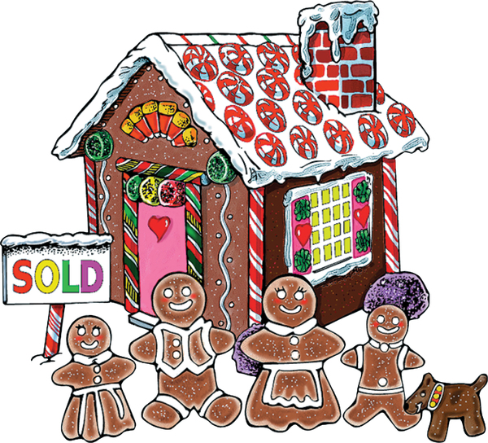

Cubs Light the Way (Lights)
Equipment: yule log with battery-operated candles for each rank. Please refer to Ceremonies for Dens and Packs for ideas on how to create a yule log.

The Scout and their parents come forward to receive their recognition. The Cubmaster hands awards to parents, and each Cub Scout lights a candle with the assistant Cubmaster’s help.

The Cubmaster speaks about each badge as it is presented.

CUBMASTER: The Bobcat badge is symbolized by this light, whose flame glows with the understanding of the Cub Scout Promise and motto, which unite us.

The Wolf badge is symbolized by this light. Our candles glow brighter for this Scout who has grown in their understanding of their family and community.

The Bear badge, its light glowing even brighter, is presented to this Scout in recognition of completion of achievements at home with their family, in their community, for their personal growth, and for their citizenship skills.

The Webelos badge is symbolized by this light, which glows brighter still with the confidence this Scout has gained in completing their activity badges and understanding of Webelos.

The Arrow of Light is the brightest of all, for it glows with the full light of Cub Scouting.

(An alternative is to use electric candles for all ranks, attached to a dimmer switch. The assistant Cubmaster can turn up the dimmer switch slightly as each rank is announced, until it is at full light with the Arrow of Light. Look in Ceremonies for Dens and Packs for ideas. This can be adapted to a closing ceremony by dropping the word “badge,” adjusting some verbiage and saying at the end, “each level of Cub Scouting brightens our world and lights the way for others around the world as we learn about others and respect their traditions.”)

Holiday Advancement Ceremony
Personnel: Cubmaster or Advancement Chair
Props: Hearth made of cardboard or heavy paper (free standing or taped to a wall of frame of some kind).
Stocking made of paper or material for each Cub Scout receiving an award.
Preparation: Attach awards to each stocking and each stocking to hearth.
CM or Advance Chair: Last night someone came and hung these stockings here. Let’s see what is in them. As I call your names, please come forward with your parents and find your stockings and hand them to me. (Announce Cub Scouts awards and give them to parents to present to their sons.) Ask Cub Scouts some friendly questions about the requirements (What did you cook, what did you like at the firehouse, where did you go for …) to get across the idea the awards were earned.

Light of Cheer
Materials: Candles (one large and one slightly smaller representing Scouting spirit and cheerfulness, plus a smaller candle for each rank that will advance at this meeting), table for candles, matches
or lighter. Please adapt for flameless candles, if necessary.
CM: “First, I light the candle of Scouting spirit (lights largest candle). The light from this candle leads us as we walk along our Scouting trail. May its brightness always show us the Scouting way.
“From the flame of Scouting spirit, I will light the candle of ‘cheerful.’ We have 12 points of the Scout Law that serve as our guide. We have picked cheerful as our focus tonight to honor the season of hope and good thoughts toward others.” (The Cubmaster lights the next largest candle from the flame of the larger one.)
Have on the table the same number of smaller candles for each rank that will advance. The color of these candles can correspond with the ranks if you wish: yellow of Lion, orange for Tiger, red for Wolf, green for Bear, dark blue for Webelos Scouts.
CM: “Will (names of the advancing Scouts) and their parents or guardians please come forward? I will light your (rank) candle from the cheerful candle. You have been cheerful Scouts as you have worked toward this award.” (Present rank patches.)
Repeat the last paragraph for each rank that will advance.

The Lights are Beautiful
Set Up: Have enough appropriately sized light bulbs light so that each Scout receiving an award (or each Scout in attendance) will receive a light bulb to give to their parents to screw into a socket on the string of lights.
Materials: Long string of large outdoor Christmas lights (C7 or C9 style) where each light screws into the base and is not dependent upon other lights in the string.
The string of lights should be unplugged and have no lights screwed into it (or as many sockets empty as there are Scouts receiving awards or as there are Cub Scouts in the pack – could have more than one string... depending on how you want to do it)
Scene – Ask two or more adult leaders (depends on the length of your string of lights) to come to the front of the room to hold the string up... OR you could lay the string of lights across a large table or tables.
Cubmaster: This month we’ve really talked about all the lights around us at the holidays. I want you to know that you Cub Scouts that are a part of our pack are bright lights to me at all times. Your shining faces and examples help me and the other adults all year round – but we seem to notice that more as we watch your excitement during the holidays.
Your lights have been really shining this month in the work that you’ve done toward ranks, arrow points, and activity badges.
Cubmaster announces and distributes advancements one rank at a time.
As awards are distributed, give each Scout a light bulb.
Make sure to include Scouts who might not be on your list of awards this month. Ask each Scout to give the light bulb to their parents to take up and put into the string of lights...
OR other adult leaders could add their “lights” as well.
Cubmaster: All of our lights are now part of this long string and when we add the Cub Scout program (plug in the lights) we are beautiful to see! (replace non-working bulbs at this point... ☺)
Thanks for all of you this month for being a great part of our pack!

Old-Fashioned Christmas (Traditions)
Arrangements: Cubmaster and Committee Chairman stand behind head table, which holds all the awards and a box of Christmas tree decorations. Nearby is an undecorated tree. As each Cub Scout receives their award, the Cub Scout and their parents are given a decoration to put on the tree. The tree can already have a string of lights, which are turned on at the end of the ceremony.
Cubmaster: Tonight, we're celebrating an old-fashioned Christmas. One of the most popular customs in America is decorating the Christmas tree. As each Cub Scout receives their award tonight, we're going to give them and their parents an opportunity to help decorate our tree. Since Cub Scouting is a family program, we want our pack families to help make our Cub Scouting Christmas tree bright and festive.
(Calls each rank forward one at a time. Have after presenting awards, give each Cub Scout an ornament to put on the tree. They return to their seats.)

And there you have our beautiful Christmas tree. Now we're going to turn on the lights representing all members of our pack families.
You can see how each decoration and light make the difference in the appearance of our tree. In the same way, each member of our pack, Cub Scouts and adults, makes a difference in the success of our pack's operation and success. Thanks to you all.

Santa's Magic Advancement
Equipment: Christmas tree with lights, extra large cardboard telephone, small Christmas stockings with awards inside, candy canes for all children at the pack meeting.
Personnel: Santa Claus, elf (Cubmaster).
Setting: Hang the stockings with awards inside on the tree. Light the Christmas tree and dim the room lights. Santa Claus is outside the room but can be heard by the audience.
Cubmaster: (speaking into telephone) Santa Claus, you will be welcome at the pack meeting. What can we do to help you get here, Santa?
Santa Claus: Why, sing "Here Comes Santa Claus". It will give me all the magic I need to arrive. But remember, everyone must sing for the magic of their voices to guide me.
Cubmaster: Okay Santa. We'll do our best! (Hangs up the phone and leads the song.)
On the last notes of the song, Santa arrives, calling "Ho, ho, ho, Merry Christmas!" and carrying his bag of gifts, including candy canes for all the children. CM takes the stockings from the tree and picks out the advancement awards, calling for the recipients and their parents to come forward. After the parents have pinned awards on the Cub Scouts' uniforms, Santa gives candy canes to all the children.

Snowflake Ceremony
Materials: A large cutout snowflake, awards attached to small snowflake cutouts
CM: (Holding the large snowflake) “This giant snowflake is a symbol of the wonder of the winter season. No two snowflakes are alike, and each is one of the most beautiful objects formed by nature. In the same way, every Cub Scout is a unique wonder, learning and progressing through life in their own way. Tonight, we have Cub Scouts who are creating their own singular designs in life by traveling further along the Cub Scout trail. (Call forward the Cub Scouts and their parents or guardians. Present awards.)

Snowflakes
CM: One of the most beautiful objects formed by nature is a snowflake. It would take most of us a long time to design a shape as beautiful as a single snowflake. Yet, in an ordinary snowfall, billions upon billions of snowflakes fall to the earth, and no two are exactly alike.
CM: Tonight, we are gathered much like snowflakes, in that we are here because of beautiful objects; our Cub Scouts and their "designs" are each as different. Would our Lions and their parents please come forward to receive their honors?
CM: Every Cub Scout is a unique wonder, learning and progressing through life in their own way. Tonight, we have Cub Scouts who are creating their own singular designs in life by traveling further along the Cub Scout trail. Would our Tigers and their parents please come forward to receive their honors?
CM: Let us look at our Tigers tonight. We gathered them up, and now they are being carried along the path of Scouting. They are creating their own singular designs in life by traveling further along the Cub Scout trail. Would the Tigers and their parents please come forward to receive their honors?
CM: When water freezes to become a snowflake, it forms crystals. This simply means that the water comes together in a geometric shape we call a crystal. As it freezes, the crystals are small and almost invisible. But when the snow is formed, these crystals are carried up and down in the atmosphere on currents of air. Like snowflakes in the sky, our Wolves are being carried along the Scouting trail. Would our Wolves and their parents please come forward to receive their honors?
CM: As the crystals move up and down, some of them begin to gather around each other, forming a nucleus that lets the crystals grow larger. Soon, there may be hundreds of crystals together.
Our Bears are much like the crystals at this stage. They have gathered in groups together around their den leader. They have grown through their advancements. Would the Bears and their parents please come forward to receive their honors?
CM: When a group of crystals is large enough, it begins to float down toward the earth and we call it a snowflake. These represent, of course, our Webelos Scouts - growing rapidly and maturing constantly. They are gaining ground toward their next step in Scouting. Will the Webelos Scouts and their parents please come forward?
CM: I would like all the Scouts who received awards tonight to please stand. Each snowflake begins as a single drop of water and grows to different sizes. You too are growing. May you always recognize the beauty of your differences and enjoy your unique place in life.
Stockings Were Hung
Set-up: Each rank is inside a small stocking or attached to a small paper stocking. Each stocking should clearly show the Cub Scouts’ name. Stockings are hanging on (taped to) a mantle.
Build mantle by using 2 ladders with a board placed between the higher rungs. Set a Christmas centerpiece on top of board and paper to make a fake fireplace, if desired. Object in using the higher rungs is that parents will need to assist the Cub Scout in getting their rank.
Cubmaster enters and examines stockings hanging. Then comments: '*My, we've had a lot of hard-working Scouts this month. Stockings are over-flowing with achievements. Would the following Scouts and their parents come forward as I call them? Parents, please help your Cub Scout remove their stocking just as you have worked with your Cub Scout to help them earn their rank,"
(Call each rank and their parents forward and present awards followed by a cheer.)

Plan something extra for any Arrow of Light awards -- a large stocking with an arrow as well as rank and have Cub Scout repeat the Scout Oath. Or have the den chief wearing a Santa cap making a personal delivery for Arrow of Light award.

Suggestions for Holiday Advancement Ceremonies
An adult, dressed as Santa, could arrive with his pack on his back, which contains the awards to be presented. It is a special treat to receive an award from Santa himself.
Make a large papier-mâché snowman to hold the awards. Awards could either be put in snowman or removed from an opening cut in his back, or they could be fastened to a long scarf around his neck.
Awards could be taped to large cardboard cutout ornaments, which decorate a Christmas tree. When a Cub Scout's name is called, they go to the tree and find their ornaments.
A large papier-mâché Christmas stocking could set on head table to hold awards, or a large knit or felt stocking hung from a fireplace. Santa makes presentations.

Twas the Night of the Pack Meeting
Assistant Cubmaster or another leader reads the poem and leads the cheers.. Cubmaster presents the awards with help of committee chair or advancement chair. Might have awards attached to a candy cane.

‘Twas the night of the pack meeting and all through the place,
Not a Cub Scout was stirring, anticipation on each face.
It was time for advancements and they all turned an ear,
So when their name was called, they would hear it loud and clear.
The Cubmaster was checking his/her list, not only once but twice,
To see which Cub Scouts had worked hard and earned awards this night.
When all of a sudden the Cubmaster as ready with helpers nigh,
To pass out awards as the Cub Scouts called were filing by.

First came the Lions all new to the pack.
Akela is ready, with the guidance and experience they lack,
They’re active, energetic and ready to learn.
Hard working and enthusiasm is no concern.
(Call Lions and their parents forward and present awards. Cheer)

We can’t forget Tigers, with parents in tow
They’re a great group in our pack, and they’ll help it grow.
With orange hat and scarf, they’re easy to spot,
But keeping up with them is, most decidedly not!
(Call Tigers and their parents forward and present awards. Cheer.)

Next are the Wolves, experienced that is true
But there is still much to learn, Akela’s not through
Come up all our Wolf Cubs, you are Wolves to be praised,
Adventures and much more you’ve done
So, with Wolf Badge and belt loops, to rank you are raised.
(Call Wolves and their parents forward and present awards. Cheer)

Fourth are the Bears most experienced so far,
Akela’s teachings they’ve heeded, they’re way above par.
Come all our Bear Cubs, your work and learning is applauded,
For completing core and elective Adventures, tonight you’re rewarded.
(Call Bears and their parents forward and present awards. Cheer)

Last are the Webelos Scouts, but not least to be sure,
Akela’s lessons they’ve learned, now Scouts BSA is their lure.
Come up all our Webelos Scouts, your Adventures are harder,
Your accomplishments you wear so proudly on your shoulder.
(Call Webelos Scouts and their parents forward and present awards. Cheer)

Winter Wonderland
There is something refreshing about the look of a field or woods after a good snowstorm. It’s the look of a clean, unblemished land. I’m sure it was this picture that was on the person’s mind when the term “Winter Wonderland” was first coined. Even when we think of the words ourselves, I’m sure there’s more than one of us here that thinks of such a picture. Close your eyes for a moment and think about it… Winter Wonderland. Winter Wonderland. Winter Wonderland.
Keeping your eyes closed, I want you to concentrate on the image that comes to mind when I give you another phrase: Cub Scout Wonderland. Cub Scout Wonderland. Cub Scout Wonderland.
I don’t know about the rest of you, but the image that comes to mind for me is one of fun. Kids running around having a good time doing things. But I also see smiles on Cub Scouts’ faces for having done things really well. I see the look in their eyes that comes from having done something they never even thought they’d be able to do. It’s the look of excitement and wonder. It’s the look of goodness—a healthy, hardy look.
Okay. Now let’s open our eyes and see these same things in real life. Look around and what do you see? I’ll tell you what I see. I see you, Cub Scouts, who are pleased with yourselves for having succeeded beyond measure. I see the parents who are proud of what they sons are doing and glad that they are part of it. I see the brothers and sisters who are having almost as much fun as their Cub Scout brothers are having. It is a sure sign of the success of the Scouting program and the all of your hard work.
Tonight, we will recognize our Lions, Tigers, Wolves, Bears and Webelos Scouts who have worked so hard and achieved so much.
[For each rank, call off the award and/or rank, say a few words about it, the call the Scouts' names, inviting them forward with their parents to receive their awards.]

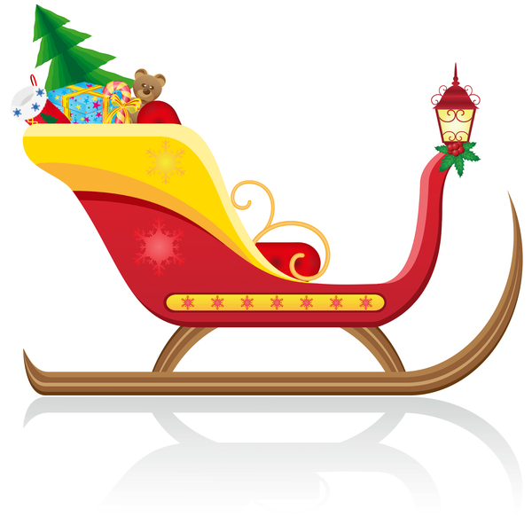

LEADER RECOGNITION
& INSTALLATION

Here’s to the Scouters’ Spouses
Obtain Scouter's Husband awards (#33765) and Scouter's Wife Awards (33766) from National Supply (www.scoutstuff.org) or your local National Shop.
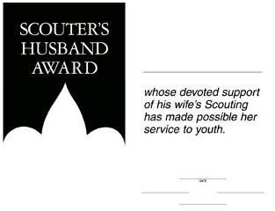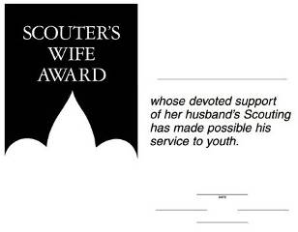
Fill In the information and sign them.
Then at a Pack Meeting (Blue & Gold?) call them forward, read Here’s to the Scouters’ Spouses and present the certificates.

Here’s to the Scouters’ Spouses
By Carol Shaw Lord
You quietly sit
While we threaten to quit
And encourage us to keep on a tryin’.
Without you being strong
We wouldn’t last long
You’re the one’s we always rely on.
You listen (without squawks)
While we practice our talks
While we’re gone you pick up the slack.
You do our share of chores,
And butler the doors,
And help keep us on the right track.
Here’s to our spouses
Who care for our houses,
That’s great help we could never hire.
Why, you hardly even mutter
While the house fills with clutter
As the Scouting stuff piles ever higher.
For all your warm greetings,
When we come from our meetings,
And helping us out in a crunch,
For manning the phone,
And your struggles alone,
We say to you all, thanks a bunch!

Christmas Wreath
- Have each Scout trace their hand on green construction paper.
- Cut out all the hands and place them together in a circle with the fingers pointing outward, forming a wreath.
- Decorate with red berries using markers or crayons.
- Give to the head of their Chartered Organization as a ‘Thank You' and Christmas Card. (Or Cubmaster. Or each Den for their Den Leader. Or one for each Committee Member. Or ...)

The Light of Scouting
Setting – You will need candles for every person in the pack. Wrap each candle in foil to create a drip plate.
Scene – Dim the lights in the room. There should be two candles on a table in the front of the room. The pack committee should be near the front with the Cubmaster and the Assistant Cubmaster. The den leaders line up on each side of the room after the pack committee, and the Scouts line up next to their den leaders. Make sure the Cubmaster has a lighter.
(Cubmaster lights one of the candles on the table
and turns to speak to the group.)
This candle represents the spirit of Scouting. All by itself in this big room, it doesn’t seem like much. But then, the spirit of Scouting finds me, as your Cubmaster
(Lights the 2nd candle from the 1st, and continues.)
While this is a little better, it is not nearly enough light. Fortunately, the spirit of Scouting continues to spread from me to the Assistant Cubmaster and to our wonderful Pack Committee
(Cubmaster lights candle of assistant Cubmaster, and then they each light one candle of the pack committee members. Lighting continues from one candle to another until all the pack committee candles are lit.)
The spirit of Scouting doesn’t stop there! It continues to spread as more and more folks learn about the riches and treasures found in our program.
(Den leader candles are lit from pack committee members.)
Are you starting to see a pattern? Don’t you think having even more spirit would be better? How do the den leaders spread their Spirit? That’s right! They spread the spirit of Scouting with their dens and all the Tigers, Wolves, Bears, and Webelos Scouts can experience this spirit.
(Den leader lights one candle of the den and Scouts light one candle from a previous candle until all Scout candles are lit.)
Wow! Isn’t this better? Let’s consider that this is just one pack. We’re a small part of one district in one council in the United States. The spirit of Scouting burns all over the world! So, when our light combines with all the other lights in all the other packs all over the world, the spirit of Scouting becomes a tremendous beacon to guide Scouts on their journey through life. I hope you carry this spirit of Scouting with you all your life!

Scouting is a Candle
Materials – Candles - longer tapers, OR small birthday cake candles. Mount each candle on a piece of wood/plywood – write in black marker – thank you for shining your light in our pack.
Have committee chair read this poem: Poem could be read before or after Cubmaster's presentation, your choice
Scouting is a candle that will light you on your way.
It’s trying on your honor, and helping every day.
Exploring worlds around you and looking wider still.
Pitching tents out in the woods and hiking up a hill.
Music and voices blended under God’s majestic sky,
Helping those around you, kindness in great supply.
The meaning in a moment, in a smile, or in a tear,
Makes you a little taller with each new Scouting year.
A promise to your God and to your country, too,
Makes you a part of your world, and your world a part of you.
It’s something that you carry wherever you may go,
A secret deep inside you that only Scouts would know.
But it’s the kind of secret that you want the world to know,
You can’t hide all the happiness; you can’t hide all the glow.
A candle glows together, it shines externally.
Make it shine on everyone, that’s the way the world should be.
Cubmaster: Tonight, we would like to say thank you to some leaders and parents who have lit up our pack meeting with their helping hands. (Call adults forward and give them thanks and the memento.)

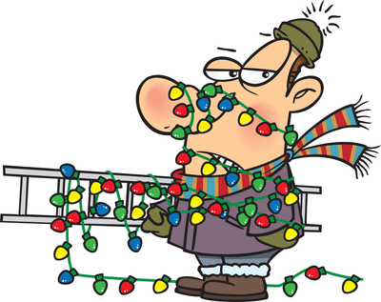

Trained Leader Recognition Ceremony
Materials: large pine bough, bucket of dirt, trained patches, pins (straight or safety).
Personnel: Akela = Committee Chair or Cubmaster, Old Wolves = Several previously trained leaders, Baloo = Pack Trainer, Bagheera = CM (or Assistant CM if CM is leading ceremony)
Akela: Old Wolves, you were charged with teaching these Cubs in the ways you have been taught. Has this been done?
Old Wolves: Aye, old lone one, it has been done.
Akela: Baloo, do they know the ways of the Pack?
Baloo: Aye, Akela
Akela: Bagheera, have you taught them the ways of our Program?
Bagheera: Yes, Akela, it has been done.
Akela: Then let the ceremonies begin. (Plant pine bough in front of you) By completing your training, you have become acquainted with the Cub Scout program.

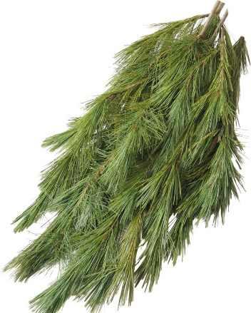
Let this pine bough represent that program. The heavy main stem represents the Aims of the Cub Scout Program. The smaller stems are the Ideals. (Point out each, as you explain). Each needle is a part of the Program; the Den Meetings, Pack Meetings, Outings, Advancement, etc. The needles grow in clusters. The clusters need many needles to appear healthy and beautiful.
Let us keep in mind as we return to our own Packs, the need to develop all parts of the Program. As I read the names of those to be recognized, would you please come forward.
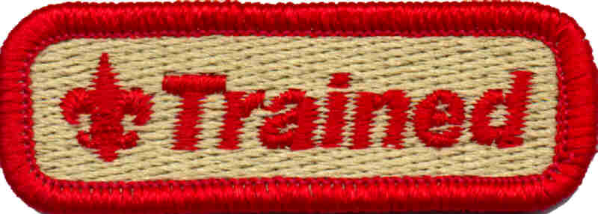
Read off each name, pin on trained patch, give card and have Committee Chair or Pack Trainer give each a needle cluster from the bough. Have the participants form a "U" in front of you. When all have received their recognition, go on.

Akela: You have each received two tokens here today. The pine needle cluster is to keep you ever mindful of the many parts that make up a healthy Cub Scout program. The trained patch is for you to display on your uniform to alert others to your knowledge and dedication to the Cub Scout program.

Do you pledge to accept the responsibility of seeing that the Cub Scouts in your own Packs, put in your charge, benefit from the lessons you have learned here this weekend? If so, answer "I will".
Wait for answer
Then you have achieved the right to join the Old Wolves and take your place as leaders of Cub Scouts. Do this with dignity, dedication, and honor. Do not let the Tabaqui and Shere Khan distract you from your task.
Lead cheer.

SONGS

Be Kind to Your Scouting Friends
(Tune: Stars and Stripes)
Be kind to your Scouting friends,
That's a pledge from one Scout to another. Be kind to your leaders today,
'Cause for helping they don't get any pay. Be kind to your neighbors and friends,
'Cause by caring you follow Scouting's letter. Scouting and friendship are grand,
And as we grow, the world will know, We've made things better.

Cascabeles
Jingle Bells in Spanish
¡Cascabeles, cascabeles,
Tra la la la la!
¡Qué alegriá todo el diá,
Tra la la la la!
Pronunciation guide:
A = ah E = eh I = ee O = oh Qué = kay

Christmas Song
Tune: Rudolph the Red Nosed Reindeer
Here's to the Scouts in our den,
As they follow, help and give;
All of the Scouts in our den,
Know just how a Scout should live.
Now it's time for Christmas,
We've been very helpful kids,
We've gathered lots of old things,
Fixed them up like brand new toys.
Saved our pennies every meeting,
Bought a lovely Christmas tree;
Trimmed it up to take to
Our den's adopted family.
Bright and early Christmas morning
When they see our shiny toys;
We'll be happy that we shared our
Christmas joys with other girls and boys.

Christmas Spirit
Tune: Silent Night
God is night, stars are bright.
Leaders and Scouts stand in the light.
Singing carols to family and friends
Spreading joy that never ends.
Sweet their voices ringing
Christmas spirit to share.

Christmas Time
Tune: Jingle Bells
School is out, we won’t pout
Cubs shout “Hip’-hurray.”
Something special’s coming soon,
And it is Christmas day,
Wrap the gifts, trim the tree,
Mind your mom and dad.
You’ll get presents if you do,
Wow, won’t we be glad?

Cub Scout Christmas
Tune: White Christmas
I’m dreaming of a Cub Scout Christmas
Where Cub Scout pants are given me
Then my eyes will water
Tho’ they hadn’t oughter
When a belt to hold them I will see
I’m dreaming of a shirt to hold badges
With a neckerchief and Cub Scout slide
Or a pocket knife, to last for life
Making my smile a mile wide.

Cub Scout Days
Tune: O Christmas Tree
O Cub Scout day, O Cub Scout days
They are my fondest memories.
O Cub Scout day, O Cub Scout days
How filled you were with fun.
Den leaders led with love and care
Cubmasters the awards did share.
O Cub Scout days, O Cub Scout days
Start me on my way to Eagle.

Do Your Best - Are You Sleeping
Tune: Are You Sleeping
When you do your best
When you do your best You'll feel great
You'll feel great
Make and do for others Make and do for others Spread good cheer Spread good cheer

Dreidel, Dreidel, Dreidel
I have a little dreidel I made it out of clay
And when it's dry and ready Then dreidel I shall play!
Chorus:
Oh - dreidel, dreidel, dreidel I made it out of clay
And when it's dry and ready Then dreidel I shall play!
It has a lovely body
With legs so short and thin And when my dreidel’s tired It drops and then I win!
Chorus

My dreidel’s always playful It loves to dance and spin
A happy game of dreidel Come play now, let’s begin!
Chorus

Every Year
Tune: Old MacDonald Had A Farm
Every year we bake some pies,
Yum, yum, yum, yum, yum. Coconut and lemon pies, Yum, yum, yum, yum, yum.
With a big slice now and a glass of milk. Extra slices if I may.
Every year we bake some pies, Yum, yum, yum, yum, yum.
Every year we go see Grandma, Ho, ho, ho, ho, ho.
She always lets us trim the tree. Ho, ho, ho, ho, ho.
Up go the lights, and up goes the tinsel. Everyone helps as we decorate it.
Every year we go see Grandma, Ho, ho, ho, ho, ho.

Give a Gift
Tune: I'd Like to Teach the World to Sing
I'd like to give the world a gift,
That all men will be free.
And though I'm just a growing kid,
There's things that I can see.
I see that Scouting is a way
To start to understand,
That caring, helping, smiling,
Help me learn and give a hand.
And so at Christmas there's a gift
That you can give to me.
Please help me grow in mind and spirit
To be what I can be.

Giving Time
Tune: Jingle Bells
Giving time, sharing time
Fun for everyone
Scouters know that Christmas is
The time for deeds well done
Giving time, sharing time
Let us all take part
Join with Cub Scouts all around
And give gifts from the heart

Hanukkah Fun
Tune: Mary Had a Little Lamb
Hanukkah is here at last,
Here at last here at last.
Hanukkah is here at last.
Oh what fun we'll have.
We spin the dreidel merrily,
Merrily, merrily.
We spin the dreidel merrily,
Oh what fun we'll have.
The candles burn so happily,
Happily, happily.
The candles burn so happily
Oh what fun we'll have.

A Hanukkah Song
Tune: 3 Blind Mice
Eight bright lights, eight bright lights, See how they glow, see how they glow, They call to mind the Maccabees,
The struggle for our liberties, The glory of their victories, Eight bright lights.

He’ll Be Driving 8 Brown Reindeer When He Comes
Tune: She'll Be Coming 'Round the Mountain
He'll be driving 8 brown reindeer when he comes,
He'll be driving 8 brown reindeer when he comes,
He'll be driving 8 brown reindeer, driving 8 brown reindeer,
He'll be driving 8 brown reindeer when he comes.
(Other verses)
He'll be coming down the chimney when he comes.
He'll be dressed up in a red suit when he comes.
We'll all peek to see him when he comes.
We'll give him milk and cookies when he comes.

I’m a Little Dreidel
Tune: I’m a Little Teapot
I’m a little dreidel
Made of clay.
Spin me around when you want to play
When I fall down, if you don’t win
Just pick me up and spin again.

I'm Playing in The Snow
Tune: I’m singing in the Rain
I’m playing in the snow.
I’m playing in the snow.
What a glorious feeling
It’s snowing again.
Making snowman tonight
For the whole world to see
I’m happy just playing
In the snow.

In the Good Old Wintertime
Tune: ‘In the Good Old Summertime”
In the good old wintertime,
In the good old wintertime,
I love the snow, the rain, the sleet,
This season you can’t beat.
I’m frozen in, I’m frozen out It is without a doubt,
The coldest time of all the clime,
In the good old wintertime.

Jingle Bells
Clap your hands, stomp your feet, wiggle all around.
Reach your hands high in the air, and now let's touch the ground.
Hold your head, hold your hips, give yourself a hug.
Lay down flat upon the ground, but watch out for the bugs.

Jolly Old Cubmaster
Tune: Jolly Old St. Nicholas
Jolly Old Cubmaster,
Lend your ear this way.
Don’t you tell a single soul,
What I’m going to say. Christmas Eve is coming soon,
Now you dear old man
Tell me who has earned their rank,
Tell me if you can.
Has Bobby earned his Lion rank?
Did Jill achieve her Wolf?
Have the Bears carved two items out?
Is Jane a Webelos Scout?
Now don’t you think that this is
A present that’s the best
Tell me now dear Cubmaster
Tell me who’s advanced.

Lights in the Window
Tune: Clementine
We see lights outside of houses
Candles in the windows bright
But the thing that make our hearts glow
Is the fire at our campsite.
We like hiking, and adventure
Helping others is our quest.
And we always share Scout spirit
When we try to do our best.
As the lights glow at this time of year
We pause to say a grand thank you
To the leaders who spend time with us
Now and all the whole year through.

New Year of the Gold and Blue
Tune: Auld Lang Syne
Should all our Cub Scouts Do their best
From this year to the new,
We’ll have a kind and thoughtful world
With the help of gold and blue.

Presents
Tune: Rudolph
Present are being hidden
I’m as curious as can be
I want to find out somehow
If some of them might be for me
Everywhere I have been searching
I have looked both high and low
Then one day I realized
What I was doing wrong.
I need to start being good
And sharing all day long
I knew then I needn’t worry
Santa just would not forget
And I shall be very happy
By giving more than I shall get.

Oh Christmas Tree
Tune: 0’ Tannenbaum
(1) Oh, Christmas tree! Oh Christmas tree!
Your needles falling down on me.
Oh Christmas tree! Oh Christmas tree!
Your needles falling down on me.
"It's freshly cut," the salesman said.
But now you're home, I see you're dead.
Oh Christmas tree! Oh Christmas tree!
Your needles falling down on me.
(2) Oh Christmas tree! Oh Christmas tree!
You fell over on my TV.
Oh Christmas tree! Oh Christmas tree!
You fell over on my TV.
The cable lines are in a pinch,
I can't watch Snoopy or the Grinch.
Oh Christmas tree! Oh Christmas tree!
You fell over on my TV.
(3) Oh Christmas tree! Oh Christmas tree!
There's something under you I see.
Oh Christmas tree! Oh Christmas tree!
There's something under you I see.
Is it a present gaily wrapped?
No, it's a blob of gooey sap.
Oh Christmas tree! Oh Christmas tree!
There's something under you I see.

Randall, the Red-Cheeked Cub Scout
Tune: Rudolph The Red-Nosed Reindeer
Randall, the red-cheeked Cub Scout
Had a very cold, cold nose
And if you ever noticed
You could even say it flows
All of the other Cubbies
Used to laugh and point it out
That Randall, the red-cheeked Cub Scout
Had a very runny snout
Then one day the den leaders
Took Randall out of sight
And told him that it’s time he knew
How to wipe his nose just right
Now all the other Cubbies
Think Randall is a “Class-A” Scout
Cause Randall, the red-cheeked Cub Scout
Finally learned to blow his snout.

Rudy, The Red-Nosed Cub Scout
Tune: Rudolph, The Red-Nosed Reindeer
Rudy, the red-nosed Cub Scout,
Had a very runny nose;
And if you ever saw it,
You would probably say, "Oh, Gross!"
All of the other Cub Scouts
Used to laugh and say, "Oh, Ick";
Parents would not go near him
'Cause they thought they might get sick.
Then one winter's Pack Meeting,
The Cubmaster said, "Sign's Up!"
Rudy, with your nose so wet,
A box of Kleenex is what you'll get!
Then all the Cub Scouts cheered him,
As he blew and blew and blew;
Rudy, the red-nosed Cub Scout,
We will DO OUR BEST with you!

S-A-N-T-A
Tune: BINGO
There was a chubby merry man
And Santa was his name-o
S-A-N-T-A, S-A-N-T-A, S-A-N-T-A
And Santa was his name-o
Repeat verse substituting a clap for the letter S,
then S-A, Then S-A-N, ...

S-A-N-T-A
Tune: BINGO
Every Cub Scout has a friend
And Santa is his name-o
S-A-N-T-A,
S-A-N-T-A
S-A-N-T-A
And Santa is his name-o.

Sing song through six times, the first time just spelling out the name S A N T A; second time, spell out first four letters and clap the A etc.

Santa’s Coming ‘Round the World
Tune: “Are You Sleeping”
Chorus –
Santa’s coming, Santa’s coming,
Round the world, round the world;
He has many faces;
Seen in many places;
Santa Claus, Santa Claus.
Chorus
In France he’s Father Christmas
Who fills’ the children’s wishes;
Santa Claus, Santa Claus.
Chorus
In Hungary Kris Kringle
Brings gifts to make tots tingle;
Santa Claus, Santa Claus.
Chorus
In Belgium child leaves carrots bunched
For Nicholas’ horse to munch;
Santa Claus, Santa Claus.
Chorus
No matter what his face or name
Good will and peace are just the same;
Santa Claus, Santa Claus.

Scout’s Christmas
Tune: Jingle Bells
Dashing through the den,
With a rope held by each end,
Tying a bowline knot
Then showing what I've got. Whittling with my knife
On a practice Dial soap bar. I can hardly wait,
Scout camp can't be far. Bait a hook,
Learn to cook, Bike ro-de-os. Neckerchief slides,
Canned food drives, Learning to take photos. Pancake mix,
Carving sticks, Keeps us on the run. Our families
Make all these Memories so much fun.
Dashing through the camp, Putting up the tents, Popping all the corn, Blowing that morning horn.
Of Scout camp we all dream We'll soon be old enough
Lions, Tigers, Wolves, and Bears
We're made of real tough stuff!
Half-hitch knots, Setting up cots,
Playing fun new games. Hammers and nails, Compass and trails,
Arrow points are the thing. Santa's coming,
We've been good,
As good as we can be... Load our stocking With a pocket knife,
Eagle Scouts we want to be!

Scouts Winter Song
Tune: If Your Happy And You Know It
If you have a cold and you know it blow your nose
If you have a cold and you know it blow your nose
If you really have a cold, then grab just one of those If you really have a cold blow your nose.
If you're a Scout and you know it say 'Do Your Best'
If you're a Scout and you know it say 'Do Your Best'
If you're a Scout and you know it, then your deeds will surely show it,
If you're a Scout and you know it say 'Do Your Best'
If you're in a snowball fight, duck your head.
If you're in a snowball fight, duck your head.
If you're in a snowball fight, then don't freeze up in fright.
If you're in a snowball fight, duck your head.
If you sing our winter song, then do all three.
(sniffle, sniffle, Do Your Best, Kersplat, Too late!)
If you sing our winter song, then do all three.
(sniffle, sniffle, Do Your Best, Kersplat, Too late!)
If you sing our winter song, then the cheer will keep you warm.
If you sing our winter song, then do all three.
(sniffle, sniffle, Do Your Best, Kersplat, Too late!)

Tommy, the Cub Scout
Tune: Frosty the Snowman
Tommy, the Cub Scout
Was a very happy boy
With a uniform of blue and gold
And a den that gave him joy.

Tommy, the Cub Scout
Earned his badges one by one.
He did his best and met the test.
A good citizen he's become.

He helps out other people when
He sees they need a lot.
He does his chores around the house
And feeds his dog (named Spot).

Tommy, the Cub Scout
Does his duty willingly.
Someday he'll join a Scout troop
And a fine man he will be.

Twelve Scouting Days of Christmas
Tune: 12 Days of Christmas.
On the first day of Scouting, my Cubmaster gave to me
First Day - A Lion Scout roaring at me!
Second Day - Two roaring Tigers,
Third Day - Three skinny Wolves
Fourth Day - Four hungry bears
Fifth Day - Five Webelos Scouts
Sixth Day - Six Adventure belt loops
Seventh Day - Seven dynamite den chiefs
Eighth Day -Eight shouting Cub Scouts
Ninth Day - Nine raingutter regattas
Tenth Day - Ten derby cars
Eleventh Day - Eleven wacky skits
Twelfth Day – Twelve silly cheers

Alternate lines:
On the first day of Christmas, my Cubmaster gave to me…
A Cub Scout with a great big smile.
2 uniforms,
3 den chiefs,
4 Cub Scout hats...
5 Tiger groups...
6 slides a missing...
7 drivers needed...
8 friends a joining...
9 parents helping...
10 cars a racing...
11 Scouts advancing...
12 leaders resting...

Alternate lines:
On the first day of Scouting, my Cubmaster gave to me…
A Cub Scout with a great big smile.
2 uniforms,
3 den chiefs,
4 Cub Scout hats...
5 Tiger groups...
6 slides a missing...
7 drivers needed...
8 friends a joining...
9 parents helping...
10 cars a racing...
11 Cub Scouts advancing...
12 leaders resting...

Twelve Days of Cub Scouts
A Bobcat pin for all to see.
2 Den Numbers,
3 Scout pins
4 Neckerchiefs
5 Golden Slides
6 Den Meetings
7 Scout Hats
8 Tubs of Popcorn
9 Knotted Ropes
10 Pinewood Derby Cars
11
12 Belt Loops

Winter Pokey
Tune: The Hokey Pokey
You put your right mitten in,
You take your right mitten out
You put your right mitten in,
And you shake it all about.
You do the winter pokey (shiver)
And you turn yourself around.
That's what it's all about!
Continue adding additional verses:
left mitten, right boot, left boot, long scarf, warm cap, snowsuit, etc.

When You’re Helping And You Know It
(Tune: When you’re happy and you know it)
When you’re helping and you know it, Lend a hand When you’re giving and you show it Things are grand If you’re helping and you’re giving
Then you help make life worth living
Keep on helping, keep on giving Take a stand

CHEERS

Print: Cheers and Applause's
cut into strips and put in Cheer box
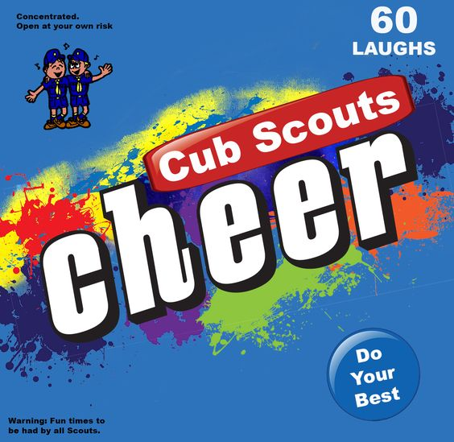
Cheers add fun to meetings and campfire programs. Use cheers during Cub Scout den meetings, pack meetings, or campfires. The cheer graphic can be printed and attached to a blue bag or a box wrapped in blue construction paper. Stuff the cheer box with themed cheers written on strips of paper before each meeting. Someone (e.g., assistant Cubmaster) should be assigned to jump up and enthusiastically lead cheers throughout the meeting (e.g., after a skit or advancement ceremony). Download the graphic at www.shac.org/Data/Sites/1/media/resources/leader-guides/Cheer-Box-1200x1170.jpg

Applause stunts are a great way to recognize a person or den in a pack meeting for some accomplishment they have performed. Be sure before you start that everyone knows and understands the applause stunt and how to do it. Applause stunts serve more than one purpose -- they not only provide recognition but also help liven up a meeting. Applause stunts need to be fun. Strive for quality of performance in your stunts. Another important side effect of Applause stunts is they provide” wiggle time” for all the Scouts and siblings during the ceremonies so they sit still during the serious moments. It is a lot easier and a lot less stressful to lead a cheer and have fun than to be constantly reminding the Scouts to sit quietly.

Candle Applause: “Flicker, flicker, flicker.”

Christmas Bells Applause: Pretend to hold a bell rope. Have the left side of the audience to say "DING" on the down stroke. Have the right side of the audience to say "DONG" on the up stroke. Repeat three times.

Christmas Stocking - Pretend to empty your stocking and then put it on your right foot.

Dad’s Gift - Act as if opening a gift and when open say, “Oh, a new tie! Just what I needed.”

Dasher - Slide hands against each other, making loud swishing noises.

Double Ice Cube Cheer: Make an ice cube with a thumb and index finger of each hand, saying, “TOOOOO COOOOOOOL!"

Eskimo Cheer: Brrrrr-rrr, Brrrrr-rrr.

Frosty the Snowman - “Thumpity, thump, thump!” twice.

Frozen Cub Scout: Wrap your arms around yourself, and say, “BRRRRR!”

Goodbye Santa Applause Pretend to throw a pack onto your back and say, "Merry Christmas to all and to all a good night."

Ice Cube Cheer: Shape an ice cube with a thumb and index finger, saying, "COOOOOOOL!"

Jack in the Box - Squat down and then jump as high as you can and say, “Boing!”

Jingle Bells I - Stand and wiggle all over while saying ‘jingle, jingle, jingle.”

Jingle Bells II - Give everyone a jingle bell and everyone shakes them at the same time.

Merry Happy - One side yells “Merry Christmas” and the other side answers “Happy New Year.” Repeat three times.

Mistletoe - Pretend to hold mistletoe over your head and make kissing sounds.

Present Cheer: Pretend that you are opening a present. When you open the box, say, “Oooh, Aaaaah!”

Reindeer Cheer - “On Dasher, Dancer, Prancer and Vixen, On Comet, Cupid, Donner and Blitzen!”

Rudolph Applause - Put thumbs to head with fingers pointing up and form antlers; wrinkle nose and say, “Blink, blink, blink.”

Santa - “Ho, ho, ho!” Hold stomach as you laugh (Optional) Pull on reins & say, "Where's Rudolph?"

Santa Claus: Reach out and hold stomach saying loudly, "HO, HO, HO" three times. Variation: Add: "MERRY CHRISTMAS!"

Santa Claus Chimney: Pretend to be driving your sleigh, say: "Whoa!" (pulling up on the reins), get out of the sleigh, pretend to climb into the chimney, begin to slide down and struggle, say: "Wheeze, grunt, rattle, clank, oh, no," move hands as if falling trying to grasp the sides of the chimney, then yell: "Craaaasssshhhh and then put your finger to your mouth and say, "Shhhhhhh!"

Silent Night - Stand up, cup hands around mouth (as if yelling) and silently mouth the words “Great Job!”

Snowball Applause: Reach down and pick up some imaginary snow, pack it into a ball. Pull arm back. Throw, and yell, "Splaaaatttt!"

Snowglobe - Pretend to hold a ball in your hand, shake it up and down and say, “Oooo! Aaah! Oohh!”

Silent Night - Stand up, cup hands around mouth (as if yelling) and silently mouth the words “Great Job!”
Sleigh: Say “Ding-a-ling” three times.

Working Elf: Pick up hammer and say, Nail, nail, nail, Glue, glue, glue, Build, build, build."

Cheer Yell
Props: Six posters with the letters “C,” “H,” “E,” “E,” and “R” (one on each poster), and one poster with the letters “FUL” on it
Seven Cub Scouts hold up the posters as the Cubmaster calls the letters.
CM: “Give me a C! (A Scout holds up a poster, prompting the audience to yell “C!”)
“Give me an H! (The next poster goes up, etc.)
“Give me an E! “Give me another E! “Give me an R!
“What are we full of?” (The audience yells “Cheer” when the poster with “FUL” goes up.)

This can be repeated multiple times—slower, faster, louder, softer, etc.

RUN-ONS

Ho, Ho, Ho
Q: How does Santa Claus water his garden?
A: With his ho, ho, hose
Q: How does Santa Claus keep his legs warm?
A: With his ho, ho, hose
Q: How does Santa Claus weed his garden?
A: With his hoe, hoe, hoe
Q: What does Santa Claus eat for breakfast?
A: His Cheerios, hos, hos
Q: What is Santa Claus’s favorite dessert?
A: Ho Hos

RUN-ONS
- “Harry,” said Mother severely, “there were two pieces of pie on the shelf this morning, and now there is only one. How did that happen?
- “I don’t know,” said Harry, regretfully. “It must have been so dark that I didn’t see the other piece.”
- If a Cub Scout found a dollar in every pocket in their pants, what would they probably have?
- Someone else’s pants.
- Why did Santa only take seven reindeer on Christmas Eve?
- Comet had to stay home and clean the sink.

I am around long before dawn.
But by lunch I am usually gone.
You can see me summer, fall, and spring.
I like to get on everything.
But when winter winds start to blow;
Burr, then it's time for me to go!
What am I? Answer: The dew
Which moves faster, heat or cold? Heat – everybody catches cold!
In what year did Christmas Day and New Year’s Day fall in the same year? It happens every year!
If you were standing directly on Antarctica’s South Pole facing north on Christmas Day, which way would you travel if you took a step backwards? North – all directions from the South Pole are north!
Clara Clatter was born on Dec. 27th, yet her birthday is always in the Summer! How is this possible? She lives in the Southern Hemisphere, where the seasons are reversed.

#1: We are going to have lots of Christmas flowers this year.
#2: Why is that?
#1: Last year I planted all the Christmas Bulbs.

- So, what are you getting mom and dad for Christmas?
- A list of what I want.
- Why did the silly boy/girl take the Christmas tree to a barber?
- Because his/her mother said that it needed to be trimmed.

KNOCK KNOCKs
Knock, Knock
Who’s There?
Murray
Murray Who?
Murray Christmas to all and to all a Good Night.

Knock Knock
Who’s There?
Pizza
Pizza Who?
Pizza on Earth, Good Will to Man.

Knock Knock
Who’s there?
Donut
Donut who?
Donut open till Christmas!

Knock, Knock
Who’s there?
Avery
Avery who?
Avery Merry Christmas!

Knock, Knock
Who’s There?
Lettuce.
Lettuce Who?
Lettuce in, it’s freezing out here.

Knock, Knock
Who’s there?
Snow
Snow who?
Snow business like show business!

JOKES & RIDDLES

Cub 1: What's red and white, and red and white,
and red and white?
Cub 2: A candy cane?
Cub 1: No, Santa Claus rolling down a hill.
Cub 1: What is red, white, and blue?
Cub 2: Santa Clause with a cold!
Cub 1: No! A sad candy cane.
Cub 1: Why did Santa only take 7 reindeer on his trip?
Cub 2: Comet had to stay home and clean the sink.
Cub 1: What do you have in December that you don't have in any other month?
Cub 2: The letter "D".
Cub 1: What do you call a chicken at the North Pole?
Cub 2: Lost.

Q: What does a Christmas tree eat with?
A: U-tinsels.
Q: What do you get when you cross a shark and a snowman?
A: Frostbite.
Q: Who is two feet tall and sings “Blue Christmas?”
A: Santa’s Elvis.
Q: What do you get when you cross Frosty the Snowman with a baker?
A: Frosty the Doughman.
Q: Why is Santa like a light switch?
A: He goes up and down a lot during the night.
Q: Why did Comet stay home on Christmas Eve?
A: She was cleaning the kitchen sink.
Q: What do snowmen eat for lunch?
A: Iceburgers.
Q: What did the walrus say to the polar bear?
A: Have an ice day!
Q: What does Santa have for a snack on Christmas Eve?
A: Peanut butter and jolly!
Q: What’s in December that isn’t in any other month?
A: The letter “D”!
Q: How many pieces of candy can you put into an empty stocking?
A: One! After that, it’s not empty!
Q: Which Holiday candles burn longer, reds or greens?
A: Neither all candles always burn shorter!

Christmas Funnies
Question: Why does Santa have 3 gardens?
Answer: So he can ho-ho-ho.
Question: What do you get when you cross a snowman with a vampire? Answer: Frostbite.
Question: What do you get when you cross an archer with a gift-wrapper? Answer: Ribbon hood.
Question: What do you call people who are afraid of Santa Claus? Answer: Claustrophobic.
Question: What do snowmen eat for breakfast?
Answer: Snowflakes.

Cub #1: What’s the difference between the Christmas alphabet and the ordinary one?
Cub #2: The Christmas one has No L (Noel)
Cub #1: How do sheep in Mexico say Merry Christmas?
Cub #2: Fleece Navidad!
Cub #1: What does a cat on the beach have in common with Christmas?
Cub #2: Sandy claws!
Cub #1: What kind of candle burns longer – a red one or a green one?
Cub #2: Neither – candles always burn shorter!
Cub #1: What is a cat on ice?
Cub #2: A cool cat!

Christmas: When you exchange hellos with strangers and good buys with friends.
Christmas: The time when everyone gets Santamental.
Santa Claus is a Jolly fellow! Imagine all that driving and still being able to say "Ho! Ho! Ho!
I remember my dad was shopping in a toy store. He said, "That's a terrific train set. I'll buy it."
The Clerk said, "Great, I'm sure your son will love it."
Dad said, "Maybe you're right. I'll take two."
Q: Why did Santa spell Christmas N-O-E?
A: Because the angel had said, “No L!"
Q: Why did the gingerbread man go to the doctor?
A: He was feeling crummy.
Q: Why does Santa's sled get such good mileage?
A: Because it has long-distance runners on each side.
Q: Why is it so cold on Christmas?
A: Because it's in Decembrrrrrrrrrr!

What do you call an old snowman? Water!

What does Santa do in his garden? Hoe, hoe, hoe!

SKITS

Baden-Powell & Good Deeds
Setting: An adult dressed as Baden Powell, and standing off to the side of the stage (or a large picture of him, with the sound of his voice coming from off-stage.) A group of Cub Scouts are sitting in the middle, looking like they are talking. (Moving their mouths and hands, but not saying anything). If possible, it would be great to have stars on the wall behind the Cub Scouts, with small white Christmas lights, not turned on, but able to be turned on at the end.
Baden-Powell: When I founded Scouting, I wanted Scouts to learn how to take care of themselves. But I also taught them to be kind to others – to do a good deed every day. I often think (that) when the sun goes down, the world is hidden by a big blanket from the light of heaven – but the stars are little holes pierced in that blanket by those who have done good deeds in this world. The stars are not the same size; some are big, some are little, and some men have done small deeds – but they have made their hole in the blanket by doing good before they went to heaven.
Cub #1: (Looking at a second Cub Scout) Wow, you’re doing great – you almost have the Scout Oath and Law memorized! But remember to put in “..to help other people” – Baden-Powell wanted Scouts to always do a good deed each day.
Cub #2: What kind of good deed?
Cub #1: Well, Saturday my family helped plant trees along the river – it was hard work, but fun, too. And wow, did I get dirty!
Cub #3: Today, I helped my den leader clean up after we finished our project – that was a good deed, too.
Cub #2: So, I need to do a good deed every day? Sounds kind of hard.
Cub #4: Well, sometimes you have to work hard to do a good deed – My dad and I helped my neighbor paint his fence – and that was hard work.
Cub #5: But sometimes, a good deed is pretty easy. There’s a new boy in my class, and he was kind of lost – so I helped him find the cafeteria and meet some of my friends – I guess that was my good deed for the day.
Cub #2: Hey, I helped my Mom bring in all the groceries from the car – was that a good deed.
Cub #6: Sure, that was a good deed. Just remember to be kind and helpful, and you won’t have any trouble doing a good deed each day…
Cub Scout pauses, then looks like they have a great idea
Hey, even helping you learn the Scout Law and Oath is a good deed!
Lights go out as Christmas lights go on in the room.
Voice of Baden-Powell is heard from off-stage….
Baden-Powell: … some stars are little, some are big – but all those good deeds have made their hole in the blanket – by Scouts doing their good deeds for the day.

Gift of Goodwill
Arrangement: A group of 8 Cub Scouts are gathered around, wrapping Christmas gifts. Each Cub Scout is wrapping a gift. Den Chief (DC) enters.
DC: Hey guys, let me see what each one of you is wrapping.
- Gloves for my Dad.
- An owl plaque for my mom.
- Oreo cookies for my little brother… maybe he’ll quit eating mine
- A doll for my sister.
- Wind chimes for my mom.
- Ink pens for my big brother… maybe mine will quit disappearing.
- A lamp for my mom.
- A lacy handkerchief for my grandma. She likes to wave them goodbye.
DC: Hey, you guys are really giving Goodwill. (laughs)
All: We hope so. Aren’t we supposed to do that year round?
DC: Yes, but let me show you something that’s quite unusual. (He takes a large piece of poster board and a marking pen. He calls on each Cub Scout in order to name the gift he is wrapping, and he writes the first letter on the board. Such as a G for gloves, etc. The result spells out Goodwill, which he holds up for the audience to see.)
Cub #1: Hey, that’s all right! We’re giving Goodwill separately together!
All: (Look at Den Chief.) Figure that one out!

G-I-V-E-S- Goodwill
This skit can be incorporated into many ceremonies. It is especially suitable for use during the time that your community is participating in a United Way campaign or an independent finance drive for Friends of Scouting (FOS) or Sustaining Membership Enrollment (SME).
PERSONNEL: Five Cub Scouts.
EQUIPMENT:
Five large cards, each printed with a letter of the word G-I- V-E-S on front and the part on back in BIG print ARRANGEMENT:
Each of the five Cub Scouts holds his card with the blank side to the audience.
One at a time the Cub Scouts step forward, turn their card so the audience may see the letter, and recite the phrases given below. When all have recited, they will be lined up left to right, their letters spelling out the word GIVES.
Cub # 1: G-Stands for Giving. It's always good to give.
Cub # 2: I-Stands for Intentions. May mine be always right.
Cub # 3: V-Stands for Valiant. A trait of great might. Cub # 4: E-Stands for Eager. From beginning to end. Cub # 5: S-Stands for Sharing. This makes me a friend

Holidays Around the World
Setting: Have on hand the props shown in parenthesis. You could have a narrator say the verses, and the Cub Scouts could come in and hold up their prop. Cub Scouts could also read the verses, but they do need to be read loudly and clearly, so that people can understand them.
Narrators or Cubs read one verse at a time:
In India and Thailand, they celebrate
The Festival of Lights
With little lamps or lotus boats
That float into the night.
(Cub holds up a votive candle in a little foil boat folded up to look like a lotus, or just folded up like a boat)
In Sweden, too, the honor Santa Lucia
Queen of Light,
The oldest girl will wear a crown
With candles warm and bright
(Cub carries a wreath holding candles,
or just a picture of a girl as St. Lucia)
In Mexico, the children gather
Goodies from the floor,
For they’ve broken the piñata,
Filled with candy treats galore!
(Cub brings in a piñata)
In Poland, on the table,
Under dishes they put straw,
And they leave a chair that’s empty
For the holiest child of all
(Cub with a handful of straw or a small chair)
In Holland, children fill their shoes
With Carrots and with straw,
In hopes “Black Pete” will substitute
A gift for one and all.
(Cub with wooden shoes or just a bunch of carrots)
In Israel, the children play
With a special top,
For a special day
(Cub with a dreidel)
In England, children hang a sock –
One that doesn’t have a hole!
They hope it will hold presents
And not a lump of coal!
(Cub with a stocking)
Let’s Celebrate! Let’s Celebrate!
And learn of special ways
That people all around the world
Celebrate their holidays!
(Cub with a globe or a map of the world)

A Holiday Recipe
Preparation:
The scene opens with a Chief Cook and his helpers busily cooking something in a large kettle. They can be dressed as cooks in old white shirts and white construction paper hats, or as elves in tunics made from grocery bags and painted. Each should have a large spoon for “tasting”.
There should be a number of labeled containers visible. These may be empty cereal boxes or cans covered with paper or painted and labeled “Worship”, “Love”, “Family”,
“Friends”, “Tree”, “Gifts”, etc.
Let the Cub Scouts suggest the “ingredients”.
The Chief Cook can use a “recipe card” which is the script.
CHIEF: (Thoughtfully) Let’s see, I think we should start with the most important ingredient. It is so often left for last and forgotten. Charles, bring me “Worship”. (Charles does so) Let us use the greatest care in adding this. (They pour in very seriously and carefully). Now, Abe, bring me the “Love”. This is what holds the entire result together. (Helper Abe brings the “Love”, which is added.)
Asst Baker: Do we need both “Family” and “Friends”, Sir?
(He brings the two containers)
CHIEF: It would be all right with one or the other, but it’s much better with both! Pour them in! (Assistant Baker enthusiastically adds them.)
ABE: (carrying “Gifts’ container) Should we add the “Gifts” now?
CHIEF: (laughing) Oh ho! Those can be added any time! Some people think they come first! Go ahead. (Abe pours them in. The Chief Cook stirs the mixture and tastes it.) Hmmm. It lacks something. It isn’t spicy enough. (The helpers all take a taste with their spoons.)
Charles: I know! We have forgotten the tree.!
CHIEF: Exactly! That always adds flavor. (Again he stirs, and again they all taste,) It still isn’t right! (As they stand, thoughtfully tasting, Edmund enters) -
Edmund: What are you making?
OTHERS: It’s a secret.! –
Edmund: Please tell me!
CHIEF: Oh, all right. (He whispers something into Edmund’s ear) Then says aloud - But it just isn’t coming out the way it should!
Edmund: Here, let me taste it. (He does so, thinks a minute, then realizes what is needed.) I know just what it needs and where to get it. I’ll be right back! (He dashes off stage and is back in a moment with a Cub Scout who is carrying an enormous box labeled “Good Will”) It needs a lot of “Good Will” and Cubs always have a lot of that!
CHIEF: That’s it exactly! Come on, Cub Scouts, let’s see if this doesn’t do the trick! (They all help lift and pour. They stir and taste it.) Perfect.! Let’s serve it right now! (He reaches into the kettle and pulls out a long, folded paper banner. The helpers take their places in line, holding the banner for the audience to see as the Chief Cook pulls it out, It reads, “THE HAPPIEST HOLIDAY EVER.”)
ALL: HAPPY HOLIDAYS, everybody!

This dialogue is merely a suggestion; might also be used as a pantomime with good results. The skit is so much a pantomime that the dialogue is secondary. It can really be “hammed-up” during the tasting scenes.

Ice Fisherman
Two men are fishing through a hole in the ice, but are having no luck. A Cub Scout fishing through a nearby hole keeps pulling one fish after another. The men ask if they might trade places with the Cub Scout. The Cub Scout mumbles agreement, they trade places, but the men still have no luck, while the Cub Scout continues to catch fish. One man asks the Cub Scout what the secret is. The Cub Scout mumbles an incoherent answer. The man can’t understand the Cub Scout and asks the Cub Scout to repeat their answer. Finally, the Cub Scout spits something into one hand and says loudly: “You’ve got to keep your worms warm!”

The Key
Props:
- A large door marked “Happiness” with easily read letters
- Seven cut outs resembling keys with words written on them in large letters. One key labeled on front for each item listed below
Personnel: 7 Cub Scouts.
Each Cub Scout takes their key and tries to open the door. As they cross in front of audience, make sure the key is in front of them with the word facing the audience. If you want, have Cub Scouts announce what their key is (read the one word)
Cub # 1: (key called Effort) – They try to open the door but cannot unlock it. (He steps aside.)
Cub # 2: (key called Knowledge) – They try to open door, but cannot (He steps aside).
Cub # 3: (key called Wealth) - Does same as other Cub Scouts.
Cub # 4: (key called Honesty) - Does as others.
Cub # 5: (key called Truth) - Does as others.
Cub # 6: (key called Cooperation) - Does as others.
Cub # 7: (key called Love) – They open the door to find a big gift.
Narrator: Love opens the door to happiness because with love comes the gift of sharing your, knowledge, wealth, effort, and honesty, and truthfully in a cooperative spirit. Love is the spirit of caring and sharing. Let us keep the caring, sharing, feeling all year round for that is the Spirit of Scouts.

The Light of Scouting
Set Up:
  - A candle for every person in the pack.
  - Wrap each candle in foil to create a drip plate.
  - Cubmaster (CM), Assistant Cubmaster (CA), Committee Chair (CC), Den Leader (DL)
Scene :
  - Dim the lights in the room.
  - There should be two candles on a table in the front of the room.
  - The pack committee should be near the front with the Cubmaster and the Assistant Cubmaster.
  - The den leaders line up on each side of the
room after the pack committee
  - The Scouts line up next to their den leaders.
  - Make sure the Cubmaster has a lighter.
CM: Lights one of the candles on the table and turns to speak to the group.
This candle represents the spirit of Scouting. All by itself in this big room, it doesn’t seem like much. But then, the spirit of Scouting finds me, as your Cubmaster (lights the second candle from the first, and then continues.)
While this is a little better, it is not nearly enough light. Fortunately, the spirit of Scouting continues to spread from me to the Assistant Cubmaster and to our wonderful Pack Committee (Cubmaster lights candle of Assistant Cubmaster, and then they each light one candle of the pack committee members. Lighting continues from one candle to another until all the pack committee candles are lit.)
CC: The spirit of Scouting doesn’t stop there! It continues to spread as more and more folks learn about the riches and treasures found in our program. (Den leader candles are lit from pack committee members.)
DL: Are you starting to see a pattern? Don’t you think having even more spirit would be better? How do we, the den leaders, spread our Spirit? That’s right! We spread the spirit of Scouting with our dens and all the Tigers, Wolves, Bears, and Webelos Scouts can experience this spirit. (Den leader lights one candle of the den and Scouts light one candle from a previous candle until all Scout candles are lit.)
CM: Wow! Isn’t this better? Let’s consider that this is just one pack. We’re a small part of one district in one council in the United States. The spirit of Scouting burns all over the world! So, when our light combines with all the other lights in all the other packs all over the world, the spirit of Scouting becomes a tremendous beacon to guide Scouts on their journey through life. I hope you carry this spirit of Scouting with you all your life!

Reindeer Game
Announcer (bursting with enthusiasm): Good evening, ladies and gentlemen, and welcome to our program. Tonight, some lucky member of our audience will win $10,000.00 - if they correctly answer our skill testing question! (Scans the audience and picks out the planted helper). You, Cub Scout, would you like a chance at this great prize?
Helper: Oh, yes! (Leaves the audience and joins the announcer on the stage)
Announcer: Tonight, our questions is: "Name two of Santa's reindeer!" You have 10 seconds to think about it. No help from the audience, please. (Buzzer sounds) Time's up! Now, give me one of the two reindeer names.
Helper Would one be Rudolph?
Announcer (jumping with joy) Yes! That's absolutely correct! You are half way to $10,000! Now, can you give me one more name?
Helper (Thinks and scratches head) Well; how about Olive?
Announcer (Groans): Olive! Whoever heard of a reindeer named Olive?
Helper Well, they sing about her in the song about Rudolph. You know it, we've all heard them. They sing "Olive the other reindeer!"

Santa’s Big Secret
Characters:
- Santa Claus (Scout uniform under Santa suit),
- Reporter,
- Numerous elves (Scout uniforms under jackets). Scene: Elves are in background working making toys or putting toys in sacks. Santa is directing them when reporter comes out with microphone.
Reporter: This is Scoop Smith the roving reporter for radio station WCUB, on the scene here at Santa’s workshop. Santa, may we have a word with you please?
Santa: Oh sure, we’re real busy getting ready for our deliveries. What can I do for you?
Reporter: All of our listeners want to know how you got into the gift giving business. Did your father give gifts or what?
Santa: Well, it all began when I was eight years old... I just started doing good deeds, you know, helping people and such... and it just became a habit.
Reporter: Good deeds, huh, that sounds familiar. Say, what is that under your jacket?
Santa: That’s my best kept secret... (Opens jacket)
Reporter: A Cub Scout Uniform!!!!!! You’re a Cub Scout?
Santa: Yes, well, no. I WAS a Cub Scout, then a Eagle
Scout, and then a Venturer. I wear this uniform to remind me of where it all started... way back years and years ago. I just loved helping other people and doing good things.
Reporter: Well, that explains your involvement, but how do you get all of these elves to help you?
Santa: Show the man... (Elves open jackets to show Cub Scout Uniforms.)

Solving a Christmas Problem
Personnel: 8 Cub Scouts
Equipment: Christmas tree, chair
Setting: As the scene begins, a Cub Scout (#6) is seated, head in hands by a Christmas tree.
The other Cub Scouts enter and speak to him
- What is really wrong with you, we’ve got a lot of work to do.
- Come on don’t be so down. Your face looks terrible with that frown.
- Tell us why you are so sad. At Christmas time, you should be glad.
- Maybe with Christmas so near, he’s worrying about what he’s getting this year.
- Come on and let me help you out. Because helping others is part of being a Cub Scout.
- (Jumps up and with a big smile on face and shakes hands and slaps on back on Cub Scout #5)
That’s it! That’s it! Thanks old Buddy, my thinking sure was pretty muddy!
- (All look puzzled at each other) What did they do that made things right? I guess I’m just not too bright.
Cub #6: (speaking with lots of expression) I don’t have money to buy my Mom a gift you see, but now I know I’ll give her just helpful me!
- Wow, I’m glad you’ve helped us all remember, the important part of that holiday in December
(All put their arms around each other and
walk off stage in a happy group)

Trimming the Christmas Tree
Cast: Group of Cubs, Den Leader (DL),
Materials: Scout staff with sprig of evergreen lashed to the top;
Materials to make snipping and sawing sounds (You can prerecord these on a cassette tape.)
Setting: Den Leader (DL) is on stage;
The Cubs are off to the side.
Two Cubs enter.
- Go ask the den leader how this tree is supposed to look.
- Goes to leader, acts out asking question. Leader acts out response. The Cubs run off stage, and audience can hear the sounds of sawing, snipping etc.)
- (Enters, goes to leader.) Like this?
DL: (Looks over at the Cubs who are positioned to let the leader see, but not the audience.) More off of this side. (Gestures Cub Scout runs off stage.) More sawing sounds are heard.
Repeat this several times, with leader pointing and gesturing about different sides of the tree. Everyone is getting more and more tired. Finally after many sounds of sawing and snipping the Cubs all march over to the leader, carrying the staff with the sprig attached to the top, and show it to the leader and the audience. Leader groans and all leave.

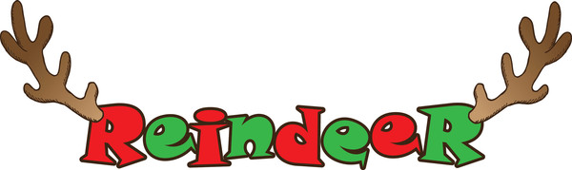
Who Stole the Christmas Cookies?
Setting: Cub Scouts gathered around a refrigerator (just a large piece of paper with a refrigerator drawn on it) Cubmaster(CM) is out of sight, holding several cookies and a glass.
Cub #1: Wow, I’m really looking forward to Christmas – I can’t wait to see what I get!
Cub #2: Yeah, I think we’re already – wonder what I’ll get?
Cub #3: Oh no! I forgot!
All: (except 3) What did you forget?
Cub #3: We forgot the cookies and milk for Santa!
Cub #4: Oh, that’s easy – my Mom even has a special plate. (Pretends to reach up in a cupboard, pulls out a plate) “See – it’s perfect for Christmas”
Cub #5: Great, all we need now are the cookies and milk!
Cub #6: I’ll get the milk.
Cub #1: I’ll get the cookies from the cookie jar! (Reaches up and pretends to get a really large object)
Cub #2: Wow, that’s a big cookie jar! (Pretends to take the lid off the jar)
All: (Looking inside the jar, then looking horrified) Oh, no, it’s empty!! Now what can we do?
CM: (Enters holding cookies and an empty glass) Wow, those were some great cookies. But I need some more milk.
All: STOP! Put down those cookies!
CM: (Looking startled) But they’re delicious! I just need some more milk…..
All: No, you’ve got to put down those cookies – they’re for Santa!
CM: Oh, sorry, I didn’t know…(Puts them on the plate)
All: Wow, glad there were still some left!
CM: I’ll tell you one thing – Santa is going to LOVE those cookies! (All leave the stage)

A World of Celebrations
Setting: A group of Cub Scouts – each one should have the props close, or behind their back. (You can substitute customs from any country – especially if you have children who come from other cultures)
Cub #1: Well, we’re ready for Christmas – we dug out our stockings (holds up stocking) and we’re going to hang them by the fireplace. (Looking at another Cub Scout) Are you ready at your house?
Cub #2: Oh, we don’t have stockings at my house.
Cub #1: What, you don’t get your stocking filled with goodies? How awful!
Cub #2: My family is from Holland – we have a different custom. Children put their wooden shoes out, with some straw in them. (holds up some straw)
Cub #3: What’s the straw for?
Cub #2: It’s for St. Nicolaus’ donkey.
All : He has a donkey? Not reindeer?
Cub #2: That’s right – he takes the straw for the donkey and leaves gifts in the shoes. But it’s NOT on Christmas Day. We go to church then. But on Dec. 6th, St. Nicolaus comes and leaves gifts.
Cub #3: Well, I guess that’s as good as a stocking. You know, my Mom is from Sweden, and they do things different there, too. On St. Lucia Day, Dec. 13th, my oldest sister wears a wreath on her head with candles in it. (Holds up a picture of a girl dressed for St. Lucia Day)
Cub #4: What’s the wreath for?
Cub #3: Well, it’s because she is supposed to represent Saint Lucia, who brought food to Christians who were hiding from their enemies in dark caves. And besides, it’s really dark in the winter in Sweden – the sun barely shines – so Swedish people love to see light. My sister brings special sweet buns to my parents while they’re still in bed.
Cub #4: Do you get some, too?
Cub #5: Well, everyone gets some – but first, my parents get theirs – and me and my brothers wear hats with stars – it’s from an old legend.
Cub #4: So, what about Santa?
Cub #3: Well, here in America, we do have Santa, but we also leave some food for the Juul Nisse.
Cub #4: What’s that?
Cub #3: In Sweden, elves called Juul Nisse help children with their chores and bring them gifts – so we leave them food to say thanks!
Cub #5: You know, my grandpa is from Mexico – the children get their gifts on January 6th – it’s called Three Kings Night, after the three wise men.
Cub #6: What do they do on Christmas?
Cub #5: Oh that’s great, too. We always have tamales and go to church – and in Mexico, they have Las Posadas.
Alls: What’s that?
Cub #5: Well, for nine nights in a row, people join a procession, and go from house to house – they pretend to be Mary and Joseph, looking for an inn to stay in. Everyone decorates their house with paper banners, and there is lots of singing.
Cub #6: So, do people let them in?
Cub #5: No, they have to go from house to house each night, and everyone says there is no room, till they get to the right house.
Cub #6: What happens then?
Cub #5: Oh, when they get to the right house, they get to come in and there’s a party! There’s a piñata (holds up a piñata or a picture of one) to break, filled with candy and little gifts. It’s a lot of fun!
Cub #6: Wow, people celebrate Christmas in lots of different ways!
All: But it all sounds like fun!

CUBMASTER MINUTES

Cheerful Thought
- “Some think that cheerfulness comes from getting. Others know it comes from giving.” Lord Baden-Powell, founder of Scouting
- You can be grouchy and grumpy, or you can be happy and cheerful. It is up to you. We have a choice. We can be pleasant or unpleasant. Which do you choose?

Christmas Spirit & the Gimme Pig
Ideas and Stories for the Scoutmaster’s Minute, BSA, 1956
There's a strange animal to be found in especially large numbers at this time of the year. It's called a "gimme pig." You can recognize it very easily. It will be saying something like this, "Gimme a bicycle. Gimme an electric train. Gimme a record player, Gimme a motor scooter. Gimme a pony."
(Okay, so it's a little dated - IPod, IPad. You can update it to the popular toys of the current year)
Do you think you have ever seen any of these strange animals?
Surely you haven't seen one in this Scout room!
No Scout could possibly be a gimme pig.
A Scout is pledged to help other people at all times.
He wants to give - that's what he's thinking about.
A real Cub Scout never thinks "gimme."
They think about the good they can do, the happiness they can bring to somebody else. Because, as you know, they put other people ahead of themselves.
They are thinking about other people especially at this time of the year.
What will you give this Christmas?
How much service to other people?
How much happiness to your family?
What will you give?

Closing
In the season of happy days,
I’d like you to keep in mind
the recipe for a wonderful
day — it works all year ‘round.
Recipe for a Wonderful Day
- 1 cup friendly words
- 2 heaping cups understanding
- 2 cups milk of human kindness
- 2 heaping tablespoons of time and patience
- 1 dash gentle humor
- 1 pinch spice of life
- 1 drop warm personality
Measure words carefully; add cups of understanding to milk of human kindness. Sift together three times to make a smooth paste, cook with gas on the front burner. Keep temperature low so it never boils over, Season with gentle humor, warm personality and spice of life. Serve in individual molds. Works best with a good mixer.

Cubmaster’s Minute (Gifts)
Each of us have some traditions that are only practiced by our own families. Let’s remember to enjoy those traditions and our families at this time of year. Remember it is better to give than to get. See if you can find the joy in giving this year!

Cubmaster’s Minute
Tonight has been a lot of fun. We have a lot of cheerful faces in the room, we played games, we received our awards, etc. It’s easy to be cheerful when things are going our way, right? But what about those times when things are messing up: we forgot our homework, we were late to school, our favorite computer game is broken? How do we act then? What about when your parents ask you to help around the house? How do we act then? Can we say we act cheerful? I challenge you to begin thinking of ways to stay cheerful when the going gets tough. Try to remember something fun you did, something great you had to eat, how awesome your best friend is, a really funny joke you know, and then the tough times might not seem so bad. Until our next pack meeting, I wish you a cheerful good night.

Cubmaster’s Minute (Winter Wonderland)
We are all like snowflakes, all unique in our own special way. And just as no two snowflakes are alike, no two people are exactly the same. We show reverence for all those we come in contact with: reverence for one’s beliefs, reverence for one’s belongings, and reverence for one’s privacy. In doing so, we show reverence for ourselves.

December Lights Closing Ceremony (Lights)
This is the season of decorations and lights. It is a time when the days are shorter and the nights are long. But, somehow, things seem brighter. Shopping centers are bright with holiday decorations and lights. Thousands of homes have single candles to light the way for the Christ Child. Other thousands have candles burning to commemorate the miracle of the oils of Hanukkah. Even the stars in the winter sky seem brighter. The most brilliant glow comes from the spirit of goodwill that you live all year round in the Scout Oath and Scout Law. Let us all stand and repeat them together.

Good Turn
Most of us are happiest when we are doing something for others. Think for a moment of a time when you were helpful to someone. Chances are, it made you feel pretty good. Of course, we feel best when we do something for others without being found out. When we help others regularly, it soon becomes a habit and to be a natural thing. Once you establish this habit, you will learn the real meaning of the good turn.

A Good Turn
In a past issue of Scouting magazine, there is a story about a Webelos Scout named Daniel Simon of Pack 381, Buffalo Grove, Illinois. Daniel earned a $750 gift certificate, and instead of spending the money on himself, he filled seven shopping carts with toys for other children who might not get anything that holiday season. It was a fine act of kindness and generosity. For Daniel, the Scout Oath and Law aren’t just words; they represent a way of life. Wouldn’t it be a great holiday tradition if we all followed Daniel’s example and performed some special good turn for someone in need? That would bring a lot of joy to the people we served. It would also bring a lot of joy to us, knowing that we had done something to make someone’s life a little better. When you ask the question, “What do you do at holiday time?” also think about what you can do to give good will and serve others at holiday time. What better way to build good memories that will last forever?

Holiday Lights
During this pack meeting, we celebrated the many ways lights are used during this time of year. Whether we are decorating our homes, celebrating our faith, or lighting a path for our Cub Scouts, lights bring a special glow of warmth to our hearts. The Cub Scout spirit held by each of our Cub Scouts brings that same special glow because the spirit of Cub Scouting lights up their path with its ideals and purposes. All Cub Scouts everywhere share special lights of character, citizenship, and fitness. It is these lights that challenge them to consistently do their best.

Holiday Lights
We all share a sense of wonder at the lights of the season—the light of hope and peace for the future—whatever our religious beliefs. As we respect our own beliefs and the beliefs of others, we light a powerful flame, which unites us all. Though individually we may be very different, by respecting those differences we unite—as a den, a pack, a nation, and a world, lighting the way for the future. (As the Cubmaster speaks, the assistant Cubmaster circulates, handing each Scout a small flashlight to hold up.)

I’ll Walk with You
In a recent program, some children sang a song called “I’ll Walk With You” – it’s a song of promise. The promise is that even if “you don’t walk” or “talk” as most people do, “I’ll walk with you.” Another promise is that even though “some people walk away from you” or “laugh at you” – that “I won’t!” Each of us should show respect for ourselves (and for others) by the way we talk and how we act! Remember - A Good Scout is Helpful, Friendly, Courteous, Kind and Brave.

Magic of Cub Scouting
To take a child and help them grow into a successful adult –That's magic.
To teach them how to make things and let them know they can – That's magic.
To watch them learn the Scout Oath and Law and apply it in their life – That's magic.
To see them grow in mind and body, overcoming strife – That's magic.
To watch their family beam with pride at everything they'll do – That's magic.
And love them even if things don't go as they wanted them to – That's magic.
And observe the Scout leaders also beaming with pride. Because we know they are learning and growing up inside – That’s Cub Scout Magic.
Potential
The child you love and teach today,
Could be the adult who saves your life one day.
A lawyer or firefighter, mechanic or doc,
Who knows the potential these children have got.
Well, he’s in a wheelchair or this one can’t read.
Hey, that doesn’t mean these children don’t have speed!
The sky is the limit and the sky has no end.
We know not the limits of how far they can bend.
Just give them the power and the love then you’ll see,
What these sweet children can grow up to be.

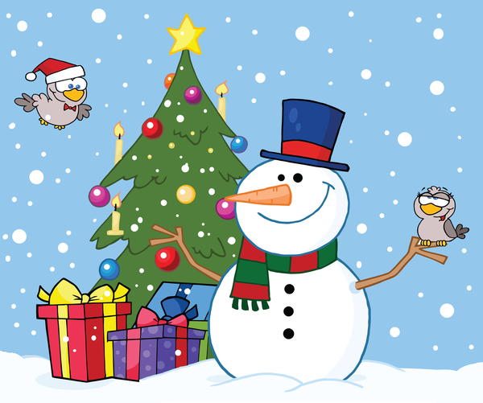
Science Behind Snowflakes
Because of the way that they grow, Each frozen white crystal of snow, Is thought in our mind, To be one of a kind.
But guess what: It just isn't so. When H²0 molecules freeze, Hexagons form with great ease. Molecular bonds
Like magical wands, Form the six-sided shapes snowfall sees. Dendrite flakes, with their six crystal wings, Are among nature's loveliest things. These flakes are unique, No two can you seek
Just the same in the white winter brings.
But at temperatures lower or higher In air that's more humid, or drier, Different shapes grow: Less unique flakes of snow
That develop much simpler attire. Needles, and Columns, and Plates Are flakes with identical mates. Like wheels on a bike
These flakes look alike. Each type has quite similar traits. But the turbulent winds of a storm, With temperatures both cold and warm And mixed moisture sources, Create varying forces, That cause complex mixed crystals to form. So while some flakes can all look the same, Most are not nearly so tame. They're all based on a "hex," But they're just as complex, As the Nature from whence each one came. Now raindrops, and sleet, even hail, Are part of a simpler tale: Though they vary in size Like a bunch of french fries, Each form the same way without fail. Big drops fall from moist warmer air, Or when smaller drops join, way up there. Hailstones will grow, When strong updrafts blow.
A thunderstorm has those to spare. Sleet's just a raindrop that froze Before it crashed into your nose Wet rain that falls
And then freezes on walls, Is freezing rain. Traffic it slows. Each type of cold precipitation Has its own origination. We suffer together, The wet winter weather, No matter our town, state, or nation.

Scout’s Act of Kindness Closing
Cubmaster: To end this evening, I’d like to tell you a story.
A crowded bus stopped to pick up a bent old woman. With great difficulty she struggled up the steps with a large basket of freshly washed laundry. “You’ll have to put your basket in the rear of the bus,” the bus driver said impatiently. “I do not dare. They do not belong to me.” The woman replied.
The driver was firm. “You and that basket are in the way. Either stow it or get off.”
The old lady was almost in tears when a young man arose. “You sit here, Ma’am,” he offered. “I’ll take your basket to the back and watch it until your stop. ”The woman was doubtful, but the bus driver was about to put her off. A second lady, sitting nearby, said to the old woman, “That boy’s all right. Can’t you see his uniform? I’ll vouch for him.” The woman soon took a seat, and the basket of clothes carried to the rear. At her stop, the boy gently set the basket down by her, then returned to the bus and continued on his way. “Who’s the kid?” asked the driver to the second woman. “I do not know the kid,” was the reply, “But I do know the uniform, and you can trust it every time.”
In this season of giving and helping, let’s make certain we remember what our uniform means to others and to ourselves.

Season of Lights (Around the World)
This is the season of lights. It is a time when the days are shorter so the nights are longer, yet somehow things are brighter. Stores and homes are bright with holiday lights. Thousands of homes have a single light to show the way for the Christ child, others have candles burning to commemorate the miracle of Hanukkah, and some light candles to honor the heritage of Kwanzaa. Even the stars in the winter sky seem brighter at this time of year. But the most important glow is from the spirit of goodwill that WE live with year-round in the Scout Oath and the Scout Law. Before we all leave to get on with our holiday celebrations, let’s stand and as a group say the Scout Oath and Scout Law. Happy Holidays!

Starry Night (Lights)
Dim or turn off room lights except
for an electric candle or flashlight
This is the season of lights and stars, when days are short and nights are long with beautiful stars.
Lord Baden-Powell, the founder of Scouting, once said this to his Scouts, “I often think when the sun goes down, and the world is hidden by a big blanket from the light of heaven. But the stars are little holes pierced in that blanket by those who have done good deeds in this world. The stars are not all the same size; some are big, and some are little. So, some men have done great deeds, and some men have done small deeds, but they have all made their hole in the blanket by doing good before they went to heaven.”
Let’s remember when we look at the starry sky, to make our own hole in the blanket, by doing good deeds that spread seeds of kindness and help other people.

String of Lights
When I see a string of lights on a tree, I am amazed at how bright the small lights can be. They are like our Cub Scouts. One light by itself may not be very bright, but it certainly does its best. One Cub Scout by themself is certainly doing their best, too, but think of how much better all the Cub Scouts do when they can work together on Adventures. Look at the lights on a string of lights. When one fades, they all fade until the one light is fixed. Our Cub Scouts help each other, too, in this way – when one needs some extra support, they all pitch in and help their friend. Just as lights shine their brightest when they all work together, it is keeping our program working together for our Cub Scouts that allow them to shine their brightest.

‘Tis the Season Closing Ceremony (Traditions)
Cubmaster: This is the season of lights. It is a time when the days are shorter so the nights are longer, yet somehow things are brighter. Stores and homes are bright with holiday lights. Thousands of homes have a single light to show the way for the Christ child, others have candles burning to commemorate the miracle of Hanukkah, and some light candles to honor the heritage of Kwanzaa. Even the stars in the winter sky seem brighter at this time of year. But the most important glow is from the spirit of goodwill that we live with year-round in the Scout Oath and Law. Before we all leave to get on with our holiday celebrations, let's stand and repeat the Scout Oath and Law together. Happy Holidays!

To tell the truth
These are some of the things that will make working together and playing together easier: To tell the truth, to be honest, to be courteous, to have respect for leaders and to think of others as well as ourselves.

Traditions
Here in America we are many. We come from many lands and with us we bring our heritages. We bring our beliefs and we strengthen America when we hold to those beliefs. Each of our traditions gives us an identity, a belonging. And when we share those traditions, we expand our circle so soon we all can belong. Whether we celebrate Christmas, or Hanukah, Kwanzaa or none of these, sharing valued traditions and holding true to what they stand for will make America strong. In Cub Scouts, we are many. We come from all backgrounds and celebrate many traditions. But no matter who we are we are still part of America and we all strive to “Do Our Best”.

Why God Made Kids
God made a world out of his dreams
Of magic mountains, oceans and streams. Prairies and plains and wooded land; Then paused and thought,
“I need someone to stand ‘
On top of the mountains, to conquer the seas, Explore the plains and climb the trees, Someone to start out small, and grow
Sturdy and strong, like a tree.”
And so, He created girls and boys, full of spirit and fun To explore and conquer, to romp and run, With dirty faces, banged-up shins,
Flashing eyes, and great wide grins. When He completed the task He’d begun, He surely said, “That’s a job well done!”

CLOSING CEREMONIES

Christmas Spelling
Arrangement:
  - Nine Cub Scouts come onstage, one by one.
  - Each has a large cardboard letter with their part on back.
  - As they speak their lines, they hold up their letter
  - Ultimately, they spell out the word Christmas.
Cub # 1: C is for candles, we burn on Christmas night. To gladden weary travelers with their light so bright.
Cub # 2: H is for happiest; the happiest time of year. It's jolly, gay old Christmas tunes with all its mirth & cheer.
Cub # 3: R is for ring; we ring the Christmas bell. All the Christmas gladness, the world to tell.
Cub # 4: I is for the infant who lay in a manger. Little Lord Jesus, a dear little stranger.
Cub # 5: S is for shepherds who kept their flocks by night; And heard the angels singing, and saw a wondrous light.
Cub # 6: T is for tree, all green and gold and red. We see it Christmas morning when we jump out of bed.
Cub # 7: M is for the mistletoe we hang at Christmas time.
In merry wreaths, when candles burn and Christmas bells chime.
Cub # 8: A is for all; to all men we wish cheer. Joy and gladness, love and hope, for Christmas time is here.
Cub # 9: S is for the star that shone on Christmas night, Star and candle, bell and wreath, all make our Christmas bright.

Closing Ceremony
#1 C is for candles, we burn on Christmas night. To gladden weary travelers with their light so bright.
#2 H is for happiest; the happiest time of year. It's jolly, g#y old Christmas tunes with all its mirth & cheer.
#3 R is for ring; we ring the Christmas bell. All the Christmas gladness, the world to tell.
#4 I is for the infant who lay in a manger. Little Lord Jesus, a dear little stranger.
#5 S is for shepherds who kept their flocks by night; And heard the angels singing, and saw a wondrous light.
#6 T is for tree, all green and gold and red. We see it Christmas morning when we jump out of bed.
#7 M is for the mistletoe we hang at Christmas time. In merry wreaths, when candles burn and Christmas bells chime.
#8 A is for all; to all men we wish cheer. Joy and gladness, love and hope, for Christmas time is here.
#9 S is for the star that shone on Christmas night, Star and candle, bell and wreath, all make our Christmas bright.

Closing Ceremony (Traditions)
Cubmaster: This is the season of lights. It is a time when the days are shorter so the nights are longer, yet somehow things are brighter. Stores and homes are bright with holiday lights. Thousands of homes have a single light to show the way for the Christ child, others have candles burning to commemorate the miracle of Hanukkah, and some light candles to honor the heritage of Kwanzaa. Even the stars in the winter sky seem brighter at this time of year. But the most important glow is from the spirit of goodwill that we live with year-round in the Scout Oath and Law. Before we all leave to get on with our holiday celebrations, let's stand and repeat the Scout Oath and Law together. Happy Holidays!

Cubmaster Closing
Each of us has some traditions that are only practiced by our own families. Let’s remember to enjoy those traditions and our families at this time of year. Remember it is better to give than to get. See if you can find the joy in giving this year!

Do Your Best
Scene: Cub Scouts with key words hold up cards saying "DO YOUR BEST"
Cub # 1: DO unto others as they should do to you.
Cub # 2: That's called the Golden Rule.
Cub # 3: YOU'RE all Cub Scouts of Gold and Blue,
Cub # 4: The Pack Law is your special tool,
Cub # 5: BEST way we know to celebrate this season,
Cub # 6: Is in giving your best to others,
Cub # 7: And now we wish you, for that very reason,
All: Happy holidays! May we all be brothers.

End of Year Rededication
Setup: You'll need nine candles, one of which is taller than the others. The CM should light them all and the room should be darkened.
CM: This last ceremony of the year is one of rededication. Five candles represent our Cub Scout ranks of Lions, Tiger, Wolf, Bear, and Webelos Scouts. (Ask Lions and Tigers to stand.)
CM: Lions and Tigers, if you promise to do your best in <insert year> repeat the Cub Scout motto.
Lions and Tigers: Do Your Best
CM: (Extinguish two candle flames. Ask Wolves and Bears to stand) Wolves and Bears, if you promise to do your best in <insert year> and to advance further in Scouting and follow the Scout Oath, please recite the Oath.
Cubs: <recite Scout Oath>
CM: (Extinguish two candle flames. Ask Webelos Scouts to stand) Webelos Scouts, if you promise to do your best in <insert year> and to follow on the trail and work towards the rank of Eagle Scout, recite the Scout Law.
Cubs: <recite Scout Law>
CM: These three candles stand for Follows, Helps, and Gives - which mean that you as Cub Scouts will be loyal. (Extinguish their three flames.)
CM: The large candle, the spirit of Scouting, still burns as it does in the hearts of Cub Scouts everywhere. May it continue to burn brightly in your heart throughout <insert year> as we go onward and upward in Pack . Good night, Cub Scouts.

Happy Holidays!
Personnel: Cubmaster, 6 readers (Cub Scouts)
Props: 6 pieces of paper with the letters T-H-A-N-K-S on one side and the text on the other side in BIG print
Cubmaster: Tonight, is our last pack meeting of the year. We have had a great year together, and as we look forward to next year, we have a lot to be thankful for.
Cub # 1: (Hold up “T”) T is for Togetherness; Working together to make our pack go.
Cub # 2: (Hold up “H”) H is for Homes, families, and friends.
Cub # 3: (Hold up “A”) A is for Akela; Our parents and leaders.
Cub # 4: (Hold up “N”) N is for New friends we’ve made and experiences we’ve had.
Cub # 5: (Hold up “K”) K is for KlSMIF; keeping it simple, making it fun.
Cub # 6: (Hold up “S”) S is for Scouting; which helps us grow and spread goodwill.
CM: Thank you all for a great year! Let us now retire the colors.

Helpful to Others
Lord Baden-Powell, the founder of Scouting said this to Scouts everywhere: "I often think that when the sun goes down, the world is hidden by a big blanket from the light of heaven, but the stars are little holes pierced in that blanket by those who have done good deeds in this world. The stars are not all the same size; some are big, some are little, and some men have done small deeds but they have made their hole in the blanket by doing good before they went to heaven. Try and make your hole in the blanket by good work while you are on earth. It is something to be good, but it is far better to do good". Think of Baden- Powell's words when you promise "to help other people".

Lights
Cubmaster: This is the season of lights. It is a time when the days are shorter so the nights are longer, yet somehow things are brighter. Stores and homes are bright with holiday lights. Thousands of homes have a single light to show the way for the Christ child, others have candles burning to commemorate the miracle of Hanukkah, and some light candles to honor the heritage of Kwanzaa. Even the stars in the winter sky seem brighter at this time of year. But the most important glow is from the spirit of goodwill that WE live with year-round in the Scout Oath and Law. Before we all leave to get on with our holiday celebrations, let’s stand and repeat the Scout Oath and Law together....

GIFTS Closing Ceremony
Set Up: Den Chief (DC) or Den Leader (DL) and 5 Cub Scouts. Be sure Cub Scouts have learned their parts or create cards with pictures on the audience side and the words on back in LARGE type.
DC/DL: What you are is God's gift to you. What you make of yourself is your gift to God. Make it a good gift.
- Work while you work.
- Pray while you pray.
- One thing at a time. That is the way.
- All that you do, do with all your might.
- Things done halfway are not done right.
All: (Together) Do Your Best!

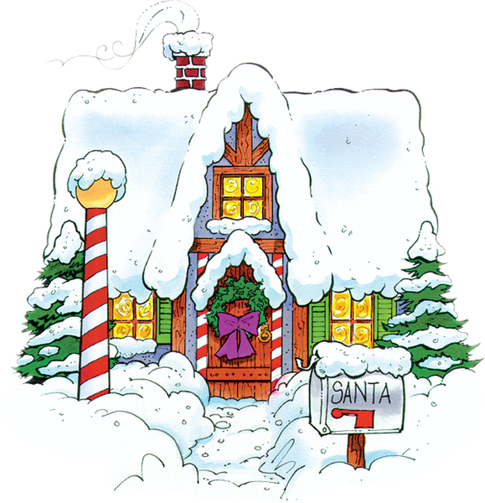
Goodwill Closing Ceremony
Set Up: 8 Cub Scouts each with a sign with one of the letters on front. The words are written on the back in large print. Cub Scouts say their parts in turn.
- G - Good Cub Scouts are friends to all.
- O - On their honor to obey the Scout Law
- O - Once they show how HELPFUL they are
- D - Doubled friendships will surely be found.
- W - Working together being HELPFUL will make the world a better place.
- I - Including as new friends -- Cub Scouts from each faith and race.
- L - Leaving behind them a path of good cheer from being HELPFUL.
- L - Let's all practice being HELPFUL now and all through the year.
- Wishing you all Goodwill. Thank you and good night. You are dismissed.

Make Good Use of Time
Set up: Give 10 Scouts each a line of the poem to repeat.
Narrator - Time is the most valuable thing in the world. It’s not possible to stretch a day longer than 24 hours, nor a year longer than 365 days (except in a Leap Year!). Time wasted is time lost. Time lost can never be found. Tomorrow, today will be yesterday.
Making good use of your time doesn’t mean you have to rush about every minute. There are so many things to do that you’ll need to think about how you’re going to spend your time, so that you make the most of it, and live your life to the fullest.
- Make time to pray...it helps to bring God near and washes the dust from your eyes.
- Make time for family and friends... it is the source of happiness.
- Make time for work...it is the price of success.
- Make time to think...it is the source of power.
- Make time to read...it is the source of knowledge.
- Make time to laugh...it eases life’s problems.
- Make time to love...it is the reason for life.
- Make time to dream...it hitches the soul to the stars.
- Make time to play...it is the secret of youth.
- Make time to sleep...it is the fountain of mental and physical strength.

Rabbi & The Soap Maker
A Rabbi and a soap maker were walking along and the soap maker questioned the Rabbi by asking, "What good is religion? There's been religion for a long time, but people are still bad to each other." The Rabbi was silent until they saw a boy who was dirty from playing in the street. The Rabbi asked the soap maker, “What good is soap?
We've had soap for many, many years and people still get dirty.” The soap maker protested the comparison and insisted that the soap had to be used in order to keep people clean. "Exactly my point," said the Rabbi. "Religion," he said, "has to be applied in order to do anybody any good."

Recipe for a Happy Family
Three to ten Cub Scouts can help. One Cub Scout reads from a cookbook, one Cub Scout stirs pot, the rest add the ingredients. Cover old cans with paper and label. Fill each can with something to make it look real.
Scene: Cub Scouts around a table, with a large pot and ingredients on top of table.
Cub Scout 1 stands by pot and stirs slowly as ingredients are added.
Cub Scout 2: (Has cookbook and starts to read.) Here is the recipe for a happy family.
Cub Scout 1: Do we have everything?
Cub Scout 2: (Looks around and other Cub Scouts nod their heads yes.) First, we need three cups of eagerness.
Cub Scout 3: Here it is (Pours it in.)
Cub Scout 2: Next is two cups of laughter.
Cub Scout 4: I’ve got that (Pours it in.)
Cub Scout 1: (Looks into pot.) This is beginning to look enticing!
Cub Scout 2: Two cups of courtesy.
Cub Scout 5: (Looks at can.) This is it. (Pours it in.)
Cub Scout 2: Who’s got two cups of helpfulness?
Cub Scout 6: I brought that. (Pours it in.)
Cub Scout 2: Next, we need some adults to help.
Cub Scout 7: I found two really good ones! (Pours it in.)
Cub Scout 1: (Looks in pot.) Wow! That made this really great!
Cub Scout 2: Now we need one cup of ability to follow instructions.
Cub Scout 8: I have that. (Pours it in.)
Cub Scout 2: Next is a gallon of patience.
Cub Scout 9: I looked all over, but I found plenty. (Pours it in.)
Cub Scout 2: The last ingredient is three cups of love for each other.
Cub Scout 10: (Pours it in.) I got that, but I added a little more than the recipe called for.
Cub Scout 1: Okay, I’ll mix it well.
Cubmaster: What do we have? A recipe for a happy family!
Serve generous portions frequently!

A Season of Giving
Setting – 6 Cub Scouts and Cubmaster (CM); Scouts should memorize verses.
Scene – Scouts in a line or come in one by one to say a verse.
CM: We’ve spent some time tonight celebrating the many lights that bring joy and peace to our world. In many customs, this is a season of giving and receiving gifts. Our Cub Scouts would like to share with you some gifts you may not see advertised this season.
- Give your parents the words, “I love you.”
- Give an ear to someone who needs a listener.
- Give a hand to someone less strong.
- Give an old friend a surprise visit or letter.
- Give a former neighbor a phone call.
- Give yourself time to reflect during this season.

Snowflake Closing Ceremony
Have Cub Scouts and family members cut out snowflakes when they enter the pack meeting, and put their names on them. (Six sided snowflakes can be made by folding a square sheet of paper in half, and then into thirds.) Tape or fasten to a wall, curtain, blackboard or window.
Have you ever caught a snowflake on a black piece of paper and studied it? It is so delicate and fragile that it melts almost before you can pick out its unique shape and structure. And it is unique, because each snowflake forms its own pattern of crystals in a six-sided shape. No two are exactly alike. There may be some that are similar, but none are the same.
Each of you created a snowflake tonight. Look at the variety and differences. Each of you started out with the same materials, but you created something that is truly unique.
Every person is unique, too. You may have your Mom's eyes, or your Dad's sense of humor. You may even be a twin and look so much alike that people have trouble telling you apart. But you are different in the things you like, the things you think, and the way you live your lives. You have your own unique contribution to make to the world. You have your own unique gifts and talents that will benefit you and those around you. You have your own unique style, laugh, dreams, and strengths.
One snowflake will melt in an instant. But think of what happens when all those snowflakes are together in one place at one time. A pile of snow can make a ski jump, block a highway, or collapse a roof. A mountain of snow can provide water for a town for the whole summer, or carve the sides of a canyon. A lot of snow can accomplish things one snowflake can't, but it takes all of them working together to be successful.
Let's unite ourselves, each unique individual, and work towards the common goals of citizenship, service, physical and spiritual strength, and brotherhood, and see what a contribution we can make to the world. Let's stand and repeat the Scout Oath and Law.
These are Gifts that Cub Scouts Give
Setting – 8 Cub Scouts and Cubmaster, small gift-wrapped boxes (or candles) with the words written on the back.
Scene – Cubs line up across the front of the room, with the Cubmaster. As each Scout speaks part, and presents gift to the Cubmaster.
CM: These are gifts that Cub Scouts give.
- Happiness
- Cheerfulness
- Honesty
- Sincerity
- Courtesy
- Thoughtfulness
- Friendliness
- Reverence
CM: Good night to all.

Three Candles
Directions: Three Cub Scouts. They walk to the front of the room to extinguish the candles.
- As I put out this white candle, which represents purity, may we be mindful that a Cub Scout is clean. They are clean in body and thought. They stand for clean speech, clean sports, and clean habits. They travel with a clean crowd.
- As I put out this blue candle, which represents loyalty, may we as Cub Scouts be ever mindful to be loyal to whom loyalty is due. We are loyal to our den leader, our home, our parents, our country, and our God.
- As I put out this red candle, which represents courage and sacrifice, may we be mindful of the sacrifices that have been made for us by many others that we may continue to enjoy freedom, liberty and justice in the great nation of the United States of America.

Wonderland of Wonderlands: The U.S.A
Set Up: Cubmaster (CM) or den chief or den leader and 5 Cub Scouts. Be sure Cub Scouts have learned their parts or create cards with pictures on the audience side and the words on back in LARGE type.
CM: As we think about tonight’s theme, Winter Wonderland, we should also think about the other wonderlands that we have been blessed to know and experience. Here are some thoughts to ponder…
- If we could shrink the Earth's population to a village of precisely 100 people, with all existing human ratios remaining the same, it would look like this:
- There would be 57 Asians, 21 Europeans,
14 from the Western Hemisphere (North and South) and 8 Africans.
- 51 would be female; 49 would be male.
70 would be non-white; 30 white.
70 would be non-Christian; 30 Christian.
- 50% of the entire world's wealth would be in the hands of only 6 people and all 6 would be citizens of the United States.
- 80 would live in substandard housing.
70 would be unable to read.
50 would suffer from malnutrition.
- 1 would be near death, 1 would be near birth.
- Only 1 would have a college education.
No one would own a computer.
CM: When one considers our world from such an incredibly compressed perspective, the need for both tolerance and understanding becomes glaringly apparent. So look around you and embrace your fellow citizens of the world, all members of a village called humanity, who breathe life into this planet each in a unique manner and for only a miniscule moment in time - then leave their individual legacies to form, molecule by molecule and compound by compound, the history of the human race. We are one. Let's love one another, living and working together in peace and shared prosperity.

SLIDES

Christmas Light Bulb Slide
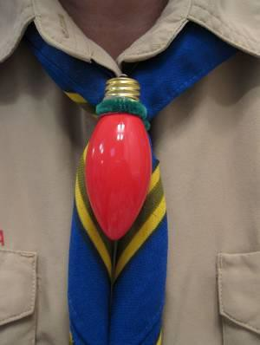
Materials:
8 inches of green chenille stem
1 C9 replacement bulb for Christmas lights
Loaded hot glue gun Sharpie marker

- Make a loop in the middle of the 8-inch chenille stem and form it tightly around the base of the light bulb where the glass meets the metal.
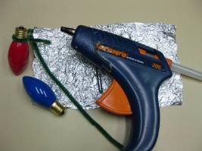
- Remove the stem and apply hot glue around the base of the bulb and quickly replace chenille stem. Be careful! The glue is hot!
- After the glue cools, give the chenille stem a hard twist tight against the bulb and add another drop of glue to the twist to hold it.
- Add your name and date and you are ready to go!

Flickering Candle Slide

Materials:
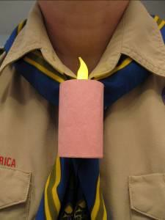
Battery operated L.E.D. flickering candle tea light
Paper towel or toilet paper roll cardboard tube Construction paper- white for a Menorah candle, red, black or green for a Kwanzaa candle or pink or yellow for a birthday candle 1/2 of a chenille stem, preferably the color of your “candle”
Scissors Ruler Pencil
Exacto Knife or awl Loaded hot glue gun White glue
Rubber band

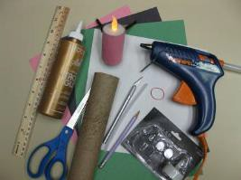
- Mark and cut the cardboard tube 2 ½ inches long. Be careful not to squish your tube. (Any longer and you can’t reach in and turn on your flame)
- Slit the tube lengthwise, from top to bottom. You need to do this so that you can tightly wrap one end of the tube around the base of the candle tea light.
- Run a thin line of hot glue along the inside rim of the cardboard tube at one end and quickly roll tightly around the candle base. Hold until the glue has set. Add more glue to the overlapped cardboard to hold the side together.
- Measure and cut construction paper to wrap around “candle”. Glue and use a rubber band to hold until the glue sets.
- Form the ½ chenille stem into a square bottomed “U” shape. The base should be about 1 inch wide. Glue perpendicular to the back seam of the candle about 1 inch down from the top. Add your name and the date, turn on your candle and voilà!

GAMES

After You
Materials: Dishes of yogurt or dry cereal, spoons, string
- Divide players into pairs. Partners sit facing each other with a small table, chair, lapboard, etc., between them.
- Give each pair two spoons joined together with a length of string so spoons are only six inches apart.
- Place a dish of yogurt or dry cereal in front of each person.
- On signal, everyone starts to eat.
- Each person must eat only from his or her own dish and must not lift the dish off the table.
- The pair finishing their dishes first wins.
- Encourage the players to use good table manners.

Balloon Round Up
Supplies: You will need a large barrel or box and one balloon for each Cub Scout. Each den has balloons of a different color from every other den. The barrel must be too small to hold all the balloons.
  - Place the barrel in the center of the playing area and line up equal numbers of Cub Scout by dens on opposite sides of the room.
  - On signal, the Cub Scouts put one hand behind their backs and with the other hand, try to tap the balloons in the air and into the barrel.
  - When the barrel is full, stop the game and count the balloons in the barrel by color.
  - The winning den is the one that got the most balloons into the barrel.

Candle and Straw Relay Race
Materials: 1 candle and a box of matches per team and 1 drinking straw per team member
- Each team member is given a straw.
- They have to race to the opposite end of the hall where their candle and box of matches is located.
- They must light the candle and then blow it out by blowing the flame through the straw.
- This can also be played in subdued lighting.

Candy Bar Game
As our families run here and there, little time is spent together. This game gives your family an opportunity to gather together and have FUN!
Objective: Each person tries to get as many candy bars as they can.
Materials: 1 Candy bars for each player or couple
1 brown lunch sack for each player or couple Timer, Wood die
Bowl, Good Attitude
Timer: Set timer in another room, so no one can watch to see how much time is left. A stop timer is perfect. Most families play for about a half-hour. After playing a few times, you will know how much time needs to be adjusted. It’s fun to vary the time from each game to keep them off guard.
Preparation: If using this game for a party, assign each person to bring two candy bars. Take the candy when they arrive. One person (mother, father, or party leader) places two candy bars in a brown sack. Fold down the top of each sack the same. If there are extra bars, place them in a bowl. Place a mark, (x) on the bottom of one of the bags.
Starting the game:
  - Have everyone gather in a circle.
  - Place bowl inside the circle.
  - Each person or couple picks a sack out of the center.
  - Explain that each sack contains two candy bars and no one is to look until directed to do so.
  - Each person looks into their own sack but does not tell what kind of bars they have.
  - Everyone closes their bag. Players may look inside any sack that is their own during the game.
  - Who goes first? The player with the mark on the bottom of their sack. That player rolls first then follows to the left.
Roll Die: A player has to follow what has been rolled.
  - Take the Bowl: If rolled the player takes all the bars.
  - Trade sacks: Player picks another player to trade sacks with. Remember: You want the most candy
  - Lose a turn: Lose next turn.
  - Add Bar to Bowl: The player takes a bar from his sack and adds to the bowl. Don’t let people know your sack is empty. This might help out when trading. If you receive an empty sack don’t say anything. Just hope you can pass is off
  - Double take: A player who rolls this takes one bar from the players on his left and right. If the player is out of bars, you’re out of luck.
  - Guess a Bar: Players need to watch bars and sacks as they are exchanged.
When rolled a player says a person name and tries to guess the candy bar in their sack. The players only need to answer with a yes or no. If the player asked has the bar, they must give it to the roller.
Ending the Game: When the timer goes off everyone keeps the sack that they end up with. If a player has rolled the die when the timer goes off, that player may complete his turn. At this time any bars left in the bowl must be rolled for.

Candy Cane Pass (Relay Race)
Supplies: 4 candy canes per team (have several extras in case of breakage)
Play:
- The first player of each team holds 4 candy canes, one between each of their fingers on one hand.
- On ‘Go!’ they pass the candy canes to the next teammate in line – no using of the other hand to help!
- The relay continues down the line, teammate to teammate, without dropping the candy canes.
- If any candy canes are dropped, the relay starts over for that team.
- The first team to complete the relay wins.

Christmas Card Match-Up
Equipment: Several old Christmas cards cut diagonally into two, and divided into two carrier bags with one half of each card in each bag.
Setup:
- Take one bag and spread its cards in various places around the hall.
- Players are divided into two teams.
Game Play:
- Give one half-card to the first player of each team.
- Each player goes off to find the matching half and bring it back to their team.
- The next player is given another half-card.
- Play continues until all cards are matched.
- The team with the most complete pairs collected at the end wins.

Dreidel Games

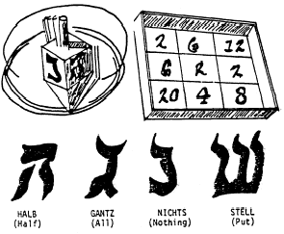
The Dreidel Game is played by making a game board from a large box top which has been squared off with appropriate numbers in each square. Each player spins the dreidel and adds or subtracts his or her score depending upon which side of the dreidel faces up and on which number it rests.
For example, if the dreidel faces up Stell on 20, the player loses 20. First player to accumulate 25 points is the winner.
The Put-Take-Nothing Game begins with each player receiving an equal amount of small candy, raisins or nuts. Each player puts one item into a "pot", or "kitty", and the players spin the dreidel in turn. Scoring is the same as in the Dreidel Game. When a player gets "Gantz", or all, each player puts in another item to make a new "pot". The game ends when one player has accumulated all of the items.
Hide the Dreidle (Hanukkah top) one Cub Scout leaves the room. The others hide the dreidle. The Cub Scout returns. The others yell "hot" and "cold" depending on whether they are near or far. You can use real or paper dreidle.
Pass the Dreidel Cubs sit in circle, start music. Pass the top around the circle. When the music stops, the Cub holding the dreidel drops out. Last Cub is the winner.
Dreidel Game
  - Players from the Red Caps and the Green Caps take
turns in being blindfolded, turned about, and given an opportunity to bring the sack down with a swipe of the wand.
  - If a Red Cap brings down the sack, then his teammates are privileged to scramble for the contents.
  - If it is brought down by a Green Cap, only the Greens have the privilege.
  - Players are not allowed to coach a contestant.

“Dreidel, dreidel, dreidel, I made it out of clay…” Even if you’re not Jewish, the odds are that this catchy little song has gotten stuck in your head at least once—and even if you are Jewish, you probably weren’t aware that the word “dreidel” is derived from the German “dreihen,” meaning “to spin,” and that dreidels originated in a popular Yiddish gambling game. Here’s how to spin your dreidel the modern way.
Things You'll Need
Dreidels
Chocolate candies wrapped to look like coins or Candies, Nuts, raisins, or other items for tokens
Steps
Step One Assemble a kitty. The stakes in a dreidel game aren’t money, but tasty snacks—Hershey’s Kisses, raisins, M&M’s, or (traditionally) Chanukah gelt, that is, foil- wrapped chocolate coins. Distribute the kitty equally among the three, four, or more players in the game. Each player puts one of his “tokens” in the center of the table, creating the dreidel “pot.”
Step Two Have each player spin the dreidel in turn. If you look closely at the dreidel, you’ll see that each of its four sides is decorated with a different Hebrew letter: nun, gimel, hey, and shin—which supposedly stand for the Hebrew phrase meaning “A great miracle happened there.” (Actually, these letters derive from the words inscribed on the Yiddish precursor of the dreidel, but there’s no harm pushing this myth on kids.)
Step Three The rest of the game proceeds as follows: if the player spins a “Nun,” they collect nothing (“Nisht” in Yiddish) and yields to the next player. If they spin a “Gimel,” they win the entire pot (Gimel stands for “Gesht,” which is Yiddish for “get.”) If they spin a “Hey,” he gets half the pot (“Halb” in you-know what), and if they spin a “Shin” they have to put one of his own pieces in the pot (“Shin” derives from the Yiddish “Shtel,” meaning “set.”)
Step Four If a player manages to collect all the items in the pot, she is the winner. However, it’s possible to prolong a dreidel game indefinitely (or at least until dinner is ready) by giving other players candy "loans."
Tips & Warnings - Playing the dreidel game with real money is discouraged, but occasionally adults will agree to fund the kitty with small coins if the players agree to contribute all of their winnings to charity.

Fill Santa’s Sack
Divide players into two or more teams. Place the teams at opposite ends of the room. Give each team a scarf of one color for the team (blue for one team, gold for another, etc.), and a big garbage bag. Scatter equal numbers of each color of inflated balloons around the floor in the center of the room. On a signal, each team runs in and fills its sack with as many balloons of its color as it can in the time allowed. Remind them that broken balloons don’t count.
Filling Santa's Pack
What you’ll need:
- A balloon for each player, color-coded for each team
- A large barrel or trash can
Set Up:
- Form two den size groups and line them up on the opposite sides of the room.
- Give one team balloons of one color; give the other team a contrasting color.
- Ask them to blow up their balloons and tie them.
- In the center of the room, have a large container - but not one large enough to hold all the inflated balloons.
Action:
- On signal, have all the Cub Scouts try to tap their balloons into the barrel with one hand behind their back.
- When the container is full, stop the game.
- The team with the most balloons in the container wins.

Fumble Fingers Relay
Materials: 2 jars with screw on lids, 10 toothpicks, 2 pair of large mittens
Directions: Each team has a pair of large mittens. At a goal line is a jar, one for each team containing five toothpicks. On signal, the first person from each team races to the goal line, puts on the mittens, removes the lid, empties the jar, picks up the toothpicks and puts them back in the jar and screws on the lid. They take off the mittens and races back to hand them to the next player, who repeats the action.

Hanukkah Games
Hide the Dreidle (Hanukkah top) one Cub Scout leaves the room. The others hide the dreidle. The Cub Scout returns. The others yell "hot" and "cold" depending on whether they are near or far. You can use real or paper dreidle.
Hanukkah Peanut Hunt Buy package of peanuts. Write K on 4, H on 4, N on 4, U on 4 and A on 4. Hide all the peanuts, lettered and unlettered, hunt for 5 minutes.
10 points for greatest number
5 points for each lettered peanut
20 points for a Cub Scout finding enough to write HANUKKAH
Pass the Dreidel Cub Scouts sit in circle, start music. Pass the top around the circle. When the music stops, the Cub holding the dreidel drops out. Last Cub Scout is the winner.

Hide the Dreidel, Ornament, or Holiday related item
Cub leaves the room. The others hide the item. The Cub returns. The others yell "hot" and "cold" depending on whether they are near or far.
Holiday Handshake
Call the Cub Scouts to attention and give each five Holiday stickers or candy canes. On signal, each Cub Scout is to introduce himself to five parents other than his own. Each time they must leave a sticker or candy cane with them. (Parents do not accept it until the introduction is complete and Cub Scout can repeat the parent’s name.) The first Den to complete the project assembles as a Den and reports to the Cubmaster. Give them a cheer or two.

Holiday Peanut Hunt
Buy package of peanuts. Write the letters for a holiday related word on some of the peanuts (e.g. K on 4, H on 4, N on 4, U on 4 and A on 4).
Hide all the peanuts, lettered and unlettered, Hunt for 5 minutes.
Award –
10 points for greatest number of peanuts, 5 points for each lettered peanut
20 points for a Cub finding enough to write the word (e.g. HANUKKAH)

Icicle Hunt
Needed are pieces of string in different lengths. Hide the icicles (string) have the Cub Scouts look for them. The winner is the player whose strings form the longest icicle when laid end to end, not the player who collects the most string.

Ice Cube Race
Materials: A bag of ice, two spatulas, four containers
Directions: Place ice in two of the containers. Place the other two containers a fair distance away. Object of the game is to move the ice from one container to the other, by using the spatula. Cub Scouts must pick up an ice cube with the spatula and run to the other container and deposit the ice cube. First team to have all the ice in the opposite container wins.

International Games
Bivoe Ebuma (Clap Ball), Cameroon, Africa
Divide den into two teams. Teams line up parallel and facing each other six feet on either side of a center line. The two teams toss a small rubber ball back and forth. No player may step across the center line. When the ball is caught, the catcher must clap their hands and stamp their feet once. If a player forgets to clap and stamp, a point is scored against their team. Keep the ball moving fast.
Catch the Dragon’s Tail, Taiwan
Two single lines are formed with each person’s hands on the shoulder of the person in front of him.
Until the signal “GO” is given, the dragons must each remain in a straight line. The starter begins the countdown - “Em-Er-San-Ko!” or “I-2-3-GO!” The “fiery head” of each line then runs toward the “lashing tail” and tries to catch the last man. The whole dragon body must remain unbroken. If anyone lets go, the dragon’s body is broken and the dragon dies. A new dragon must be formed with the head becoming the tail and the next in line having a turn at being the head. If, however, the head player touches the tail, they may continue to be the head.
Ringalevio, USA
Ringalevio is a variation of Hide and Seek. There are two teams, runners and chasers. Chasers stand inside a circle (base), eyes closed counting to 100 while the runners hide in the area. The chasers begin to hunt and when a runner is caught, the chaser shouts “Ringalevio.” The runner is then taken to base. The idea is to capture all runners, but a speedy runner can save their friends by stepping inside the circle (without being caught). When all runners are captured, change sides.
Coyote and The Sheep, USA
One Cub Scout is the shepherd, one the coyote and the rest are sheep. The shepherd and the sheep form a line, hands clasped around waist of the Cub Scout ahead, with the shepherd in front. As the coyote approaches, the shepherd asks, “What do you want?” The coyote replies, “I want fat meat!” The shepherd calls, “Then go to the end of the line where the fattest lambs are.”
The whole line of sheep still holding onto each other begins to run away. The coyote gives chase, trying to tag the last sheep in line. When the coyote tags the last sheep, the shepherd becomes the coyote, the next Cub Scout in line becomes the shepherd, the coyote goes to the end of the line.
Chef Manda (The Chief Orders), Brazil
One Cub Scout is the Chief and stands in front. When they say, “The Chief orders you to laugh,” all other players must laugh. If they say, “He/She orders you to laugh,” no one should laugh because all valid commands are prefaced by “The Chief”. A player who does not obey proper orders is eliminated.
La Canasta (The Basket), Brazil
The players sit in a circle. Each is assigned the name of a different fruit. “IT” stands in the center and says, “I went to the market and bought some pears and grapes (or other fruit).” The players assigned the fruit “IT” mentioned try to change places while “IT” tries to sit down in one of their places. The one left standing is the next “IT”.
Cherry Chop, France
This is usually played with cherry pits at harvest time. You can use pebbles or marbles.’ Place a shallow bowl about two feet in front of a line of Cub Scouts. Put one pebble or marble in it and give each player 5 or 10 others. In turn, each uses their pebbles to try to knock the pebble out of the bowl. If they succeed, they keep it and the leader-places another pebble into the bowl. If a player misses, they must put one of their pebbles in the bowl. Winner is the one with the most pebbles at the end of the game.
Pebble, Greece
(6 to 20 players) One player is chosen to be “IT” and is given a small object to hold in their hand (marble, washer, small ball, pebble, etc.) The others stand in line with hands out, palms together and palms up. “IT” selects a goal IO-30 feet away beyond the line of players. They walk along the line and pretends to drop the pebble into each player’s hand. Somewhere along the line, they actually drop the pebble into a player’s hand.
When a Scout gets the “pebble”, they triy to reach the goal and back to “IT”, who remains on the horizontal line. The player on their right attempts to catch the Scout with the pebble. If the runner succeeds in reaching “IT” without being caught, they become “IT”. If they are caught, the one who catches him becomes “IT”. The Scout who receives the pebble may choose their own time to run, but must start before “IT” reaches the end of the line.
Palito Verde (Green Stick), Greece
“IT” carries a green stick (a neckerchief may be substituted). The other players form a large circle, facing inward with their hands behind their back. “IT” travels around the circle and at some point they place the stick or neckerchief in the hands of a player. That player immediately races after “IT” around the circle. If “IT” is tagged before “IT” can get to the chaser’s old place in the circle they remain “IT”. If “IT” reaches the space safely the chaser becomes the new “IT”.
Scoop Lacrosse, Canada
Lacrosse was played by Canadian and northeastern U.S. Indians. In this variation, lacrosse “sticks” are scoops made by cutting plastics, gallon size bottles. Use a soft rubber ball of about baseball size.
Goals may be two large cartons of the same size or you can set up 5-foot square frames at opposite ends of the field for goals.
Teams try to get the ball into their opponent’s goal. Players may pass the ball or run with it but may not touch it with their free hand. A player may try to knock the ball out of an opponent’s scoop with their own scoop.
Score one point for each goal.

Mailing Uncle Henry’s Package
Begin by saying that Uncle Henry cannot come home for the holidays and his gift must be mailed. Have the Cubs form a circle and place their hands behind them. With eyes blindfolded, pass the articles needed to mail the package around the circle. Begin with the gift (gloves or tie) and then the box, wrapping paper, ribbon, mailing paper, string, sticky tape, mailing label and stamp. After all things have been passed around, put them away. The Cub Scouts are unblindfolded and asked to write down all the things they remember that they felt. The one remembering the most is the winner.

Merry Christmas! A Pantomime Game
Players sit in a straight line. "It" stands in front of one player. This player asks "It", what would you like for Christmas?" "Can you guess" answers "It". They then makes some motion that will show what they want for Christmas. They may pretend to blow a horn, pat a kitten or puppy, or kick a football. If the player guesses correctly, "It" says "Merry Christmas" and that player becomes "It". If they guess incorrectly, "It" stands in front of another player.
You can say "Happy Hanukkah", "Happy Birthday" or whatever happens to be appropriate when you play this game.

Mitten Match Game
A Memory Game
- Make several copies of mittens and have children color each pair to match each other but be different from the other pairs of mittens.
- Cut them out,
- Then turn all mittens upside down and
Have the children take turns finding the mates. (aka Memory or Concentration)

Pass the Dreidel, Ornament, Holiday related item
Cubs sit in circle. Leader starts music. Cubs pass the item around the circle. When the music stops, the Cub holding the item drops out. Last Cub left is the winner.

Pack of Toys
All players except one are seated in a circle facing inward. Each seated player is given the name of a toy. "It" walks around the inside of the circle and says "SANTA PACKED HIS BAG AND IN IT HE PUT ".
Players representing the toys "IT" names get up and follow him around the circle. Suddenly "IT" shouts, "AND THE BAG BROKE!" All scramble for chairs including "It". The Cub Scout left without a chair becomes the new "IT".

Pass the Present
You will need a small box wrapped in ten or more layers of wrapping paper (or tissue paper or newspaper). You will also need a source of music. The players sit on the floor in a circle with one player holding the present. When the leader starts the music, the players pass the present around the circle as quickly as possible. When the music stops, the player holding the present unwraps one layer of paper.
Continue in this way until the present has been completely unwrapped. If desired, you may include a small “prize” in the box for the fortunate player who removes the last layer of wrap.

Pin the Hanukkah Candle
What you’ll need:
- A poster-size menorah
- A cardboard candle for each player
Set Up:
- Draw a menorah on a large sheet of cardboard and tape it to the wall.
- From lightweight cardboard, cut out a candle for each player.
- The candle represents the shammes or candle used to light the eight Hanukkah candles.
- Put a pin through the flame of each candle.
Action:
- Blindfold a Cub Scout and turn him around three times.
- He then tries to pin their shammes on any of the menorah's candles.
- The one who comes closest, wins.

Santa’s Bag
(Touch and tell) Number 10 paper bags from 1 to 10. Put a familiar article in each bag (preferably an article related to Christmas). and staple bag shut. Each Cub Scout is given pencil and paper on which they list numbers 1 through 10. They try to guess what is in each bag by feeling through the paper, and records on his paper. Cub Scout with greatest number of items guessed correctly wins.

Santa's Helpers
This game is a race to see which team of two can wrap a package securely first. The trick is that each team member must hold one hand behind his back, so it is very important to be able to work together. Give each pair a box, a roll/sheet of wrapping paper, tape, and a bow. Have a judge on hand to name the winning pair.

Santa Nods
- Santa is in the center of a circle made by the other players.
- Santa points at any player and says, "Santa says yes" or Santa says no".
- That player must quickly nod "yes" or shake their head "no".
- If Santa says only "yes' or "no" without first saying "Santa says", the player must not respond. If they do, they are out of the game.
- Santa should give commands quickly.
- The last person still in the game becomes the new Santa.
- Santa Says (aka Simon says)
- Pretend to cut down a Christmas tree
- Say Merry Christmas
- Throw a snowball
- Say Ho, Ho, Ho
- Jump down chimney
- Stuff stockings
- Drive a sleigh
- Feed reindeer
- Build a snowman
- Tip toe like Santa across a room
- Wrap a present
- Drink egg nog
- Dance like a snowflake
- Laugh (like a bowl full of jelly)
- Rub your beard
- Check the naughty or nice list
- Carry a bag of toys
- Put presents under a tree
- Hang up mistletoe
- Kiss mommy
- Say Now Dasher
- Lick a candy cane
- Eat cookies
- Hang an ornament
- Hang a wreath
- Ring a bell
- Melt like an elf
- Sneak like an elf
- March like a nutcracker
- Run like a gingerbread man
- Waddle like a penguin
- Fly like an angel

Santa Trip
Players sit in a circle. The first player says, “On Christmas Eve, I’m traveling with Santa and I’m going to visit (name a place starting with an “A”) and delivering a (name an object starting with “A”).” The next player repeats the first place and object and adds a place and object beginning with “B”. Continue the game through the alphabet alternating places and objects.

Snowball Drop
Equipment: White Ping Pong ball, table.
Setup:
- Divide the participants into teams of 3-6.
- Each team kneels on opposite sides of a table.
Game Play:
- The object is to blow a “snowball” (ping pong ball) so that it will ‘drop’ off the edge of the table on the opponent's side.
- This scores one point. No one is allowed to touch the snowball or the table in any way.
- First team to score three points wins.
- Repeat play for the other participants, as needed.

Snowball Fight
This is an oldie, but a goodie. Designate an area and determine the turf for each of the teams. This can be halves of a room or even quarters of a room. Provide old newspapers or scrap 8½ x11” copy paper to each team with instructions that they are to crumple them up, piece by piece (you may want to pre-tear the pages in half) to make snowballs and then throw them at another team. After a set time, the team with the least number of snowballs on their turf is the winner. Everyone helps clean up and make sure they all wash the newsprint off their hands!

Snowball Relay
Players divide into two teams and line up behind starting line. Give each team a "snowball", either Styrofoam or cotton and a piece of cardboard. On signal, first player on each team tries to move ball across floor and back by fanning it with cardboard. Player may not touch snowball with hands or cardboard. First team to finish is winner.

Snow Blowers
Before the game, have each Cub paint and decorate a paper towel tube (snow blower). You will need to attach large cups to the long edges of the table, making sure the cup lips are level with the table surface. Fill each cup halfway with small prizes (candy, erasers, etc.) and clear the chairs away from the table. Pair up the Cubs and have them on opposite sides of the table (maybe do 2 pair at a time). Place a ping-pong ball on the table between each pair and let them blow through their snow blowers. If the ball goes off the table, place it on again. Once a Cub gets his ball into one of the cups, they may select one prize. Then the next pair of Cubs plays. Play continues until every Cub has won at least one prize.

Snow Clothes Relay
Materials: Two outfits of outside clothing (i.e. coats, mittens, boots, snow pants, scarf, hat, etc.), two paper bags. (Adult sized clothing makes this really funny)
Directions: Place the clothing in two bags. One team member must run across the room put the clothes on in order of receiving them out of the bag. Then run across the room and take it all off, for the next player to put on. First team to have all players finish, wins the game.

Snowball Race
Materials:
- A container of small marshmallows per team
- A plastic spoon
- An empty container per team
Set Up:
- Players set in lines of equal length; 6 players per line.
- A container of marshmallows is placed in front of each line and an empty container is placed beside the player at the end of the line.
- Each player is given a small plastic spoon.
Action:
- On signal, the first player takes one marshmallow in their spoon and transfers it to their neighbor's spoon and so on down the line.
- The player at the end of the line receives the marshmallow and places it in the empty container and yells "It's a hit!"
- This is the signal for the first player to start the next marshmallow down the line.
- Any marshmallow that is dropped must be replaced on the spoon by the person who dropped it before it can be passed along.
- The team getting all their marshmallows into the container first, wins.

Snowball Throw
Use a large Styrofoam ball. The Cub Scouts are seated on the floor. “It” sits in the center of the circle. The Cub Scouts throw the snowball to each other while “it” tries to intercept. When they succeed, the Cub Scout who threw the snowball becomes “it”.

Snowmelt
Everyone turns into a snowman and at the signal "the sun comes out," the snowmen begin to "melt down" to the floor - the last one to melt completely (stretch out on the floor) is the winner. Rule: keep moving at the same time.

Snowshoe Relay
Divide den into two teams. Give each team two show boxes, and set up a chair across the room for a turning point. On signal, the first player on each team puts on his "snowshoes" and races around the chair and back to the starting line where the next player dons the boxes and races. Continue until all have run. Have an extra "shoe" on hand if any break upright. If necessary, spread or pipe a little extra icing along either side to help support it. Take an end wall and ice both the side edges. Spread or pipe a line of icing on the board at a right angle to the first wall, and press the end wall into position. Repeat this process with the other two walls until they are all in position. Leave the walls to harden together for at least two hours before putting on the roof. Spread or pipe a thick layer of icing on top of all the walls, and fix the roof pieces in position; the roof should overlap the walls to make the eaves. Pipe or spread a little icing along the crest of the roof to hold the two pieces firmly together. Leave overnight to set firmly.
When ready to decorate, make the remaining icing. In a large bowl, lightly whisk 4 egg whites, and mix in remaining confectioners' sugar as before. Use this to make snow on the roof, and to stick various candies for decoration. Finish with a fine dusting of sifted confectioners' sugar.

Star Markers
Give each Cub Scout a 5: square of paper. At the signal, each player rips the paper, trying to make a five-pointed star. Judge calls time after 30 seconds, whether the star is finished or not. Best one wins.

S T O P
You will need: 2 sets of large cards - there are four cards in each set and the letters on the cards spell S-T-O-P.
You get up eight people and stand four on each side of you facing the audience.
Directions:
- Give each team member one of the cards from their set of STOP cards.
- To start with they should spell out STOP as viewed from the audience.
- The idea is that they have to rearrange themselves to spell out the word that you tell them.
- The first team to finish each word is the winners. The words you can have are STOP,
- TOPS, POST and SPOT. There is lots of room for fun here, try telling them to spell a word they are already lined up spelling and see what happens.

Tree Decorating
Players are seated in rows with an equal number in each row. They are numbered consecutively from front to back and each No. 1 is given a piece of chalk. On signal, No. 1 players run to a blackboard and draw the base for a Christmas tree. (can use poster board) They return to their seats and hand the chalk or crayon to the No. 2 player,
who must draw the branches. No. 3, the candles. No. 4, certain number of ornaments. No. 5, add star to top of the tree. No. 6, write Merry Christmas under the tree. Team to complete their picture first wins.

Trim the Tree
- Line up the dens for a relay.
- Attach large sheets of paper to the opposite wall and give each Cub Scout a different colored crayon.
- On signal, the first Cub Scout to their paper and outlines a Christmas tree.
- Then the next Cub Scout runs up and draws in a stand.
- The others draw ornaments or lights.
- The first team to trim its tree wins.
Variation:
- Have an adult by the poster paper with a stack of cards
- On each card is one item to be drawn
- As each Cub Scout arrives, they pick a card and draw the item listed on it.
- This may mean ornaments are drawn before the tree
- The results are usually interesting

Unscramble the String Lights
(aka. Tangle Knot)
Directions: Everyone stands in a circle. Each Cub Scout reaches in with their right hand and joins hands with someone NOT standing next to him. The repeat with left hands. Do not join both hands with the same person. Working as a group, try to untie the string of lights without breaking any grips. Hands may be rotated but should never lose contact. This can test the flexibility of the players/string. If the group is hopelessly tangled, the leader may break apart one set of hands and join somewhere else. If successful, the group will end up in an untangled circle.

What Does the Snowman Say? Nothing
What you’ll need:
A hat, preferably a bowler hat and a scarf
Set Up:
One Cub Scout, the snowman, dressed up in the hat and scarf, stands stiffly facing the group. They must not respond in any way - by giggling, moving or speaking.
Action:
- The object of the game is for the other Cub Scout to get a reply to their questions, such as "What's your middle name? Who's your best friend? Do you like ice cream?" or to make the snowman laugh by making faces. No touching is allowed.
- Establish a short time limit and play several times. Any Cub Scout who gets a response from the snowman becomes the next one.
- Finish up with SNOWMELT: everyone turns into a snowman and at the signal "the sun comes out," the snowmen begin to "melt down" to the floor - the last one to melt completely (stretch out on the floor) is the winner.
- Rule: keep moving at the same time.

What’s Wrong with Christmas?
Holiday Kim’s Game
- This is a good quiet game for use at Den meetings. On a table or tray place a number of Holiday (Christmas, Hanukkah, Kwanzaa) type objects, such as a candy canes, bells, sprigs of holly, etc.
- Scatter through these a number of objects, which are not a part of Christmas, such as Halloween mask, green shamrock, red heart, hard-boiled egg, etc.
- Cover all objects until time to play the game;
- Then remove the cover and give Cub Scouts two minutes to look at all the objects.
- Recover the objects, and give each Cub Scout a pencil and paper.
- Ask them to write down all non-Holiday (non- Christmas, non-Hanukkah, non-Kwanzaa) items.
- Cub Scout with longest list wins.

Who Stole the Cookies?
Cubs sit in a circle and are numbered.
They start to alternately slap their own knees and then clap hands with the Cubs on each side of them.
The Cubs chant: Who stole the cookies from the cookie jar?
The Leader chants: Number (i.e. 5) stole the cookies from the cookie jar.
Number responds: Who me? All reply: Yes, you! Number 5 chants: Couldn’t be! All reply: Then who?
Number 5 replies: Number (i.e. 12) stole the cookies from the cookie jar!
Number responds: Who me?
And the game goes on -
The idea of the game is to keep the, rhythm of slaps and claps going, while continuing the chant with new number being called each time. As the Cubs get used to the game, the leader can speed it up.

THEME RELATED STUFF

TRADITIONS
Christmas on December 25
Celebrations during the mid-winter season were common, even before Christmas was celebrated on December 25. Christmas was once a moveable feast celebrated many different times during the year. Pope Julius I made the choice of December 25 in the fourth century AD because this coincided with the pagan rituals of Winter Solstice, or Return of the Sun.
The intent was to replace the pagan celebration with the Christian one. In 1752, 11 days were dropped from the year when the switch was made from the Julian calendar to the Gregorian calendar. The December 25 date was effectively moved 11 days backwards. Some Christian church sects, called Eastern Orthodox, still celebrate Christmas on January 7 (previously Dec. 25 of the Julian calendar).
Many of the traditions associated with Christmas (giving gifts, lighting a Yule log, singing carols, decorating an evergreen) hark back to older religions.

The Origin of the Kettle
In December of 1891, a Salvation Army Captain in San Francisco had resolved to provide a free Christmas dinner to the area's poor persons. But how would he pay for the food? As he went about his daily tasks, the question stayed in his mind. Suddenly, his thoughts went back to his days as a sailor in Liverpool, England. He remembered seeing passersby at Stage Landing place their charitable contributions into a large pot they called "Simpson's pot." The next morning, he secured permission from the authorities to place a similar pot at the Oakland ferry landing at the foot of Market Street. No time was lost in securing the pot and placing it in a conspicuous position so that all those going to and from the ferryboats could see it. In addition, a brass urn was placed on a stand in the waiting room for the same purpose.
Thus, Captain Joseph McFee launched a tradition that has spread not only throughout the United States but also throughout the world.
Now kettles are used in Korea, Japan, and Chile and in many European countries. Everywhere, public contributions to the kettles enable the Salvation Army to bring the spirit of Christmas to those who would otherwise be forgotten - the aged and lonely, the ill, inmates of jails and other institutions, the poor and unfortunate. In the United States, the Salvation Army annually aids more than 7,000,000 Americans at Thanksgiving and Christmas. Kettles have changed since the first utilitarian cauldron set up in San Francisco. Some of the new kettles have such devices as a
self-ringing bell and a booth complete with a public address system that broadcasts traditional Christmas carols.
Behind it all, though, is the same Salvation Army message, "Sharing is Caring."
Hanukkah Ideas

Background
The holiday dates back 2200 years. Jews lived in Palestine, then occupied by the Syrians. Antiochus was the king of Syria. He wanted the Jews to accept the religion of the Greeks. Some did and some did not. Those that did not formed a band of loyal Jews. They were named the Maccabees. Mattahhis was their father, and Judah Maccabbee was their leader. After three years, the band captured Jerusalem, cleaned and repaired the Holy Temple.
They found a small cruse of oil to light the eternal light. However, there was only enough for one day and they sent for more oil. The small amount of oil lasted for eight days instead of one, until more oil was secured. This was considered the miracle, although the victory of the small ban over the Syrian Army was also considered a miracle.
Hanukkah is celebrated the 25th day of Kislev in the Hebrew calendar. It falls somewhere between Thanksgiving and New Year’s each year.
In homes, people decorate with paper products. They light candles each day. They start with one candle and the "shammus" which lights the other candles, and add one candle each night. They sing songs, eat potato pancakes and Hanukkah cookies. Also they exchange Hanukkah gifts and Hanukkah "gelt" (small amounts of money). They play games with the "dreidle" or top.

Hanukkah
Observed by millions of Jews around the globe, it commemorates the victory of faith over tyranny. Although Hanukkah is technically a minor Jewish festivity, it is a holiday for which Jews exchange gifts. Also, it is celebrated in the Jewish month of Kisiev, which usually falls in December. This combination has resulted in the misperception that Hanukkah is “the Jewish Christmas.” In fact this festival has a rich tradition and history of its own.
The Christmas Spider Legend
A long time ago in Germany, while a mother was busily cleaning house in preparation for Christmas, the spiders that usually stayed in the living room corner fled upstairs to the attic to escape from her broom. From the attic they could hear all the excitement from the living room as decorations were being made for when the Gift Giver was to come on Christmas Eve and bring gifts for the children.
Frantic to see the decorated tree, the spiders slowly crept downstairs for a view. Oh, what a beautiful tree! In their excitement, they scurried up the trunk and out along each branch. They were filled with happiness as they climbed all through the tree to see the glittering beauty. But alas! By the time they were through climbing all over the tree, it was completely shrouded in their dusty-gray spider web.
When the Gift Giver came, he smiled as he saw how happy the spiders were. However, he knew how heart-broken the mother would be if she saw the tree covered with the dusty webs. So He reached out and touched the webs, blessing them and turning them to silver and gold.
Thus, the custom to have a spider ornament amongst all other decorations with tinsel of gold and silver on the Christmas tree was born.
What Is Kwanzaa?
Kwanzaa is a special holiday that was created in 1966 by Dr. Maulana Karenga. Dr. Karenga wanted Black Americans to have their own holiday so they could celebrate their own unique history.
The words of Kwanzaa come from Swahili, a language that is from Africa. Swahili is special because no country can claim it as its own. Many different people all over Africa speak Swahili. Dr. Karenga chose it because it helps Black Americans remember that all of Africa their ancestral land, not just one area or one country.
The name “Kwanzaa” means “the first fruits of the harvest.”

HOLIDAY FUN FACTS
- Many people disapprove of the phrase Xmas – the original use was not disrespectful – it was based on X being the first letter of Xristos, the Greek name for Christ.
- King Richard II of England served 28 oxen and 30 hundred sheep at his 1377 Christmas feast!
- Rudolph the Red-Nosed Reindeer was written by Robert L. May as a promotion for Montgomery Ward. They distributed six million copies of the story between 1939 and 1946 alone. The song, written by Johnny Marks, came along in 1949.
- According to The Macaulay Institute in Aberdeen, Scotland, reindeer can haul up to twice their weight at speeds up to 15 miles an hour, making them great sleigh pullers.
- Over 70 million Americans give their dog or cat Christmas presents, according to an American Pet Association poll.
- “Jingle Bells,” one of the most popular holiday songs in America, was the first song ever broadcast in space, thanks to the crew of 1965’s Gemini 6 spacecraft.
- Frigg is the name of the Scandinavian love goddess who removed poison from mistletoe, bringing her son, Baldur, back to life. She was so happy, she made mistletoe a sign of love – so now people make “Kissing Balls” of mistletoe.
- The traditional Christmas ham began with the Norse custom of sacrificing and eating a pig to honor their god Freyr.
- When it's winter solstice in the Northern Hemisphere, the sun is directly overhead at noon only along the Tropic of Capricorn - Sao Paulo, Brazil, southern Madagascar, and areas north of Brisbane, Australia.

Edward Hibberd Johnson and the First Electrically Lit Christmas Tree
In 1867 retired 30 year-old Union Army General William Jackson Palmer headed west with his young assistant Edward Hibbert Johnson from their home in Philadelphia, mapping routes for the Kansas Pacific Railroad through New Mexico and Arizona to the Pacific Coast. In 1871 Edward H. Johnson, was sent back east to manage the Automatic Telegraph Company and he hired a young 24-year-old Thomas A Edison. Thus began a partnership that would last two lifetimes, Johnson’s and Edison’s. Johnson wrote of Edison: "He ate at his desk and slept in his chair. In
six weeks he had gone through the books, written a volume of abstracts, and made two thousand
experiments … and produced a solution."
Edward H. Johnson became Edison’s partner and trusted executive in Edison’s Menlo Park, New Jersey Company. On December 22, 1882, just three years after Edison’s successful experiment that created the light bulb, Edward Johnson invited some friends, and newspaper reporters to his home to see 80 walnut sized red, white, and blue light bulbs twinkling off and on the electrically rotating tree. This was the very first electrically lighted Christmas tree.
Though those first Christmas lights would be considered dangerous in our modern world, it was far safer than the lighted candles on a dead tree which had been used for centuries. From that first string of lights, the Holiday Lights we now enjoy today originated.

Holiday Traditions
Caroling, feasting, and gift giving along with the prayers and wishes - the Christmas is celebrated with high spirits all over the world. Though the mode of celebration, the dates and the traditions vary, the main spirit remains the same everywhere. For instance, the Christmas flower. If poinsettia is the Christmas flower here in United States, it is white rose in the British Isles. If gifts here and in Britain are given on Christmas, it is done on New Year in France and many other countries. While most of us celebrate it as a festive season spreading over a week, for some it is a month long festival that starts with the Advent on Sunday next to November 26 and ends on January 6 with the feast of Epiphany.

Winter Solstice
The Winter Solstice is the day on which suns rays reach the farthest south as the earth completes its 365- day orbit around the sun. That means that in the northern hemisphere, it is the darkest day of the year. Most cultures have a traditional celebration to mark this day, or, in the days following, to celebrate the gradual return of light to their dark world.
You can mark the beginning of Winter with a simple celebration of lights. Make Luminarias. Take a brown paper lunch bag and trace a simple pattern in pencil on one side. Try evergreen tree shapes, stars, or any other pattern. Punch out your design with a hole punch, spacing holes about ½” apart. Fill each luminaria with about 2 inches of sand and sink a votive candle or tea light in the center. Place the luminarias along a walk, patio, or deck. Have a grown-up light them and then bask in the glow.

Hanukkah
Hanukkah, or the “Festival of Light,” is celebrated by Jews all over the world. Hanukkah celebrates the taking back of the Temple of Jerusalem from the Romans over two thousand years ago.
When the Temple was destroyed, the lamp of the Eternal Light, which symbolized the continuation of the Jewish people, was snuffed out. Only enough oil to light the lamp for one day was found. But because of a “miracle,” the lamp burned for eight days – enough time for the temple to be rededicated.
Hanukah is celebrated with a menorah – a lamp holding eight candles – to symbolize this miracle. On each of the eight days of Hanukkah, a candle is lit.
There is no special feast, but traditional foods – especially latkes – are served. Latkes are fried potato pancakes. Friends and extended family are usually invited to the celebration, which usually includes the singing of Hanukkah songs.
Children sometimes exchange gifts and often receive “Hanukkah gelt,” or coins. They also play a game with a “dreidel,” or spinning top with four flat sides.
Paper Dreidel Items Needed:
A copy of the dreidel pattern from http://www.enchantedlearning.com/crafts/hanukkah/dr eidel/template.shtml
Scissors Glue
Crayons or markers
A straw or short wooden dowel
Optional: Thin cardboard (like from a cereal box)
Directions
Print the Dreidel pattern page from http://www.enchantedlearning.com/crafts/hanukkah/dr eidel/template.shtml
Optional: This step makes the dreidel sturdier (but it will be more difficult to cut out). Glue the printed template to a piece of very thin cardboard (like cereal box cardboard). Let the glue dry.
Decorate the dreidel, then cut along the edges. Cut an x in the tiny circle on the top
Fold along the inside lines, making a top shape. Glue the flaps inside the top.
Stick a straw or wooden dowel through the tiny circle at the top (push it gently to the bottom of the dreidel). Now you can play dreidel. Each player starts with about 20 markers (like chocolate coins, checkers, nuts, or raisins) and takes turn spinning the dreidel.
On each spin, the players put 2 markers in the center.
Do the following for each spin: nun - do nothing
gimel - take everything hey - take half
shin - put one in
The winner is the person who gets all the markers. Note: Nun, gimel, hay, and shin are the Hebrew letters used on the dreidel outside Israel (they represent the phrase, “A great miracle happened there.”) In Israel, the letters represent the phrase, “A miracle happened here.”
Simple Dreidel
Cut down a milk carton so that only the bottom two inches remain. Make a tiny hole in the center of the bottom of the carton through which a pencil can be poked.
Glue strips of blue paper to the sides of the carton and label each side with a letter: N (for nothing), G (for all), H (for half), and S (for put). Poke a pencil through the hole in the carton and practice spinning the dreidels.
Paper Cup Menorah Items Needed:
yellow and orange paint,
9 flat wooden craft spoons, fourteen 9-ounce paper cups.

Water Glass Symphony
Items Needed:
8 glasses of about the same size and shape, teaspoons,
water
Directions
- Paint the wider ends of the wooden craft spoons (fronts and backs) to resemble yellow-orange flames.
- Use a craft knife to cut a 3/4 inch slit in the bottom of nine of the paper cups.
- Cut the bottoms out of the remaining five cups and stack them rims down.
- Line up the nine cups in a horizontal row, placing the middle one atop the stack of five.
- When it is time to light the menorah, simply insert the bottoms of the wooden flames in the holes in the candles (cups).
- Decorate cups if desired

Kwanzaa
Kwanzaa is a non-religious holiday that celebrates African-American culture. It is based on various African harvest festivals. Kwanzaa lasts for seven days; it starts on December 26th, and ends on New Year’s Day. The word Kwanzaa means “first fruits” in Swahili. Maulena Karenga, an African-American scholar and activist, founded Kwanzaa in 1966.
During each of the days of Kwanzaa, family members gather to light one of seven candles. As each candle burns, the family discusses one of the seven principles (Nguzo Saba in Swahili) on which Kwanzaa is based:
- Unity (umoja), signified by the gathering of family, friends, and community
- Faith (imani)
- Purpose (nia)
- Collective work and responsibility (ujima) - the commitment to the high ideals of the African community
- Cooperative economics (ujamaa)
- Self-determination (kujichagulia)
- Creativity (kuumba)
Honoring the past (especially the history of Africa) and one’s ancestors is central to Kwanzaa.
On December 31, a Kwanzaa feast is enjoyed by family and friends. Maulana Karenga designed the feast to include the following:
- a straw placemat (mkeka),
- a holder for seven candles (kinara),
- candles (mishumaa),
- a variety of fruit (mazao),
- an ear of corn for each child in the home (vibunzi),
- a unity cup (kikombe cha umoja),
- modest gifts, especially for children (zawadi) More about Kwanzaa:
- Some communities collect food and clothing for the homeless during the seven days of Kwanzaa.
- On the seventh night, there is a feast to which friends and extended family members are invited. There are traditional foods, and cards and gifts are exchanged (although the giving of expensive commercial items is de-emphasized in favor of simple, handmade gifts). There is also singing and dancing.
- People greet each other with the Swahili expression “Habari gani,” which means “What’s new?” This is followed by a response that relates to one of the seven principles.

Kwanzaa Placemat
Make a place mat to decorate your Kwanzaa celebration table. These simple-to-make woven construction paper place mats represent a straw place mat (called mkeka in Swahili).
Items Needed:
Red, black, green, and yellow construction paper - one sheet should be extra large Scissors
Ruler (optional) Glue or tape
Directions
- Start with a large piece of construction paper.
- Fold it in half.
- While the paper is still folded, draw a series of lines across the fold, but do not draw them all the way to the edge - leave about 1 inch at the edge. For a very neat-looking place mat, use a ruler to draw the guidelines.
- Cut along the lines.
- When you’re finished cutting, unfold the piece of paper.
- Using other colors of paper, cut many strips of paper about an inch wide, and the same length as the height of the large piece of paper used in the last step.
- Start weaving the strips of paper onto the large piece of paper. Make sure that each new piece of paper is pushed up next to the previously woven piece.
- When you’re done weaving, secure each strip of woven paper using glue or tape.
- You might also have to trim the woven edges a bit to make the edges of the place mat even.
- You can now use your place mat at your Kwanzaa celebration table.

Kwanzaa Candles
Make candles (called mishumaa in Swahili) containing secret treats to decorate your Kwanzaa celebration table.
Items Needed:
toilet paper rolls (one for each candle), construction paper (black, green, red – for the colors of many African flags),
issue paper (orange and yellow), string or twist ties,
scissors, pencil, ruler,
glue or tape,
small treats to fit inside the candles
Directions
- Cover the toilet paper roll with construction paper (choose a different color for each candle you make) securing it with tape or glue.
- Cut two squares of tissue paper about 12 to 14 inches on each side and stack them on tope of each other.
- Offset the two papers so that you have 8 points. Then put your finger in the center of the tissue paper and gather the points up to form a cone-like shape.
- Gently push the center of the tissue paper into the toilet paper roll. The eraser end of a pencil may help.
- Fill the tissue-paper-lined tube with small treats.
- Use string or a twist tie to close up the tissue paper, then fluff it out a bit to make the “flames” of the candle.

Christmas in Germany
Santa Claus is known in different ways around the world. Boys and girls in Germany call him St.
Nicholas, and they have a special day for him on December 6. On the evening of December 5, he visits all German boys and girls in their homes and ask them questions about how well they are doing in their school work, whether they attend church regularly, if they behave well for their parents and teachers, and if they are lazy or slow in doing things they are asked to do around their homes. He visits them on his special day, December 6. All of the children leave one shoe out for St. Nicholas to either leave candy if they are good or twigs if they are bad.
Advent House
In German culture, beginning in the Black Forest, families make Advent Houses to count down the days until Christmas. Starting on December 1st, with the entire family present, a window in the house is opened. Behind each window is a scene depicting some aspect of the Christmas season. The candle in the center of the house is lighted, and its light shines through the cellophane window.
On December 24th, Christmas Eve, the front door of the Advent House is opened to reveal a scene illustrating the night before Christmas.
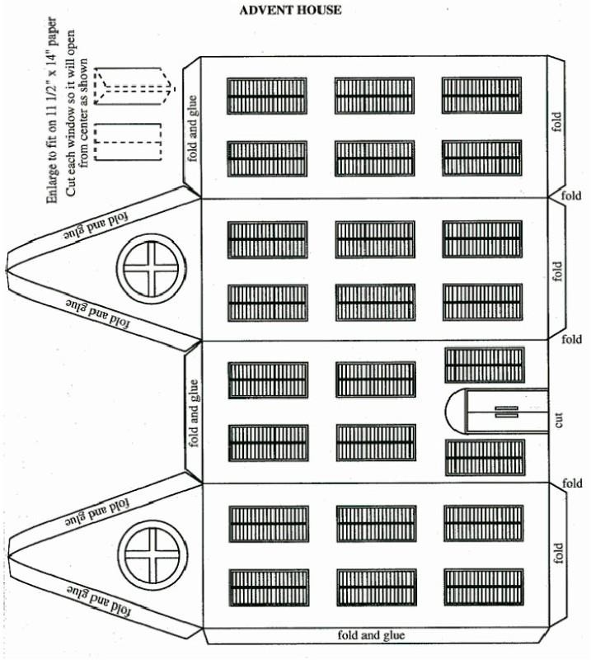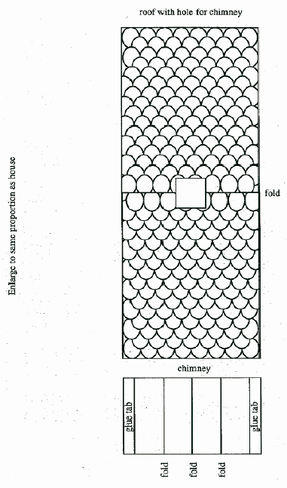

Directions
- Enlarge pattern to fit on 11”x14” paper.
- Trace pattern on tagboard.
- Cut open 23 windows and front door (an X-acto knife works well).
- Draw and cut out 24 pictures depicting Christmas to go behind windows and door.
- Door scene could be Santa or nativity scene.
- Cut cellophane to fit behind windows allowing a slight overlap for a place to glue.
- Glue cellophane in place.
- Glue picture on cellophane.
- Close shutters with a stick-on star.
- Fold house on fold lines.
- Glue on glue tabs.
- Cut out roof .
- You may color the roof and glue onto the tabs on the house.
- Or cut tongue depressors and glue them in the pattern shown, then glue roof onto tabs.
- Cut a slit in the roof for the chimney (see pattern).
- Cut, fold, and glue chimney according to pattern.
- Insert chimney in slit about one-half inch.

Advent Wreath
Advent is celebrated the four Sundays before Christmas. This is a time set aside to prepare for the coming of the Christ Child who brings gifts on the Eve of Christmas. German families have a circle of greenery with four candles in the center that sits in the middle of their table. The first week, one candle is lighted, the second week two candles, and so forth until all four candles are lighted, heralding the many lights of the Christmas tree which are to appear in but a few more days. Traditionally, purple (for repentance) candles were used, and more recently, blue (for hope).
Items Needed:
paper plate; scissors; green and yellow construction paper; violet, red, or white construction paper; yarn
- Fold the paper plate in half and cut the inside out leaving only the rim.
- Fold a piece of green construction paper in half and in half again the long way, then open the paper and cut on the lines.
- Then take each strip and fold it in half and in half again, then open and cut. This will make 16 rectangular pieces.
- Fold these 16 rectangular pieces in half once again, and draw the shape of a leaf on each piece.
- Cut the leaves out, and each piece will have two identical leaves. You may draw in the veins using pencil, crayon, etc.
- These leaves are then glued to the paper plate. Cut additional leaves as needed.
- Fold a half-sheet of violet, red, or white construction paper in half and in half again lengthwise, then open it and cut. The result is four long, rectangular shapes to be used as the candles.
- Yellow construction paper is used for the flames, following the same procedure as for cutting out the green leaves.
- Attach a piece of yarn to the back of the wreath for hanging.

Christmas Tree
The Christmas tree is another tradition that originated in Germany. In such a cold, wintry country, the evergreen was loved as a symbol of hope for the returning of the green of
summer. Trees were cut and brought inside where the boughs were decorated with lighted candles.

Pine Cone Christmas Tree
Items Needed:
Dry pine cones green glitter glue
sequins
paper star or star sticker tinsel
button or wooden disc
Directions
- Paint the pine cone with glue.
- Before the glue dries, sprinkle with green glitter.
- Top with a paper star.
- When the glitter and glue dries, you can glue on sequins or tinsel.
- Glue onto the button or wooden disc for a mini- Christmas tree on a stand.
- Or hang as an ornament by adding a ribbon.
Tips:
- If you cannot find open pine cones, place some in a 200 degree oven on a cookie sheet. They will open as they dry.
- Make a hole towards the top of the design. This is where you will hang the ornament. Using a nail, make indentations to decorate the cut-out. Attach a
string to the hole near the top. You now have great aluminum decorations for any occasion.

Christmas in the British Isles England
Throughout the month of December, people busy themselves preparing for the Christmas festivities. There are the mince pies and Christmas cakes to bake and decorate as well as the all-important Christmas pudding.
In England over the years many superstitions have surrounded this popular festive dessert. It is said puddings should be made by the 25th Sunday after Trinity, prepared with 13 ingredients to represent Christ and His Disciples, and that every member of the family take turns to stir the pudding with a wooden spoon from east to west, in honor of the Three Kings. A silver coin is always dropped into the pudding mixture before it is cooked. This is said to bring wealth, health and happiness to whomever is lucky enough to find it when the pudding is cut.
Children hang stockings on the fireplace or at the end of their beds so when Father Christmas pays a visit, they are stuffed full of goodies, but only if they have been good! Children also send letters to Father Christmas, which legend has it, if they are tossed in the fireplace, the smoke from them burning gets carried up the chimney directly to the man in the red suit!
In the days leading up to Christmas, groups of carol singers holding candle lanterns, dressed in their hats and scarves to fight off the cold, go from door to door performing traditional Christmas songs for a small charitable donation to their cause. On Christmas Eve night, children leave out a glass of brandy and a mince pie for Santa, and a carrot and bowl of water for the reindeer.

Ireland
The Irish celebrate very much like the English. In addition, in many areas, on Christmas Eve, a lit candle is placed in a window (nowadays it can be an electric light!). This goes back to traditions of hospitality in ancient times. The idea is to help light the way of the Holy Family or any other poor traveler who is out on that night.

December 26th is Boxing Day, also known as St. Stephen’s Day. It was a way for the upper class to give gifts of cash, or other goods, to those of the lower classes. There seem to be two theories on the origin of
Boxing Day and why it is celebrated. The first is that centuries ago, on the day after Christmas, members of the merchant class would give boxes containing food and fruit, clothing, and/or money to trades people and servants. The gifts were an expression of gratitude much like when people receive bonuses, from their employer, for a job well done, today. These gifts, given in boxes, gave the holiday it’s name, “Boxing Day”.
The second thought is that Boxing Day comes from the tradition of opening the alms boxes placed in churches over the Christmas season. The contents thereof which were distributed amongst the poor, by the clergy, the day after Christmas.
These days, to keep the tradition of Boxing Day alive, many businesses, organizations, and families donate their time, services, and money to aid Food Banks and provide gifts for the poor, or they may choose to help an individual family that is in need.
What a great extension of the Christmas holiday spirit. You might consider making this holiday a tradition in your family. No matter where you live the simple principle of giving to others less fortunate than yourself can be put into practice.

Christmas in France
In France, Father Christmas is called Pere Noel and he travels in the company of Pere Fouettard. Pere Noel leaves presents for good children, while Pere Fouettard disciplines bad children with a spanking. They leave a snack and a glass of wine for Pere Noel and beet greens for the donkey that travels with him. Pere Noel is tall and thin. He has a long red robe trimmed with fur.
Pere Noel brings toys to children in a sack. As he comes, he calls out “tralala, tralala, bouli, bouli, boulah.”
Families go to church at midnight on Christmas Eve. After church everyone eats a huge dinner called “Le Reveillon.” After this large dinner of goose, turkey, chicken, or beef; a fish dish, cheese, bread, wine, and fruit, many families serve a “Buche de Noel.” The Buche de Noel is a sponge cake decorated like a Yule log. Some families burn a real log in the fireplace.
French families think that mistletoe is also lucky and hang it everywhere.

Christmas in Latin America Las Posadas
Nativity Scenes are very common. In fact, Mexicans revere the Nativity so much that they recreate it with “Las Posadas”. This is a time of grand celebration and gathering. Many people take part in a reenactment of the Birth of Christ. From some churches, the priest and other believers accompany disguised children who represent Joseph, Mary and some shepherds. They go from door to door and sing popular folk songs asking for a place because ‘Mary is going to give birth’, and from inside the house the children are answered with popular folk songs denying them the entry, as it happened in Bethlehem according to the Bible. Finally, a door opens and Holly Family may enter.
Many will also attend “Pastorelas” or plays about the shepherds and their visit from the angel. In the spirit of a warm holiday, the outdoor markets offer sunny shopping and cool Christmas crafts. And to think, all these festivities last through 9 days!
On Christmas Eve, kids can expect a visit from “el Ni- o Dios”. The Holy Child brings gifts to the good girls and boys. Then on January 6, the three wise men come to visit for “Reyes Magos”. The Magi leave more gifts for the children, sometimes in their shoes!
To decorate for a Mexican Christmas, be sure to add some of the beautiful red poinsettias or “La Flor De Noche Buena”. They have been a Christmas tradition throughout much of the world since an American ambassador introduced it to South Carolina in the 1820’s. A well-dressed Mexican Christmas home would also have to have a piñata! As part of the fun, the children gather around and smack it with sticks until they are showered by the candy explosion!
Make a Piñata Materials:
10-inch balloon, newspaper,
wallpaper paste or flour-water mixture, paint or tissue paper.
Directions
- For the basic body, inflate a 10” balloon, tie a knot in the end and attach a string. Suspend the balloon by tying the string to an object inside or outside. Be sure it isn’t near anything that will cause it to burst.
- Cover the balloon with several layers of newspaper papier-mâché strips. Let it dry. Two or three layers of papier-mâché are adequate. Let dry completely.
- Tape on additional balloons and cardboard pieces for head, legs, ears, wings, etc. Cover with two layers of papier-mâché.
- Insert a bent clothes hanger as a hanger for the piñata. Cover with additional layer of papier- mâché to hold it in place, and then let it dry.
- After the piñata is completely dry, cut a hole in the back to remove the balloon and add wrapped candy or party favors.
- Paint the piñata with bright colors. Or, if desired, you can add a finishing touch of tissue paper curls. Fold 3-inch strips of colored tissue paper lengthwise and fringe them by making cuts at ½ inch intervals, leaving a ½ inch uncut edge for gluing. Turn the strips wrong-side out so they will fluff up. Wrap these around the piñata, overlapping each row as you glue it on
To use the piñata
- Hang it from a tree or other object so it swings freely.
- Blindfolded participants take turns hitting at the hanging piñata with a stick until it breaks and the goodies fall out.
- For an added challenge, hang the piñata from a cord or rope that someone can pull on so that the piñata moves up and down, making it harder to hit!
Easy Piñata Materials:
Used tissue paper,
brown paper bag (can use several bags together),
tape or glue,
magic markers or crayons, crepe paper,
scissors, stickers,
wrapped candies or small favors, yardstick or broom handle
Directions
- Wad the used tissue paper into balls to make stuffing.
- Fill the brown bag with the stuffing and treats.
- Tape or glue shut.
- Decorate as desired.
- Cut crepe paper into strips for streamers.
- Tape or glue streamers to bag.
- Twist the streamers together to make a hanging loop.
- Hang piñata in a spot where there is lots of room for treats to fall and children to scramble after them.
- Take turns with the stick until the piñata is broken.

Christmas In Italy
In Italy Christmas begins on 1st of December with the construction of the “Presepio” or Nativity. Many countries set out figurines of Mary, Joseph, and the Baby Jesus, but the Italian presepio is much larger. At the center is a big hut or stable with Mary, Joseph, Jesus, a donkey and the three kings that brought gold, frankincense, and myrrh. Outside the stable there are shepherds, with sheep of course, fishermen, curious towns people, some angels, houses, lights, little lakes usually make of blue-colored aluminum foil, with everyday animals like geese, dogs, horses, and so forth. The blacksmith is working in his g his bread, and so forth.
Italian children do not hang stockings at the fireplace for Santa, instead they believe that the Baby Jesus comes to their houses in person to bring them presents. On Christmas Eve, parents give their children corn for Jesus’ camels and a glass of milk and cookies for him. In the morning, the goodies are gone, and presents are in their place.

Christmas in Australia
In Australia, everything is topsy turvy since Christmas is in the middle of summer. But the Australians have a great time anyway, exchange Chrissie presies (not sure I have the spelling right, but those are the words) with each other, and often enjoy a barbie (not the doll, but a barbecue) on the beach on December 25th. And they have a good laugh about it all, and celebrate their differences, as they do many things, with a joke on themselves.

Christmas in Russia
St. Nicholas day was celebrated formerly in Russia, but under Communism, he was changed to Grandfather Frost and wore blue instead of red.

Christmas in Netherlands (Holland)
In the Netherlands, legend has it that Sinterklaas (St. Nicholas) arrives in the Netherlands by way of steamboat from Spain two weeks before his traditional birthday, December 6th, along with his helper, Zwarte Piet (Black Pete), who will help disperse the gifts and candy to all the good children. Sinterklaas, accompanied by Zwarte Piet, goes abroad at night and strides about the countryside wearing his red mantle, his mitre, and his golden crosier and sporting a long, white beard. Referring to his book that lists all the good and bad children, Sinterklaas will deliver pto all the good children, but watch out if you’ve bebad! The bad children may be taken back to Spain with him.
In anticipation of Sinterklaas’s nightly visit, children put their shoes in front of the fireplace. They sing traditional songs and provide a carrot or hay for Sinterklaas’s white horse. At one point in the evening
before St. Nicholas’s birthday, a loud knock will herald his arrival and at the same time candy may be thrown from upstairs; when the door is opened, a bag of gifts will be on the doorstep. At night Black Pete puts gifts and candy in the shoes.
Prior to Christmas, a custom known as Midwinter Horn Blowing is still practiced in parts of the Netherlands.
At dusk, farmers take long horns made from elder trees and blow them to announce the coming of Christ.

Festival of Light: St. Martin’s Day (Sint Maarten) in Holland
Saint Martin’s Day is on November 11th and is celebrated in Holland. Children carry lanterns and go from house to house singing songs. People give them candy and other treats. Here is a song they sing to the tune of “My Bonnie Lies Over the Ocean:”
Saint Martin once saw a beggar Who needed some food and some clothes
So he ripped his cape in two pieces And eased some of the beggar’s woes.
Martin, Martin
He always helped those in need, in need Martin, Martin
He was a saint, yes indeed!
Martin was a good and kind man. On a winter night he was returning home during a snowstorm. He was wearing a clock A homeless man appeared in the darkness. Martin felt sorry for the man and gave him half of his cloak. Now he is called St Martin and is known for his kindness to strangers. That is why Saint Martin’s Day is celebrated in Holland.

Tin Can Lanterns Materials:
1 ice-filled tin can per child hammers and short nails
1 bucket and sponge
1 8-in. plastic-coated wire per child
Method:
Notes: Prior to the activity, fill one tin can per child with water and freeze overnight to make it easier to puncture holes in the tin. Make lanterns outdoors or indoors on a plastic sheet. Keep sponges and a bucket handy.
- Use a hammer and nail to punch a hole on either side of the can’s open end.
- Punch more holes all over the sides of the can.
- When there are enough holes, empty the ice into the bucket and turn the can upside down to dry.
- To make a handle, push the wire through the first 2 holes made on the can. Twist the wire together at each hole to keep it in place.

St. Lucia Day – Sweden, Finland, Italy, and the Caribbean
St. Lucia Day is celebrated on December 13. The story behind the holiday is of a young Sicilian girl who lived over 1,700 years ago. She would not deny Christianity so she was punished and her eyes were put out. She is pictured as wearing white robes and wearing a crown of light. The light represents the breaking of the winter spell and bringing light into the world.
According to folk tradition, December 13th follows the longest night of the year in Sweden. During the winter there are only a few hours of sunlight each day. St.
Lucia is honored this day with her wreath of candles.
The oldest girl in the family is declared St. Lucia on December 13th. On this day she dresses up wearing a white robe with a red sash and a wreath with candles on her head.
The “St. Lucia” of the family serves everyone a special bun called Lussekatter.
Schools have a celebration with a St. Lucia choir. All the girls dress up as St. Lucia and the boys are “Star Boys.”

St. Lucia’s wreath

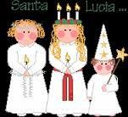
Cut a hole in the center of a paper plate so that a child’s head will fit in it. Cut out leaves from green construction paper and have children glue them to the paper plate. Make 7 paper candles stand up around the inside rim of the plate.

Star Boys
Cut an 18 inch wand from cardboard. Cover it with construction paper. Make a white star on the end of it. To make the hat roll a piece of construction paper so that it has a point on the end and staple it in place.

Festival of Light: Loi Krathong (loy-kruh-thong) Festival in Thailand
This holiday is celebrated in Thailand in November each year. “Loy” means “to float” and a “Krathong” is a lotus-shaped vessel made of banana leaves. The Krathong usually contains a candle, three joss-sticks, some flowers and coins.
The festival starts at night when there is a full moon in the sky. People carry their Krathongs to the nearby rivers. After lighting candles and making a wish, they place the Krathongs on the water and let them drift away. People are offering thanks to the Goddess of water.
It is believed that the Krathongs carry away bad luck. The wishes that people make for the new year will start. It is the time to be joyful and happy as the sufferings are floated away.

Krathong Boat
Make a paper boat to launch. Boats in Thailand have flowers and candles on them. Think about what bad feelings or happenings you would like to put on the boat to send away. Try floating your boat on a nearby stream, canal, or even in the bathtub. Search the internet for paper boat folding.

Festival of Light: Diwali in India
Diwali, meaning array of lights, is a Hindu light festival. It symbolizes the triumph of light over darkness. It is one of the most important celebrations in India.
Although it was originally a Hindu celebration, Diwali is now enjoyed by people of every religion in India. It is a family celebration which takes place in October or November and lasts for five days. This festival of lights celebrates the victory of good over evil and the glory of light.
Commemorating Lord Rama’s return to his kingdom Ayodhya after completing a 14-year exile, people decorate their homes, light thousands of lamps and give out sweets. There are fireworks in the streets.
Diwali is a time for fun and rejoicing. However, before the celebration begins there is a lot preparation.
The house must be thoroughly cleaned and windows opened in order to welcome the Laxmi, the goddess of wealth. People light up their homes using thousands of clay oil lamps to welcome the Goddess.>
During Diwali, Indians buy puffed rice to offer to Lakshmi, the Goddess of Prosperity. Have students put one cup of puffed rice in small squares of plastic wrap. Tell them to hand the rice out to friends.
New clothing is also purchased to be worn during the celebration.

Rangoli Design

- In India, a design using rice flour is made on the floor in front of the family’s shrine. Make your own Rangoli design! Use white chalk to draw a design on black construction paper.
- Color in the design with colored chalk.
- Spray the finished designs with a fixative. Find Rangoli designs online.

DECORATIONS

Christmas Pack Meeting Agenda - 1

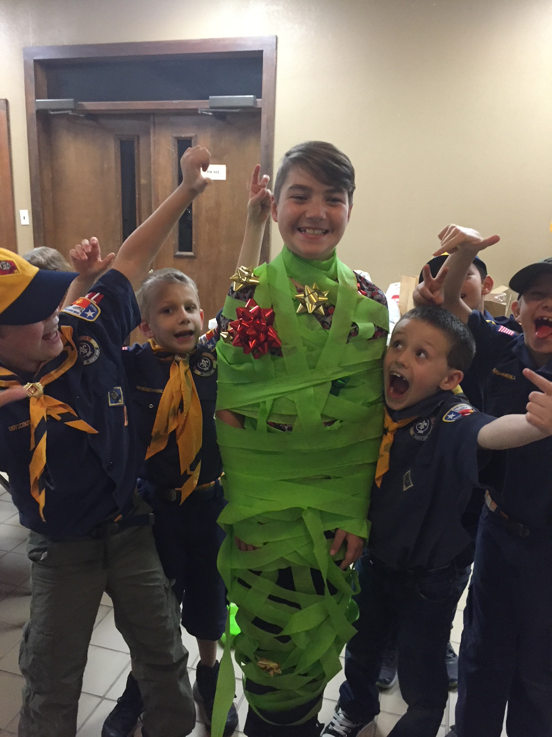
Materials
- opening/closing ceremony items: posters with C-H-R-I-S-T-M-A-S, with script on back of poster (hint: glue red tinsel to make letters)
- copies of this agenda
- printed copy of podium script
- copies of program below (printed songs and announcements), one per person attending (customize before printing)
- gathering activities: placemats, one per Cub Scout, colored pencils
- US flag and pack flag
- advancements
- props: Santa hats(s) and decorations
- games
- cheers and Cheer box or bag

Gathering Activity
Placemats: www.day-camp.shac.org/christmas-theme

Welcome
Cubmaster (wearing Santa hat): Welcome the Cub Scouts, parents and leaders.

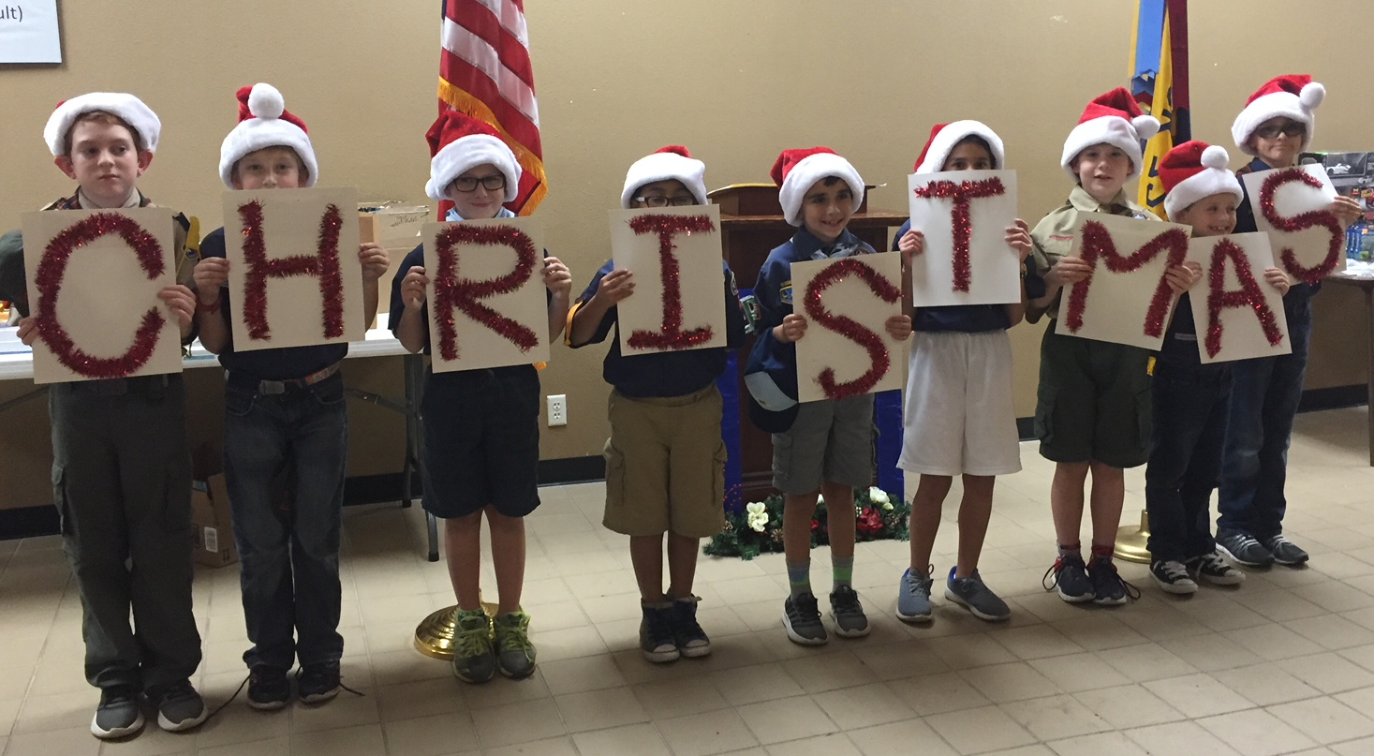
Opening Ceremony – Christmas Spelling

Arrangement: Nine Cub Scouts come onstage, one by one. Each carrying a large cardboard letter. Hint: glue red tinsel garland on poster board. Cub Scouts could wear Santa hats. As they speak their lines, they hold up their letter, each ultimately spell out the word Christmas. The script is on the back of letters in LARGE PRINT. Make sure the Scouts practice reading their script and speaking loud and looking up at the audience and projecting their voice to the back of the room.

- C is for carols and Christmas cheer.
- H is for holly that’s hanging here.
- R is for the reindeer I’ve never seen.
- I is for ivy of Christmas green.
- S is for stockings, Santa and skis.
- T is for tinsel on Christmas trees
- M is for a message to you from me.
- A is for angel atop a tree.
- S is for the secrets of every size. All wrapped and waiting for eager eyes.

Pledge

Song

Den leads a song in the program. Additional songs can be found here.

Leader Recognition

Skits
Have one or two dens perform a skit.

Audience Participation
Audience Participation

Advancement Ceremony - ‘Twas the Night of the Pack Meeting
Assistant Cubmaster or another leader reads the poem and leads the cheers.. Cubmaster presents the awards with help of committee chair or advancement chair. Might have awards attached to a candy cane.

‘Twas the night of the pack meeting and all through the place,
Not a Cub Scout was stirring, anticipation on each face.
It was time for advancements and they all turned an ear,
So, when their name was called, they would hear it loud and clear.
The Cubmaster was checking his/her list, not only once but twice,
To see which Cub Scouts had worked hard and earned awards this night.
When all of a sudden the Cubmaster as ready with helpers nigh,
To pass out awards as the Cub Scouts called were filing by.

First came the Lions all new to the pack.
Akela is ready, with the guidance and experience they lack,
They’re active, energetic and ready to learn.
Hard working and enthusiasm is no concern.
(Call Lions and their parents forward and present awards. Cheer)

We can’t forget Tigers, with parents in tow
They’re a great group in our pack, and they’ll help it grow.
With orange hat and scarf, they’re easy to spot,
But keeping up with them is, most decidedly not!
(Call Tigers and their parents forward and present awards. Cheer.)

Next are the Wolves, experienced that is true
But there is still much to learn, Akela’s not through
Come up all our Wolf Cubs, you are Wolves to be praised,
Adventures and much more you’ve done
So, with Wolf Badge and belt loops, to rank you are raised.
(Call Wolves and their parents forward and present awards. Cheer)

Fourth are the Bears most experienced so far,
Akela’s teachings they’ve heeded, they’re way above par.
Come all our Bear Cubs, your work and learning is applauded,
For completing core and elective Adventures, tonight you’re rewarded.
(Call Bears and their parents forward and present awards. Cheer)

Last are the Webelos Scouts, but not least to be sure,
Akela’s lessons they’ve learned, now Scouts BSA is their lure.
Come up all our Webelos Scouts, your Adventures are harder,
Your accomplishments you wear so proudly on your shoulder.
(Call Webelos Scouts and their parents forward and present awards. Cheer)

Cubmater Minute - The Magic of Cub Scouting

To take a child and help them grow into a successful adult –That's magic.
To teach them how to make things and let them know they can – That's magic.
To watch them learn the Scout Oath and Law and apply it in their life – That's magic.
To see them grow in mind and body, overcoming strife – That's magic.
To watch their family beam with pride at everything they'll do – That's magic.
And love them even if things don't go as they wanted them to – That's magic.
And observe the Scout leaders also beaming with pride. Because we know they are learning and growing up inside – That’s Cub Scout Magic.

Closing Ceremony

Reuse the cards from the opening ceremony. Make sure the Scouts know which script to read.

- C is for candles, we burn on Christmas night. To gladden weary travelers with their light so bright.
- H is for happiest; the happiest time of year. It's jolly, gay old Christmas tunes with all its mirth & cheer.
- R is for ring; we ring the Christmas bell. All the Christmas gladness, the world to tell.
- I is for the infant who lay in a manger. Little Lord Jesus, a dear little stranger.
- S is for shepherds who kept their flocks by night; And heard the angels singing, and saw a wondrous light.
- T is for tree, all green and gold and red. We see it Christmas morning when we jump out of bed.
- M is for the mistletoe we hang at Christmas time. In merry wreaths, when candles burn and Christmas bells chime.
- A is for all; to all men we wish cheer. Joy and gladness, love and hope, for Christmas time is here.
- S is for the star that shone on Christmas night, Star and candle, bell and wreath, all make our Christmas bright.

Podium Script: Advancement Ceremony

‘Twas the night of the pack meeting and all through the place,
Not a Cub Scout was stirring, anticipation on each face.
It was time for advancements and they all turned an ear,
So, when their name was called, they would hear it loud and clear.
The Cubmaster was checking the list, not only once but twice,
To see which Cub Scouts had worked hard and earned awards this night.
When all of a sudden, the Cubmaster as ready with helpers nigh,
To pass out awards as the Cub Scouts called were filing by.

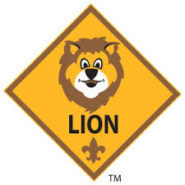
First came the Lions all new to the pack.
Akela is ready, with the guidance and experience they lack,
They’re active, energetic and ready to learn.
Hard working and enthusiasm is no concern.
(Call Lions and their parents forward and present awards. Cheer)

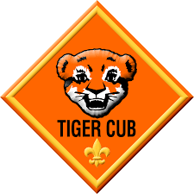
We can’t forget Tigers, with parents in tow
They’re a great group in our pack, and they’ll help it grow.
With orange hat and scarf, they’re easy to spot,
But keeping up with them is, most decidedly not!
(Call Tigers and their parents forward and present awards. Cheer.)

Next are the Wolves, experienced that is true
But there is still much to learn, Akela’s not through
Come up all our Wolf Cubs, you are Wolves to be praised,
Adventures and much more you’ve done
So, with Wolf Badge and belt loops, to rank you are raised.
(Call Wolves and their parents forward and present awards. Cheer)

Next are the Bears most experienced so far,
Akela’s teachings they’ve heeded, they’re way above par.
Come all our Bear Cubs, your work and learning is applauded,
For completing core and elective Adventures, tonight you’re rewarded.
(Call Bears and their parents forward and present awards. Cheer)

Last are the Webelos Scouts, but not least to be sure,
Akela’s lessons they’ve learned, now Scouts BSA is their lure.
Come up all our Webelos Scouts, your Adventures are harder,
Your accomplishments you wear so proudly on your shoulder.
(Call Webelos Scouts and their parents forward and present awards. Cheer)

Podium Script: Cubmater Minute

To take a child and help them grow into a successful adult –That's magic.
To teach them how to make things and let them know they can – That's magic.
To watch a child learn the Scout Oath and Law and apply it in their life – That's magic.
To see them grow in mind and body, overcoming strife – That's magic.
To watch a their family beam with pride at everything they'll do – That's magic.
And love them even if things don't go as they wanted them to – That's magic.
And observe the Scout leaders also beaming with pride. Because we know they are learning and growing up inside – That’s Cub Scout Magic.

Print: Opening /Closing Ceremony
cut into strips and glue to back of posters

Opening:
C is for carols and Christmas cheer.

Closing:
C is for candles, we burn on Christmas night. To gladden weary travelers with their light so bright.

Opening:
H is for holly that’s hanging here.

Closing:

H is for happiest; the happiest time of year. It's jolly, gay old Christmas tunes with all its mirth & cheer.

Opening:
R is for the reindeer I’ve never seen.

Closing:
R is for ring; we ring the Christmas bell. All the Christmas gladness, the world to tell.

Opening:
I is for ivy of Christmas green.

Closing:
I is for the infant who lay in a manger. Little Lord Jesus, a dear little stranger.

Opening:
S is for stockings, Santa and skis.

Closing:
S is for shepherds who kept their flocks by night; And heard the angels singing, and saw a wondrous light.

Opening:
T is for tinsel on Christmas trees

Closing:
T is for tree, all green and gold and red. We see it Christmas morning when we jump out of bed.

Opening:
M is for a message to you from me.

Closing:
M is for the mistletoe we hang at Christmas time. In merry wreaths, when candles burn and Christmas bells chime.

Opening:
A is for angel atop a tree.

Closing:
A is for all; to all men we wish cheer. Joy and gladness, love and hope, for Christmas time is here.

Opening:
S is for the secrets of every size. All wrapped and waiting for eager eyes.

Closing:
S is for the star that shone on Christmas night, Star and candle, bell and wreath, all make our Christmas bright.

 |  | Pack 72 |  |  |  | December 2017
Rudy, The Red-Nosed Cub Scout  Tune: Rudolph, The Red-Nosed Reindeer  Rudy, the red-nosed Cub Scout,  Had a very runny nose;  And if you ever saw it,  You would probably say, "Oh, Gross!"  All of the other Cub Scouts  Used to laugh and say, "Oh, Ick";  Parents would not go near him  'Cause they thought they might get sick.  Then one winter's pack meeting,  The Cubmaster said, "Sign's Up!"  Rudy, with your nose so wet,  A box of Kleenex is what you'll get!  Then all the Cub Scouts cheered him,  As they blew and blew and blew;  Rudy, the red-nosed Cub Scout,  We will DO OUR BEST with you! |  |  |  | 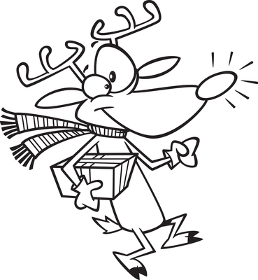 |  |  |  | January 2018  Jan 10 Den Meeting  Jan 24 Den Meeting  Jan 27 Scouting for Food  (hanger distribution)  Jan 31 Pack Meeting  February 2018  Feb 3 Scouting for Food  (food pick up)  Feb 7 Den Meeting  Feb 21 Den Meeting  Feb 23 Derby car check-in  Feb 24 Pinewood Derby and potluck lunch  Feb 28 Pack Meeting  March 2018  Mar 7 Den Meeting  March 24-25 Family Campout  Mar 28 Den Meeting  April 2018  April 4 Den Meeting  April 14 Scout Fair  April 18 Den Meeting  April 25 Pack Meeting  May 2018  May 2 Den Meeting  May 19 Banquet / Pack Meeting  June 2018  June 5-8 Day Camp: www.orion.shac.org/day-camp
A Scout’s Christmas
Tune: Jingle Bells
 | Dashing through the den,  With a rope held by each end,  Tying a bowline knot  Then showing what I've got.  Whittling with my knife  On a practice Dial soap bar.  I can hardly wait,  Scout camp can't be far.  Bait a hook,  Learn to cook,  Bike ro-de-os.  Neckerchief slides,  Canned food drives,  Learning to take photos.  Pancake mix,  Carving sticks,  Keeps us on the run.  Our families  Make all these  Memories so much fun. |  | Dashing through the camp,  Putting up the tents,  Popping all the corn,  Blowing that morning horn.  Of Scout camp we all dream  We'll soon be old enough  Lions, Tigers, Wolves, and Bears  We're made of real tough stuff!  Half-hitch knots,  Setting up cots,  Playing fun new games.  Hammers and nails,  Compass and trails,  Advancements are the thing.  Santa's coming,  We've been good,  As good as we can be...  Load our stocking  With a pocket knife,  Eagle Scouts we want to be!
Pack 72
facebook.com/pack72tomball
pack72tomball.scoutlander.com
Orion District
www.orion.shac.org
facebook.com/orionbsa
Sam Houston Area Council
www.shac.org
facebook.com/shac.bsa

Christmas Pack Meeting Agenda – 2 (Lights)

Materials
- opening ceremony items: posters with script written on the back
- closing ceremony items: 8 small gift-wrapped boxes (or candles) with script written on the back
- advancement ceremony items: Christmas tree, 5-6 colored strands of lights (e.g., yellow, orange, blue, green, red), light for top of tree, extension cord, power strip
- copies of this agenda
- printed copy of podium script
- copies of program below (printed songs and announcements), one per person attending (customize before printing)
- gathering activities: placemats, one per Cub Scout, colored pencils
- US flag and pack flag
- advancements
- props: Santa hats(s) and decorations
- games
- cheers and Cheer box or bag

Gathering Activity
Placemats: www.day-camp.shac.org/christmas-theme

Welcome
Cubmaster (wearing Santa hat): Welcome the Cub Scouts, parents and leaders.

Opening Ceremony – G*I*V*E*S
Equipment: Five Cub Scouts with 5 large cards each with a letter forming the word G*I*V*E*S. Each one has the sayings written on back in large print.
Arrangement: Each Cub Scout holds up their card and says the following:
Cub # 1: G stands for Giving, It's always good to give.
Cub # 2: I stands for Intentions, May mine always be right.
Cub # 3: V stands for Valiant, A trait of great might
Cub # 4: E stands for Earnest, From beginning to end.
Cub # 5: S stands for Sharing, This makes me a friend.

Pledge

Song

Den leads a song in the program. Additional songs can be found here.

Leader Recognition

Skits
Have one or two dens perform a skit.

Audience Participation
Audience Participation

Advancement Ceremony - Climbing the Tree
Assistant Cubmaster or another leader reads the poem and leads the cheers.. Cubmaster presents the awards with help of committee chair or advancement chair.

Materials: Have a Christmas tree with various colored lights. (This can be a cardboard tree with holes for the lights.) The bulbs should be unscrewed slightly so that they can be easily turned on at the proper time. You may wish to use different colored string of lights for each rank. For example, yellow lights for the bottom row (Lion), orange lights for the next row (Tigers), red lights next (Wolf), green lights on the fourth row (Bear), and blue lights for the top row as well as the top of the tree (Webelos Scouts), white for parents and leaders, and light for tree top.
Personnel: Cubmaster (CM) and Assistant Cubmaster (CA)
CM: As we look at our tree this evening, we see that it is dark, with only one light on. [Screw in top light.] This is the light which represents the Arrow of Light Award.
Let us see if there are Cub Scouts here tonight who can help light the way to the top of the tree, to the highest rank in Cub Scouting.
The first step along the Cub Scout trail is Lion. The Lions are beginning to learn about Scouting, citizenship, teamwork and good sportsmanship. (Call Lions and their parents forward and present awards. Cheer)
Thank you Lions. We can now turn on the lights representing the Lions.
CA: Next is Tiger. The Tigers are climbing towards the Arrow Light Award and learning about Duty to God and country, nutrition and nature. (Call Tigers and their parents forward and present awards. Cheer.)
Thank you Tigers. We can now turn on the lights representing the Tigers.
CA: The Wolves are increasing their knowledge and learning about the United States flag, keeping strong, safety, and being useful to the family. (Call Wolves and their parents forward and present awards. Cheer)
Thank you Wolves. We can now turn on the lights representing the Wolves.
CA: As the Cub Scouts grows older and stronger, they are able to climb higher. But just as it is a little more difficult to climb the upper branches of a tree, so the Adventures are a little more difficult for the Bear rank. (Call Bears and their parents forward and present awards. Cheer)
Thank you Bears. We can now turn on the lights representing the Bears.
CA: Now the Webelos Scouts in fourth grade have more climbing to do. The Webelos Scouts are increasing their knowledge of Scouting and preparing to join a troop and work towards the rank of Eagle Scout. (Call Webelos Scouts and their parents forward and present awards. Cheer)
Thank you Webelos Scouts. We can now turn on the lights representing the Webelos Scouts.
The Webelos Scouts in fifth grade only one more climb to go. This last climb will bring them to the top of the tree and the coveted Arrow of Light, the highest award a Cub Scout can earn.
(Call the 5th grade Webelos Scouts and their parents forward and present awards. Cheer)
Thank you Webelos Scouts. To encourage them on their way to the Arrow of Light, let us turn on our last light because, as you have learned throughout Cub Scouting, you have helped to make the world brighter. [Turn on another light.]
CA: These Cub Scouts have helped us light our tree, but it is still not quite as bright as it might be. Since they have received help from their parents and leaders, let us turn on a light for the parents, too. [Turn on another light.]
CM: Now our tree is complete. As you have seen, it has taken Cub Scouts plus parents and leaders to complete it. With the same effort you have shown before, keep working for the highest rank in Cub Scouting. Congratulations to you and your parents for the fine work you have done.

Cubmater Minute - December Lights Closing Ceremony
This is the season of decorations and lights. It is a time when the days are shorter and the nights are long. But, somehow, things seem brighter. Shopping centers are bright with holiday decorations and lights. Thousands of homes have single candles to light the way for the Christ Child. Other thousands have candles burning to commemorate the miracle of the oils of Hanukkah. Even the stars in the winter sky seem brighter. The most brilliant glow comes from the spirit of goodwill that you live all year round in the Scout Oath and Scout Law. Let us all stand and repeat them together.

Closing Ceremony - These are Gifts that Cub Scouts Give
Setting – 8 Cub Scouts and Cubmaster, small gift-wrapped boxes (or candles) with the words written on the back.
Scene – Cubs line up across the front of the room, with the Cubmaster. As each Scout speaks part, and presents gift to the Cubmaster.
CM: These are gifts that Cub Scouts give.
- Happiness
- Cheerfulness
- Honesty
- Sincerity
- Courtesy
- Thoughtfulness
- Friendliness
- Reverence
CM: Good night to all.
Podium Script: Advancement Ceremony - Climbing the Tree

As we look at our tree this evening, we see that it is dark, with only one light on. [Screw in top light.] This is the light which represents the Arrow of Light Award. Let us see if there are Cub Scouts here tonight who can help light the way to the top of the tree, to the highest rank in Cub Scouting.

The first step along the Cub Scout trail is Lion. The Lions are beginning to learn about Scouting, citizenship, teamwork and good sportsmanship. (Call Lions and their parents forward and present awards. Cheer) Thank you Lions. We can now turn on the lights representing the Lions.

Next is Tiger. The Tigers are climbing towards the Arrow Light Award and learning about Duty to God and country, nutrition and nature. (Call Tigers and their parents forward and present awards. Cheer.) Thank you Tigers. We can now turn on the lights representing the Tigers.

The Wolves are increasing their knowledge and learning about the United States flag, keeping strong, safety, and being useful to the family. (Call Wolves and their parents forward and present awards. Cheer) Thank you Wolves. We can now turn on the lights representing the Wolves.

As the Cub Scouts grows older and stronger, they are able to climb higher. But just as it is a little more difficult to climb the upper branches of a tree, so the Adventures are a little more difficult for the Bear rank. (Call Bears and their parents forward and present awards. Cheer) Thank you Bears. We can now turn on the lights representing the Bears.

Now the Webelos Scouts in fourth grade have more climbing to do. The Webelos Scouts are increasing their knowledge of Scouting and preparing to join a troop and work towards the rank of Eagle Scout. (Call Webelos Scouts and their parents forward and present awards. Cheer) Thank you Webelos Scouts. We can now turn on the lights representing the Webelos Scouts.

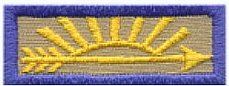
The Webelos Scouts in fifth grade only one more climb to go. This last climb will bring them to the top of the tree and the coveted Arrow of Light, the highest award a Cub Scout can earn. (Call the 5th grade Webelos Scouts and their parents forward and present awards. Cheer) Thank you Webelos Scouts. To encourage them on their way to the Arrow of Light, let us turn on our last light because, as you have learned throughout Cub Scouting, you have helped to make the world brighter. [Turn on another light.]

These Cub Scouts have helped us light our tree, but it is still not quite as bright as it might be. Since they have received help from their parents and leaders, let us turn on a light for the parents, too. [Turn on another light.]

Now our tree is complete. As you have seen, it has taken Cub Scouts plus parents and leaders to complete it. With the same effort you have shown before, keep working for the highest rank in Cub Scouting. Congratulations to you and your parents for the fine work you have done.

Podium Script: Cubmater Minute - December Lights Closing Ceremony

This is the season of decorations and lights. It is a time when the days are shorter and the nights are long. But, somehow, things seem brighter. Shopping centers are bright with holiday decorations and lights. Thousands of homes have single candles to light the way for the Christ Child. Other thousands have candles burning to commemorate the miracle of the oils of Hanukkah. Even the stars in the winter sky seem brighter. The most brilliant glow comes from the spirit of goodwill that you live all year round in the Scout Oath and Scout Law. Let us all stand and repeat them together.

Print: Opening Ceremony
cut into strips and glue to back of posters

1: G stands for Giving, It's always good to give.

2: I stands for Intentions, May mine always be right.

3: V stands for Valiant, A trait of great might

4: E stands for Earnest, From beginning to end.

5: S stands for Sharing, This makes me a friend.

Print: Closing Ceremony - These are Gifts that Cub Scouts Give
cut into strips and glue to back of posters

- Happiness

- Cheerfulness

- Honesty

- Sincerity

- Courtesy

- Thoughtfulness

- Friendliness

- Reverence

 | Pack 72 |  |  |  |  | December 2017
Christmas Time  Tune: Jingle Bells  School is out, we won’t pout  Cubs shout “Hip’-hurray.”  Something special’s coming soon,  And it is Christmas day,  Wrap the gifts, trim the tree,  Mind your mom and dad.  You’ll get presents if you do,  Wow, won’t we be glad? |  |  | 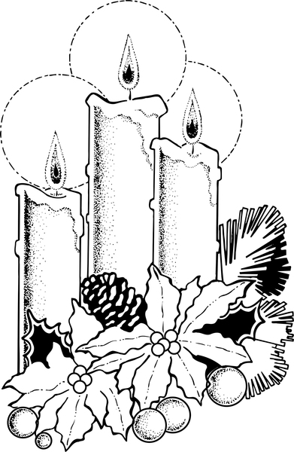 |  |  |  | January 2019  Jan 10 Den Meeting  Jan 24 Den Meeting  Jan 27 Scouting for Food  (hanger distribution)  Jan 31 Pack Meeting  February 2019  Feb 3 Scouting for Food  (food pick up)  Feb 7 Den Meeting  Feb 21 Den Meeting  Feb 23 Derby car check-in  Feb 24 Pinewood Derby  Feb 28 Pack Meeting  March 2019  Mar 7 Den Meeting  March 24-25 Family Campout  Mar 28 Den Meeting  April 2019  April 4 Den Meeting  April 14 Scout Fair  April 18 Den Meeting  April 25 Pack Meeting  May 2019  May 2 Den Meeting  May 19 Banquet / Pack Meeting  June 2019  June 5-8 Day Camp:  www.orion.shac.org/day-camp
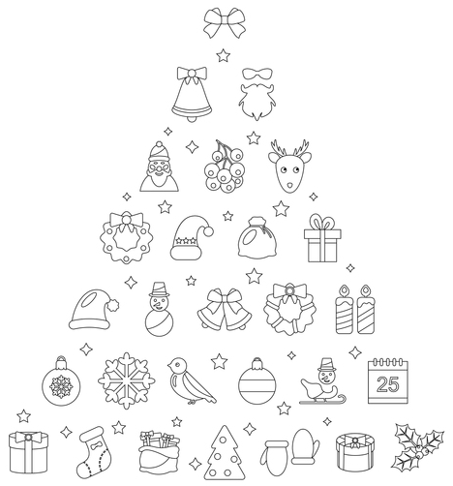 |  | Twelve Scouting Days of Christmas  Tune: 12 Days of Christmas  On the first day of Scouting,  my Cubmaster gave to me …  A Lion Scout roaring at me!  Two roaring Tigers,  Three skinny Wolves  Four hungry Bears  Five Webelos Scouts  Six Adventure belt loops  Seven dynamite den chiefs  Eight shouting Cub Scouts  Nine raingutter regattas  Ten derby cars  Eleven wacky skits  Twelve silly cheers
Announcements

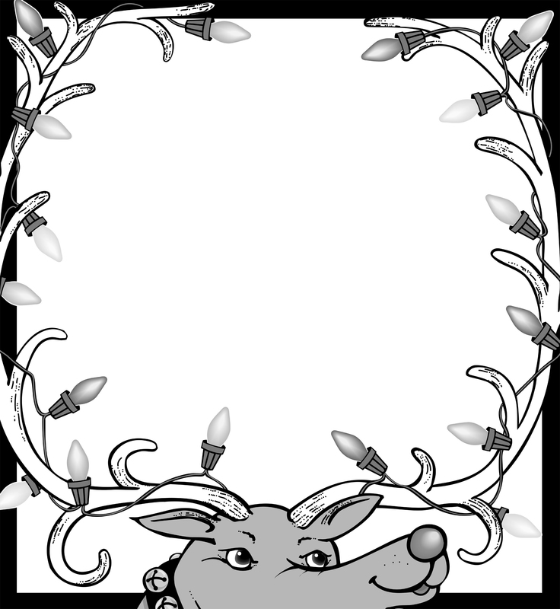
Pack 72
facebook.com/pack72tomball
pack72tomball.scoutlander.com

Orion District
www.orion.shac.org
facebook.com/orionbsa

Sam Houston Area Council
www.shac.org
facebook.com/shac.bsa

Christmas Pack Meeting Agenda – 3 (Gifts)

Materials
- opening ceremony items: Box wrapped with holiday paper and tied with a bow. In the box are a menorah, small Christmas tree, invitation, Kwanzaa candelabra, and other symbols of December holidays appropriate for your unit, small wrapped gift, small felt stocking, and card saying "Do Your Best."
- advancement ceremony items: small stocking or paper stocking for each Cub Scout clearly show the Cub Scouts’ name. tape, 2 ladders, board, Christmas centerpiece, fake fireplace
- closing ceremony items: posters (or gifts) with script printed on back (or side)
- copies of this agenda
- printed copy of podium script
- copies of program below (printed songs and announcements), one per person attending (customize before printing)
- gathering activities: placemats, one per Cub Scout, colored pencils
- US flag and pack flag
- advancements
- props: Santa hats(s) and decorations
- games
- cheers and Cheer box or bag

Gathering Activity
Placemats: www.day-camp.shac.org/christmas-theme

Welcome
Cubmaster (wearing Santa hat): Welcome the Cub Scouts, parents and leaders.

Opening Ceremony – December Gift Opening Ceremony
Props: Box wrapped with holiday paper and tied with a bow. In the box are a menorah, small Christmas tree, invitation, Kwanzaa candelabra, and other symbols of December holidays appropriate for your unit, small wrapped gift, small felt stocking, and card saying "Do Your Best."
Cubmaster: (Opens box and looks inside.) December is one of the most exciting months of the year, and certainly one of the busiest. This month we have: Christmas (Takes out tree.); Hanukkah (Removes menorah.); Kwanzaa (Removes candle holder.), (Does other symbols), and Holiday parties (Takes out invitation.).
What a great time for all of us! Our pack has had lots of fun this month working on advancements (Takes patch and beads from box.).
One of the best things was our special service project/Good Turn (Takes stocking or other symbol for the project from box.)
We've been busy, and all the time we have followed the Cub Scout Motto: (takes paper out of box and shows it while saying motto) "Do Your Best". And we have learned to Respect the traditions of other people from around the world. We are also learning to show Respect for our flag. Now Den ___ will present the colors.

Pledge

Song

Den leads a song in the program. Additional songs can be found here.

Leader Recognition

Skits
Have one or two dens perform a skit.

Audience Participation
Audience Participation

Advancement Ceremony - Stockings Were Hung
Assistant Cubmaster or another leader reads the poem and leads the cheers.. Cubmaster presents the awards with help of committee chair or advancement chair.

Set-up: Each rank is inside a small stocking or attached to a small paper stocking. Each stocking should clearly show the Cub Scouts’ name. Stockings are hanging on (taped to) a mantle.
Build mantle by using 2 ladders with a board placed between the higher rungs. Set a Christmas centerpiece on top of board and paper to make a fake fireplace, if desired. Object in using the higher rungs is that parents will need to assist the Cub Scout in getting their rank.
Cubmaster enters and examines stockings hanging. Then comments: '*My, we've had a lot of hard-working Scouts this month. Stockings are over-flowing with achievements. Would the following Scouts and their parents come forward as I call them? Parents, please help your Cub Scout remove their stocking just as you have worked with your Cub Scout to help them earn their rank,"
(Call each rank and their parents forward and present awards followed by a cheer.)

Plan something extra for any Arrow of Light awards -- a large stocking with an arrow as well as rank and have Cub Scout repeat the Scout Oath. Or have the den chief wearing a Santa cap making a personal delivery for Arrow of Light award.

Cubmaster’s Minute (Gifts)
Each of us have some traditions that are only practiced by our own families. Let’s remember to enjoy those traditions and our families at this time of year. Remember it is better to give than to get. See if you can find the joy in giving this year!

Closing Ceremony - GIFTS Closing Ceremony

Set Up: Den Chief (DC) or Den Leader (DL) and 5 Cub Scouts. Be sure Cub Scouts have learned their parts or create cards with pictures on the audience side and the words on back in LARGE type.
DC/DL: What you are is God's gift to you. What you make of yourself is your gift to God. Make it a good gift.
- Work while you work.
- Pray while you pray.
- One thing at a time. That is the way.
- All that you do, do with all your might.
- Things done halfway are not done right.
All: (Together) Do Your Best!

Podium Script: Advancement Ceremony - Stockings Were Hung

My, we've had a lot of hard-working Scouts this month. Stockings are over-flowing with achievements. Would the following Scouts and their parents come forward as I call them? Parents, please help your Cub Scout remove their stocking just as you have worked with your Cub Scout to help them earn their rank,"
(Call each rank and their parents forward and present awards. Cheer)

Podium Script: Cubmater Minute

Each of us have some traditions that are only practiced by our own families. Let’s remember to enjoy those traditions and our families at this time of year. Remember it is better to give than to get. See if you can find the joy in giving this year!

Print: Opening Ceremony – December Gift Opening Ceremony

December is one of the most exciting months of the year, and certainly one of the busiest. This month we have:

Christmas (Takes out tree.);
Hanukkah (Removes menorah.);
Kwanzaa (Removes candle holder.),
(other symbols), and
Holiday parties (Takes out invitation.).

What a great time for all of us! Our pack has had lots of fun this month working on advancements (Takes patch and beads from box.).

One of the best things was our special service project/Good Turn (Takes stocking or other symbol for the project from box.)

We've been busy, and all the time we have followed the Cub Scout Motto: (takes paper out of box and shows it while saying motto) "Do Your Best". And we have learned to Respect the traditions of other people from around the world. We are also learning to show Respect for our flag. Now Den ___ will present the colors.

Print: GIFTS Closing Ceremony

DC/DL: What you are is God's gift to you. What you make of yourself is your gift to God. Make it a good gift.

- Work while you work.

- Pray while you pray.

- One thing at a time. That is the way.

- All that you do, do with all your might.

- Things done halfway are not done right.

All: (Together) Do Your Best!

 | Pack 72 |  |  |  |  | December 2017
Give a Gift  Tune: I'd Like to Teach the World to Sing  I'd like to give the world a gift,  That all men will be free.  And though I'm just a growing kid,  There's things that I can see.  I see that Scouting is a way  To start to understand,  That caring, helping, smiling,  Help me learn and give a hand.  And so at Christmas there's a gift  That you can give to me.  Please help me grow in mind and spirit  To be what I can be. |  | 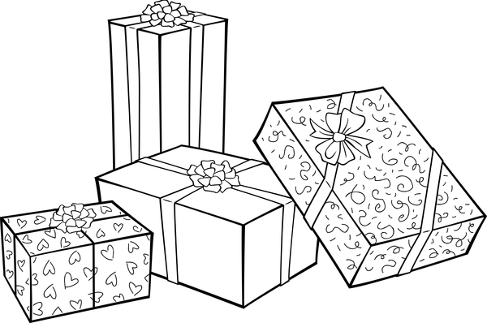 |  |  |  |  |  |  | January 2019  Jan 10 Den Meeting  Jan 24 Den Meeting  Jan 27 Scouting for Food  (hanger distribution)  Jan 31 Pack Meeting  February 2019  Feb 3 Scouting for Food  (food pick up)  Feb 7 Den Meeting  Feb 21 Den Meeting  Feb 23 Derby car check-in  Feb 24 Pinewood Derby and potluck lunch  Feb 28 Pack Meeting  March 2019  Mar 7 Den Meeting  March 24-25 Family Campout  Mar 28 Den Meeting  April 2019  April 4 Den Meeting  April 14 Scout Fair  April 18 Den Meeting  April 25 Pack Meeting  May 2019  May 2 Den Meeting  May 19 Banquet / Pack Meeting  June 2019  June 5-8 Day Camp: www.orion.shac.org/day-camp
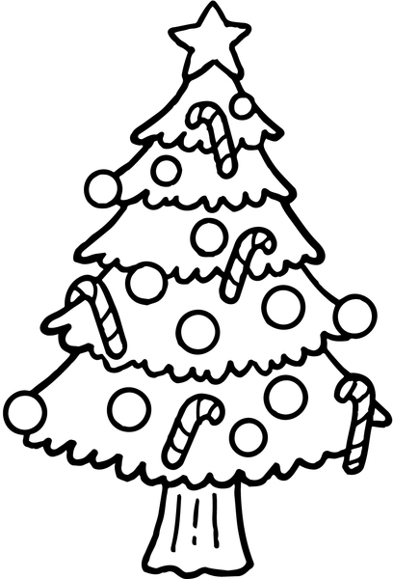 |  |  | Presents  Tune: Rudolph  Present are being hidden  I’m as curious as can be  I want to find out somehow  If some of them might be for me  Everywhere I have been searching  I have looked both high and low  Then one day I realized  What I was doing wrong.  I need to start being good  And sharing all day long  I knew then I needn’t worry  Santa just would not forget  And I shall be very happy  By giving more than I shall get.
Announcements |  |  |  |  |  |  | 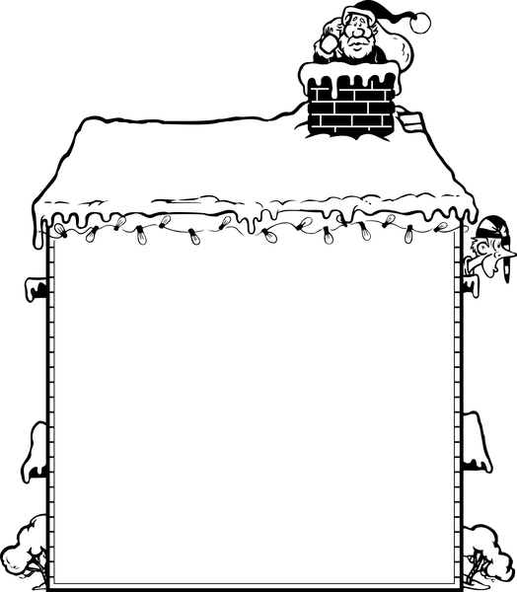  Pack 72  facebook.com/pack72tomball  pack72tomball.scoutlander.com  Orion District  www.orion.shac.org  facebook.com/orionbsa  Sam Houston Area Council  www.shac.org  facebook.com/shac.bsa

Christmas Pack Meeting Agenda – 4
(Around the World)

Materials
- opening ceremony items: picture of countries (Ireland, Scandinavi, Poland, Austria, England, Italy, Greece, Mexico) on posters with script printed on back; objects or picture for each country (fruitcake, wood ornaments, tree, green apple, ginger cookies, Ceppo, St. Basil, piñata
- closing ceremony items: posters with letters GOODWILL with script printed on back
- advancement ceremony items: see suggestions
- copies of this agenda
- printed copy of podium script
- copies of program below (printed songs and announcements), one per person attending (customize before printing)
- gathering activities: placemats, one per Cub Scout, colored pencils
- US flag and pack flag
- advancements
- props: Santa hats(s) and decorations
- games
- cheers and Cheer box or bag

Gathering Activity
Placemats: www.day-camp.shac.org/christmas-theme

Welcome
Cubmaster (wearing Santa hat): Welcome the Cub Scouts, parents and leaders.

Opening Ceremony – Christmas Around the World
Each Cub Scout holds an article representing the country, they have chosen, while they read the lines. Or instead, have each Cub Scout hold a cardboard cutout of the country they represent, with the words written on the back of the cutout for easy reading. Cub Scout can be in uniform or in costumes for countries.
- Ireland – The building of a grotto for the Nativity scene is a family project in Ireland. A Dublin fruitcake, covered with thick almond-flavored icing and decorated with green gumdrop shamrocks is the popular food.
- Scandinavia – Children, parents and even grandparents all join in making interesting straw and balsa wood ornaments in shapes of stars, angels, reindeer, and other animals. They begin making these holiday decorations on Little Christmas, the last Sunday in November.
- Poland – Here the Christmas tree is a symbol of friendship and peace, and is heavily laden with pretty ornaments. Poppy-seed rolls filled with ground poppy seed and honey paste are prepared the night before Christmas.
- Austria – Greens and apples signify hope for the coming spring and are used in the twilight tree with candles to celebrate the holidays. Linzer cakes and nut butter rounds are their Christmas delicacies.
- England – Punch and Judy shows are very much a part of the British Christmas. Plum pudding, spicy ginger cookies, shaped like cornucopias and filled with whipped cream are delightful foods.
- Italy – Instead of a Christmas tree, Italy has the pyramid-shaped Ceppo. The manger scene of hand-carved figures is placed on the lower shelf of the ceppo and small gifts for the children are put on the next shelf. Golden bread of Verona and Sicilian torrone, a multi-colored candy loaf are special pastries.
- Greece – St. Basil, who distributes Christmas toys, makes his rounds in a boat instead of a sled. New Year’s bread with a coin baked inside is served at the stroke of midnight on New Year’s Eve. Father cuts a portion of bread for each member of the family in the order of their ages. Whoever gets the piece with the coin will enjoy a year of coed luck.
- Mexico – In Mexico, the piñata filled with candy is always a favorite at Christmas time. The children strike it until it cracks and the goodies spill cut for all to enjoy.
Pledge

Song

Den leads a song in the program. Additional songs can be found here.

Leader Recognition

Skits
Have one or two dens perform a skit.

Audience Participation
Audience Participation

Advancement Ceremony - Suggestions for Holiday Advancement Ceremonies

An adult, dressed as Santa, could arrive with his pack on his back, which contains the awards to be presented. It is a special treat to receive an award from Santa himself.
Make a large papier-mâché snowman to hold the awards. Awards could either be put in snowman or removed from an opening cut in his back, or they could be fastened to a long scarf around his neck.
Awards could be taped to large cardboard cutout ornaments, which decorate a Christmas tree. When a Cub Scout's name is called, they go to the tree and find their ornaments.
A large papier-mâché Christmas stocking could set on head table to hold awards, or a large knit or felt stocking hung from a fireplace. Santa makes presentations.

Cubmater Minute - Season of Lights (Around the World)
This is the season of lights. It is a time when the days are shorter so the nights are longer, yet somehow things are brighter. Stores and homes are bright with holiday lights. Thousands of homes have a single light to show the way for the Christ child, others have candles burning to commemorate the miracle of Hanukkah, and some light candles to honor the heritage of Kwanzaa. Even the stars in the winter sky seem brighter at this time of year. But the most important glow is from the spirit of goodwill that WE live with year-round in the Scout Oath and the Scout Law. Before we all leave to get on with our holiday celebrations, let’s stand and as a group say the Scout Oath and Scout Law. Happy Holidays!

Closing Ceremony - Goodwill Closing Ceremony

Set Up: 8 Cub Scouts each with a sign with one of the letters on front. The words are written on the back in large print. Cub Scouts say their parts in turn.
- G - Good Cub Scouts are friends to all.
- O - On their honor to obey the Scout Law
- O - Once they show how HELPFUL they are
- D - Doubled friendships will surely be found.
- W - Working together being HELPFUL will make the world a better place.
- I - Including as new friends -- Cub Scouts from each faith and race.
- L - Leaving behind them a path of good cheer from being HELPFUL.
- L - Let's all practice being HELPFUL now and all through the year.
- Wishing you all Goodwill. Thank you and good night. You are dismissed.

Podium Script: Cubmater Minute

Each of us have some traditions that are only practiced by our own families. Let’s remember to enjoy those traditions and our families at this time of year. Remember it is better to give than to get. See if you can find the joy in giving this year!

Print: Opening Ceremony
cut into strips and glue to back of posters

Coming Soon

Print: Closing Ceremony
cut into strips and glue to back of posters

- G - Good Cub Scouts are friends to all.

- O - On their honor to obey the Scout Law

- O - Once they show how HELPFUL they are

- D - Doubled friendships will surely be found.

- W - Working together being HELPFUL will make the world a better place.

- I - Including as new friends -- Cub Scouts from each faith and race.

- L - Leaving behind them a path of good cheer from being HELPFUL.

- L - Let's all practice being HELPFUL now and all through the year.

- Wishing you all Goodwill. Thank you and good night. You are dismissed.

 | Pack 72 |  |  | December 2018
Oh, Christmas Tree  Tune: 0’ Tannenbaum  Oh, Christmas tree! Oh, Christmas tree!  Your needles falling down on me.  Oh, Christmas tree! Oh, Christmas tree!  Your needles falling down on me.  "It's freshly cut," the salesman said.  But now you're home, I see you're dead.  Oh, Christmas tree! Oh, Christmas tree!  Your needles falling down on me.  Oh, Christmas tree! Oh, Christmas tree!  You fell over on my TV.  Oh, Christmas tree! Oh, Christmas tree!  You fell over on my TV.  The cable lines are in a pinch,  I can't watch Snoopy or the Grinch.  Oh, Christmas tree! Oh, Christmas tree!  You fell over on my TV.  Oh, Christmas tree! Oh, Christmas tree!  There's something under you I see.  Oh, Christmas tree! Oh, Christmas tree!  There's something under you I see.  Is it a present gaily wrapped?  No, it's a blob of gooey sap.  Oh, Christmas tree! Oh, Christmas tree!  There's something under you I see. |  | 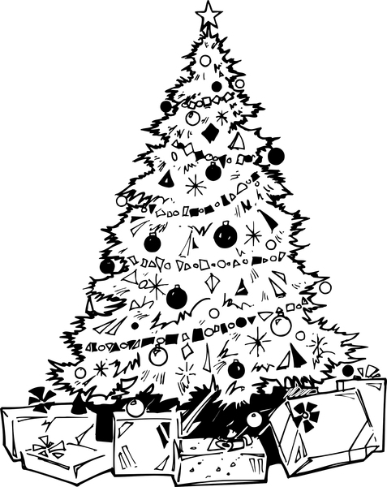 |  |  |  |  | January 2019  Jan 10 Den Meeting  Jan 24 Den Meeting  Jan 27 Scouting for Food  (hanger distribution)  Jan 31 Pack Meeting  February 2019  Feb 3 Scouting for Food  (food pick up)  Feb 7 Den Meeting  Feb 21 Den Meeting  Feb 23 Derby car check-in  Feb 24 Pinewood Derby and potluck lunch  Feb 28 Pack Meeting  March 2019  Mar 7 Den Meeting  March 24-25 Family Campout  Mar 28 Den Meeting  April 2019  April 4 Den Meeting  April 14 Scout Fair  April 18 Den Meeting  April 25 Pack Meeting  May 2019  May 2 Den Meeting  May 19 Banquet / Pack Meeting  June 2019  June 5-8 Day Camp: www.orion.shac.org/day-camp
Christmas Time  Tune: Jingle Bells  School is out, we won’t pout  Cubs shout “Hip’-hurray.”  Something special’s coming soon,  And it is Christmas day,  Wrap the gifts, trim the tree,  Mind your mom and dad.  You’ll get presents if you do,  Wow, won’t we be glad? |  | Christmas Spirit  Tune: Silent Night  God is night, stars are bright.  Leaders and Scouts stand in the light.  Singing carols to family and friends  Spreading joy that never ends.  Sweet their voices ringing  Christmas spirit to share.
Announcements |  |  |  |  | 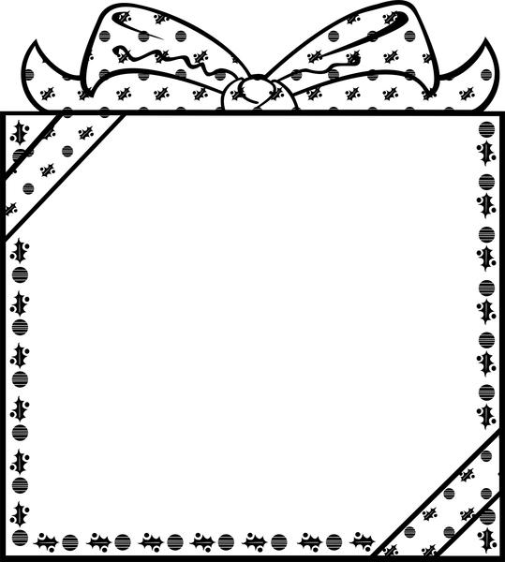  Pack 72  facebook.com/pack72tomball  pack72tomball.scoutlander.com  Orion District  www.orion.shac.org  facebook.com/orionbsa  Sam Houston Area Council  www.shac.org  facebook.com/shac.bsa

Christmas Pack Meeting Agenda – 5
(Traditions)

Materials
- opening ceremony items: small Christmas tree, mistletoe, wreath, candle, poinsettia, Christmas card, script for each Webelos Scout
- audience participation items: nearly undecorated Christmas tree, one ornament per Scout, ornament hangars
- closing ceremony items: 6 posters (T-H-A-N-K-S), with script taped to back of poster
- copies of this agenda
- printed copy of podium script
- copies of program below (printed songs and announcements), one per person attending (customize before printing)
- gathering activities: placemats, one per Cub Scout, colored pencils
- US flag and pack flag
- advancements
- props: Santa hats(s) and decorations
- games
- cheers and Cheer box or bag

Gathering Activity
Placemats: www.day-camp.shac.org/christmas-theme

Welcome
Cubmaster (wearing Santa hat): Welcome the Cub Scouts, parents and leaders.

Opening Ceremony – Traditions at Christmas
Equipment: Six Webelos Scouts. Each Webelos Scout has an object they talk about on display or a large picture of the object. Make sure each Cub Scout’s script is in LARGE print. Practice the script with the Webelos Scouts to make sure they can read all of the words. Have the Webelos Scouts practice several times to learn presentation skills. Teach them to hold the object below their face, to read with their eyes looking down and face looking up to the audience, to take a deep breath before speaking (fill lungs to the bottom), to talk slowly and loudly, and to look at the audience members in the back of the room and project their voice to them.
# 1: The Christmas Tree. The custom of decorating a small evergreen tree at Christmas time began in Germany. However, it reached America before it arrived in England. The German settlers in Pennsylvania decorated trees with lights, sweets, and colored paper. That is how the Christmas tree became part of our traditional Christmas.
# 2: The Mistletoe. Ancient Celtic priests believed mistletoe had medicinal powers and was sacred. They thought it brought good fortune. Mistletoe was also considered the plant of peace and, under it; enemies met and reconciled their differences. From this ceremony came the English custom of kissing beneath the mistletoe.
# 3: The Christmas Wreath. During the 16th century in Germany, branches of fir or spruce were intertwined in a circular shape. This symbolized the love of God, which had no beginning and no end. One legend tells of a young girl of Bethlehem who wept because she had nothing to bring to the Christ child but a crown of holly leaves. The babe touched the crown and the leaves gleamed and scarlet berries appeared where her tears had fallen.
# 4: The Christmas Candle. Medieval Christians believed that on Christmas Eve the Christ child wandered through town and countryside in search of those who believed in Him. On that night, they place candles at their windows to guide Him.
# 5: The Poinsettia. This Christmas flower was discovered in Mexico in 1828 by Dr. Joel
Poinsett. The people of Mexico and Central America call it "Flor do la noche buena" or flower of the Holy Night because it reaches full bloom at Christmas.
# 6: The Christmas Card. At Christmas in 1843, in London, "A Christmas Carol" by Charles Dickens had just been published. A friend, Sir Henry Cole, had an artist friend design a Christmas greeting to send to his friends. This was to be the first Christmas card. It took more than 30 years for them to become popular. They were first introduced in the United States in the late 1870s.
Asst CM The ___ den will perform the flag ceremony.

Pledge

Song

Den leads a song in the program. Additional songs can be found here.

Leader Recognition

Skits
Have one or two dens perform a skit.

Audience Participation
Audience Participation

Advancement Ceremony - Old-Fashioned Christmas
Assistant Cubmaster or another leader reads the poem and leads the cheers.. Cubmaster presents the awards with help of committee chair or advancement chair.

Arrangements: Cubmaster and Committee Chairman stand behind head table, which holds all the awards and a box of Christmas tree decorations. Nearby is an undecorated tree. As each Cub Scout receives their award, the Cub Scout and their parents are given a decoration to put on the tree. The tree can already have a string of lights, which are turned on at the end of the ceremony.
Cubmaster: Tonight, we're celebrating an old-fashioned Christmas. One of the most popular customs in America is decorating the Christmas tree. As each Cub Scout receives their award tonight, we're going to give them and their parents an opportunity to help decorate our tree. Since Cub Scouting is a family program, we want our pack families to help make our Cub Scouting Christmas tree bright and festive.
(Calls each rank forward one at a time. Have after presenting awards, give each Cub Scout an ornament to put on the tree. They return to their seats.)

And there you have our beautiful Christmas tree. Now we're going to turn on the lights representing all members of our pack families.
You can see how each decoration and light make the difference in the appearance of our tree. In the same way, each member of our pack, Cub Scouts and adults, makes a difference in the success of our pack's operation and success. Thanks to you all.

Cubmaster’s Minute (Traditions)
Each of us have some traditions that are only practiced by our own families. Let’s remember to enjoy those traditions and our families at this time of year. Remember it is better to give than to get. See if you can find the joy in giving this year!

Closing Ceremony - Happy Holidays!
Personnel: Cubmaster, 6 readers (Cub Scouts)
Props: 6 pieces of paper with the letters T-H-A-N-K-S on one side and the text on the other side in BIG print
Cubmaster: Tonight, is our last pack meeting of the year. We have had a great year together, and as we look forward to next year, we have a lot to be thankful for.
# 1: T is for Togetherness; Working together to make our pack go.
# 2: H is for Homes, families, and friends.
# 3: A is for Akela; Our parents and leaders.
# 4: N is for New friends we’ve made and experiences we’ve had.
# 5: K is for KlSMIF; keeping it simple, making it fun.
# 6: S is for Scouting; which helps us grow and spread goodwill.
CM: Thank you all for a great year! Let us now retire the colors.

Podium Script: Advancement Ceremony - Old-Fashioned Christmas

Cubmaster: Tonight, we're celebrating an old-fashioned Christmas. One of the most popular customs in America is decorating the Christmas tree. As each Cub Scout receives their award tonight, we're going to give them and their parents an opportunity to help decorate our tree. Since Cub Scouting is a family program, we want our pack families to help make our Cub Scouting Christmas tree bright and festive.

(Call each rank and their parents forward one at a time and present awards. After presenting awards, give each Cub Scout an ornament to put on the tree. Cheer)

And there you have our beautiful Christmas tree. Now we're going to turn on the lights representing all members of our pack families.
You can see how each decoration and light make the difference in the appearance of our tree. In the same way, each member of our pack, Cub Scouts and adults, makes a difference in the success of our pack's operation and success. Thanks to you all.

Podium Script: Cubmaster’s Minute

Each of us have some traditions that are only practiced by our own families. Let’s remember to enjoy those traditions and our families at this time of year. Remember it is better to give than to get. See if you can find the joy in giving this year!

Print: Opening Ceremony - Traditions at Christmas
cut into strips and glue to back of posters

# 1: Christmas Tree. The custom of decorating a small evergreen tree at Christmas time began in Germany. However, it reached America before it arrived in England. The German settlers in Pennsylvania decorated trees with lights, sweets, and colored paper. That is how the Christmas tree became part of our traditional Christmas.

# 2: Mistletoe. Ancient Celtic priests believed mistletoe had medicinal powers and was sacred. They thought it brought good fortune. Mistletoe was also considered the plant of peace and, under it; enemies met and reconciled their differences. From this ceremony came the English custom of kissing beneath the mistletoe.

# 3: Christmas Wreath. During the 16th century in Germany, branches of fir or spruce were intertwined in a circular shape. This symbolized the love of God, which had no beginning and no end. One legend tells of a young girl of Bethlehem who wept because she had nothing to bring to the Christ child but a crown of holly leaves. The babe touched the crown and the leaves gleamed and scarlet berries appeared where her tears had fallen.

# 4: Christmas Candle. Medieval Christians believed that on Christmas Eve the Christ child wandered through town and countryside in search of those who believed in Him. On that night, they place candles at their windows to guide Him.

# 5: Poinsettia. This poinsettia was a Christmas flower was discovered in Mexico in 1828 by Dr. Joel
Poinsett. The people of Mexico and Central America call it "Flor do la noche buena" or flower of the Holy Night because it reaches full bloom at Christmas.

# 6: Christmas Card. At Christmas in 1843, in London, "A Christmas Carol" by Charles Dickens had just been published. A friend, Sir Henry Cole, had an artist friend design a Christmas greeting to send to his friends. This was to be the first Christmas card. It took more than 30 years for them to become popular. They were first introduced in the United States in the late 1870s.

Print: Closing Ceremony - Happy Holidays!
cut into strips and glue to back of posters

# 1: (Hold up “T”) T is for Togetherness; Working together to make our pack go.

# 2: (Hold up “H”) H is for Homes, families, and friends.

# 3: (Hold up “A”) A is for Akela; Our parents and leaders.

# 4: (Hold up “N”) N is for New friends we’ve made and experiences we’ve had.

# 5: (Hold up “K”) K is for KlSMIF; keeping it simple, making it fun.

# 6: (Hold up “S”) S is for Scouting; which helps us grow and spread goodwill.

 | Pack 72 |  |  |  | December 2018
Cub Scout Christmas  Tune: White Christmas  I’m dreaming of a Cub Scout Christmas  Where Cub Scout pants are given me  Then my eyes will water  Tho’ they hadn’t oughter  When a belt to hold them I will see  I’m dreaming of a shirt to hold badges  With a neckerchief and Cub Scout slide  Or a pocket knife, to last for life  Making my smile a mile wide. |  | 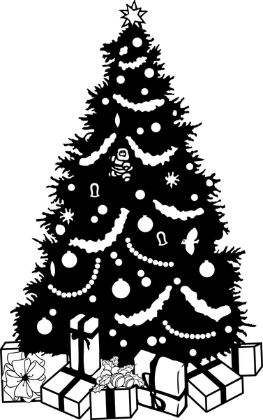 |  |  |  |  | January 2019  Jan 10 Den Meeting  Jan 24 Den Meeting  Jan 27 Scouting for Food  (hanger distribution)  Jan 31 Pack Meeting  February 2019  Feb 3 Scouting for Food  (food pick up)  Feb 7 Den Meeting  Feb 21 Den Meeting  Feb 23 Derby car check-in  Feb 24 Pinewood Derby and potluck lunch  Feb 28 Pack Meeting  March 2019  Mar 7 Den Meeting  March 24-25 Family Campout  Mar 28 Den Meeting  April 2019  April 4 Den Meeting  April 14 Scout Fair  April 18 Den Meeting  April 25 Pack Meeting  May 2019  May 2 Den Meeting  May 19 Banquet / Pack Meeting  June 2019  June 5-8 Day Camp: www.orion.shac.org/day-camp
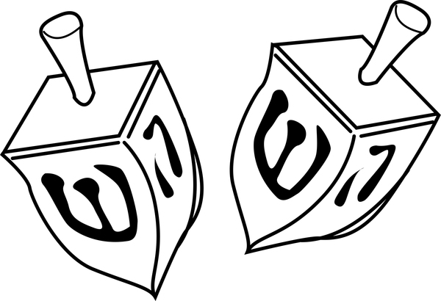 |  | I’m a Little Dreidel  Tune: I’m a Little Teapot  I’m a little dreidel  Made of clay.  Spin me around when you want to play  When I fall down, if you don’t win  Just pick me up and spin again.
A Hanukkah Song  Tune: 3 Blind Mice  Eight bright lights, eight bright lights,  See how they glow, see how they glow,  They call to mind the Maccabees,  The struggle for our liberties,  The glory of their victories,  Eight bright lights. |  | 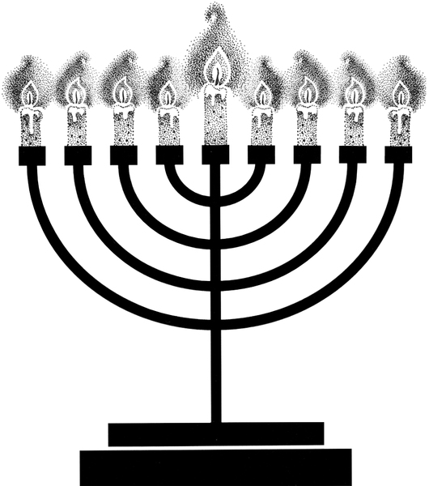
Announcements |  |  |  | Pack 72  facebook.com/pack72tomball  pack72tomball.scoutlander.com  Orion District  www.orion.shac.org  facebook.com/orionbsa  Sam Houston Area Council  www.shac.org  facebook.com/shac.bsa

Christmas Pack Meeting Agenda – 6
(Winter Wonderland)

Materials
- opening ceremony: Scouts prepare cards describing what the holidays and winter means to them
- closing ceremony items: cookbook, pot, wooden or plastic spoon, cans with labels (eagerness, laughter, courtesy, helfulness, leadership), script attached to back of cans.
- advancement ceremony items: large snowflakes with printed script on back and/or small snowflakes to give with awards
- copies of this agenda
- printed copy of podium script
- copies of program below (printed songs and announcements), one per person attending (customize before printing)
- gathering activities: placemats, one per Cub Scout, colored pencils
- US flag and pack flag
- advancements
- props: Santa hats(s) and decorations
- games
- cheers and Cheer box or bag

Gathering Activity
Placemats: www.day-camp.shac.org/christmas-theme

Welcome
Cubmaster (wearing Santa hat): Welcome the Cub Scouts, parents and leaders.

Opening Ceremony – Winter Wonderland
Setup: At the den meeting before the pack meeting, have the Cub Scouts who are presenting the opening prepare cards that describe what winter and/or holidays means to them. They will read these before the pack, so review them to make sure they’re sensible and appropriate.
Leader: Tonight, we gather to celebrate the theme, Winter Wonderland. What does that mean, Winter Wonderland? To each of us it means something different, but to all of us something special. Let’s close our eyes and think about “Winter Wonderland” and let our thoughts paint pictures of what it means to us. As we do this, let’s hear from the Cub Scouts in Den ___ who have already given some thought to what this means.
(Cub Scouts read off “To me, Winter Wonderland means…”)
Leader: So many different ideas all from the same two words. It’s no different than when we say “United States.” Again, two small words that mean many different things to many different people. But there is one way in which all of us are united—let’s stand and recite the Pledge of Allegiance followed by the Scout Oath — thoughts that bind us all together.

Pledge

Song

Den leads a song in the program. Additional songs can be found here.

Leader Recognition

Skits
Have one or two dens perform a skit.

Audience Participation
Audience Participation

Advancement Ceremony - Snowflakes
Assistant Cubmaster or another leader reads the script and leads the cheers.. Cubmaster presents the awards with help of committee chair or advancement chair.
Options: make large snowflakes and have script printe on back for CA and/or have awards attached to small snowflakes.

One of the most beautiful objects formed by nature is a snowflake. It would take most of us a long time to design a shape as beautiful as a single snowflake. Yet, in an ordinary snowfall, billions upon billions of snowflakes fall to the earth, and no two are exactly alike.

Tonight, we are gathered much like snowflakes, in that we are here because of beautiful objects; our Cub Scouts and their "designs" are each as different. Would our Lions and their parents please come forward to receive their honors? (Call Lions and their parents forward and present awards. Cheer)

Every Cub Scout is a unique wonder, learning and progressing through life in their own way. Tonight, we have Cub Scouts who are creating their own singular designs in life by traveling further along the Cub Scout trail. (Call Tigers and their parents forward and present awards. Cheer.)

When water freezes to become a snowflake, it forms crystals. This simply means that the water comes together in a geometric shape we call a crystal. As it freezes, the crystals are small and almost invisible. But when the snow is formed, these crystals are carried up and down in the atmosphere on currents of air. Like snowflakes in the sky, our Wolves are being carried along the Scouting trail. (Call Wolves and their parents forward and present awards. Cheer)

As the crystals move up and down, some of them begin to gather around each other, forming a nucleus that lets the crystals grow larger. Soon, there may be hundreds of crystals together. Our Bears are much like the crystals at this stage. They have gathered in groups together around their den leader. They have grown through their advancements. (Call Bears and their parents forward and present awards. Cheer)

When a group of crystals is large enough, it begins to float down toward the earth and we call it a snowflake. These represent, of course, our Webelos Scouts - growing rapidly and maturing constantly. They are gaining ground toward their next step in Scouting. (Call Webelos Scouts and their parents forward and present awards. Cheer)

I would like all the Scouts who received awards tonight to please stand. Each snowflake begins as a single drop of water and grows to different sizes. You too are growing. May you always recognize the beauty of your differences and enjoy your unique place in life. Cheer

Cubmater Minute (Winter Wonderland)
We are all like snowflakes, all unique in our own special way. And just as no two snowflakes are alike, no two people are exactly the same. We show reverence for all those we come in contact with: reverence for one’s beliefs, reverence for one’s belongings, and reverence for one’s privacy. In doing so, we show reverence for ourselves.

Closing Ceremony - Recipe for a Happy Family
Three to ten Cub Scouts can help. One Cub Scout reads from a cookbook, one stirs pot, the rest add the ingredients. Cover old cans with paper and label. Fill each can with something to make it look real.
Scene: Cub Scouts around a table, with a large pot and ingredients on top of table.
# 1 (Stands by pot and stirs slowly as ingredients are added).
# 2: (Has cookbook and starts to read.) Here is the recipe for a happy family.
# 1: Do we have everything?
# 2: (Looks around and other Cub Scouts nod their heads yes.) First, we need three cups of eagerness.
# 3: First, we need three cups of eagerness. (Pours it in.)
# 4: Next is two cups of laughter. (Pours it in.)
# 1: (Looks into pot.) This is beginning to look delicious!
# 5: Here are two cups of courtesy. (Pours it in.)
#6: I brought two cups of helpfulness. (Pours it in.)
#2: Next, we need some adults to help.
#7: I found two cups really good cups of leadership! (Pours it in.)
#1: (Looks in pot.) Wow! That made this really great!
#2: Now we need one cup of ability to follow instructions.
#8: I have that. (Pours it in.)
#2: Next is a gallon of patience.
#1: We might need two gallons of that. (#1 and #2 shake heads in agreement.)
#9: I looked all over, and I found plenty. (Pours it in.)
#2: The last ingredient is three cups of love for each other.
#10: I got that, but I added a little more than the recipe called for. (Pours it in.)
# 1: Okay, I’ll mix it well.
CM: What do we have? A recipe for a happy family! Serve generous portions frequently!

Podium Script: Advancement Ceremony - Snowflakes

One of the most beautiful objects formed by nature is a snowflake. It would take most of us a long time to design a shape as beautiful as a single snowflake. Yet, in an ordinary snowfall, billions upon billions of snowflakes fall to the earth, and no two are exactly alike.

Tonight, we are gathered much like snowflakes, in that we are here because of beautiful objects; our Cub Scouts and their "designs" are each as different. Would our Lions and their parents please come forward to receive their honors? (Call Lions and their parents forward and present awards. Cheer)

Every Cub Scout is a unique wonder, learning and progressing through life in their own way. Tonight, we have Cub Scouts who are creating their own singular designs in life by traveling further along the Cub Scout trail. (Call Tigers and their parents forward and present awards. Cheer.)

When water freezes to become a snowflake, it forms crystals. This simply means that the water comes together in a geometric shape we call a crystal. As it freezes, the crystals are small and almost invisible. But when the snow is formed, these crystals are carried up and down in the atmosphere on currents of air. Like snowflakes in the sky, our Wolves are being carried along the Scouting trail. (Call Wolves and their parents forward and present awards. Cheer)

As the crystals move up and down, some of them begin to gather around each other, forming a nucleus that lets the crystals grow larger. Soon, there may be hundreds of crystals together. Our Bears are much like the crystals at this stage. They have gathered in groups together around their den leader. They have grown through their advancements. (Call Bears and their parents forward and present awards. Cheer)
When a group of crystals is large enough, it begins to float down toward the earth and we call it a snowflake. These represent, of course, our Webelos Scouts - growing rapidly and maturing constantly. They are gaining ground toward their next step in Scouting. (Call Webelos Scouts and their parents forward and present awards. Cheer)

I would like all the Scouts who received awards tonight to please stand. Each snowflake begins as a single drop of water and grows to different sizes. You too are growing. May you always recognize the beauty of your differences and enjoy your unique place in life. Cheer
Podium Script: Cubmater Minute

We are all like snowflakes, all unique in our own special way. And just as no two snowflakes are alike, no two people are exactly the same. We show reverence for all those we come in contact with: reverence for one’s beliefs, reverence for one’s belongings, and reverence for one’s privacy. In doing so, we show reverence for ourselves.

Print Script: Closing Ceremony - Recipe for a Happy Family

Script for Cub Scout #1 and #2 – Add Cub Scout’s names (to help the readers) before printing and place inside a receipe book

#1 |  | (stands by pot and stirs slowly as ingredients are added.)
#2 |  | (Has cookbook and starts to read.) Here is the recipe for a happy family.
#1 |  | Do we have everything?
#2 |  | (Looks around and other Cub Scouts nod their heads yes.) First, we need three cups of eagerness.
#3 |  | First, we need three cups of eagerness.
#4 |  | Next are two cups of laughter.
#1 |  | (Looks into pot.) This is beginning to look delicious!
#5 |  | Here are two cups of courtesy.
#6 |  | I brought two cups of helpfulness.
#2 |  | Next, we need some adults to help.
#7 |  | I found two cups really good cups of leadership!
#1 |  | (Looks in pot.) Wow! That made this really great!
#2 |  | Now we need one cup of ability to follow instructions.
#8 |  | I have that.
#2 |  | Next is a gallon of patience.
#1 |  | We might need two gallons of that. (#1 and #2 shake heads in agreement.)
#9 |  | I looked all over, and I found plenty.
#2 |  | The last ingredient is three cups of love for each other.
#10 |  | I got that, but I added a little more than the recipe called for.
#1 |  | Okay, I’ll mix it well.
CM |  | What do we have? A recipe for a happy family! Serve generous portions frequently!

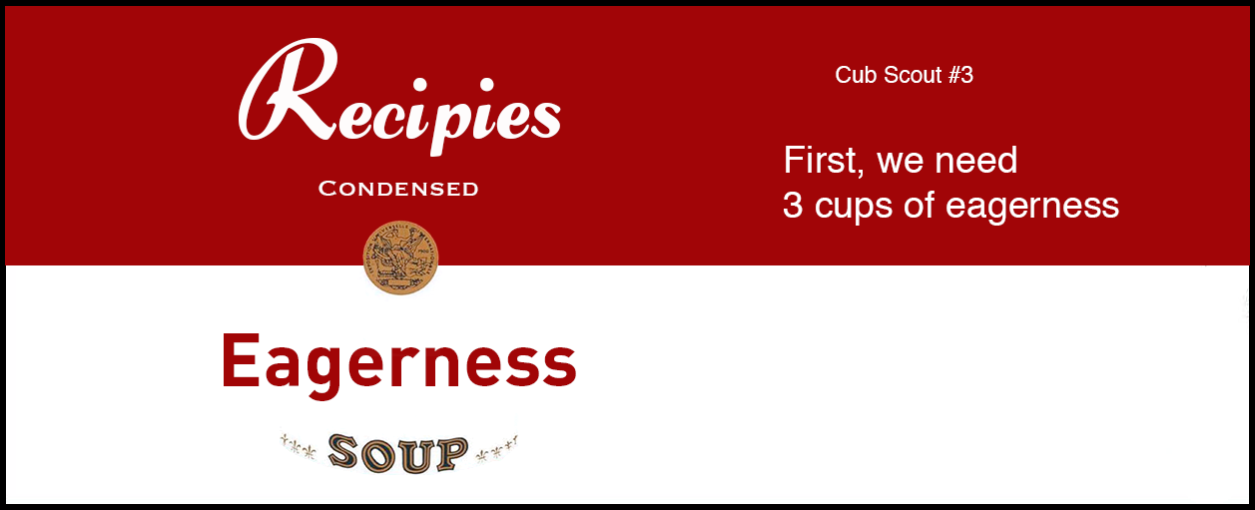
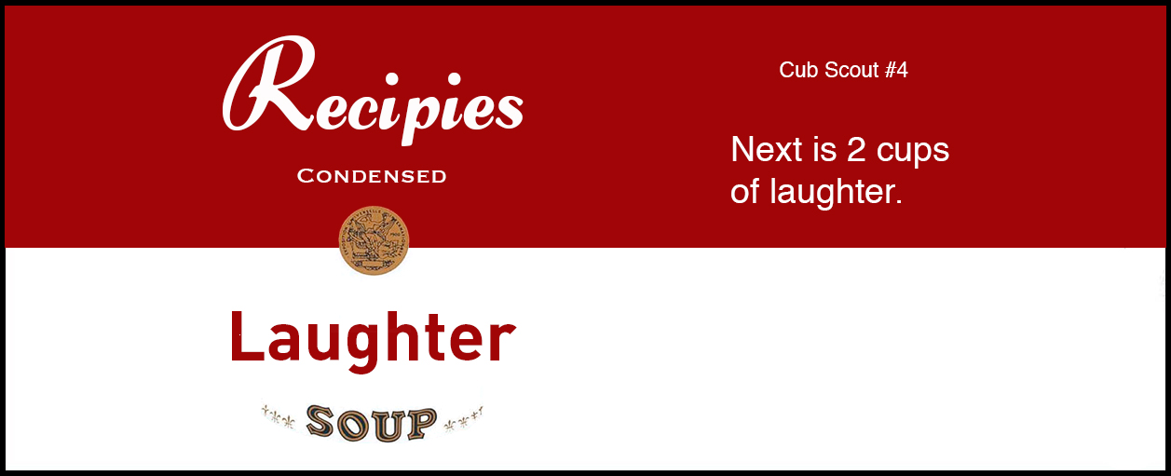

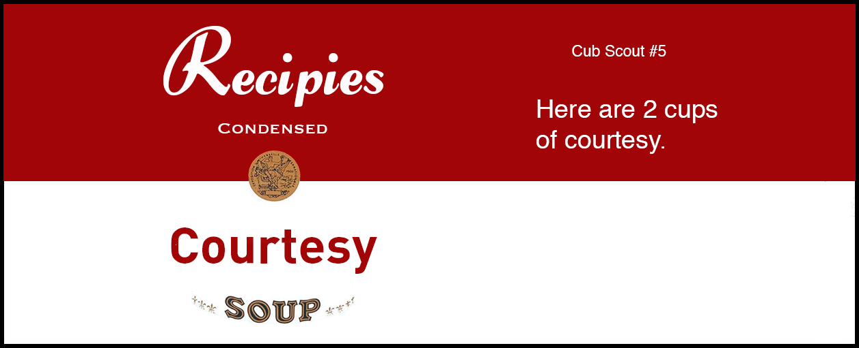

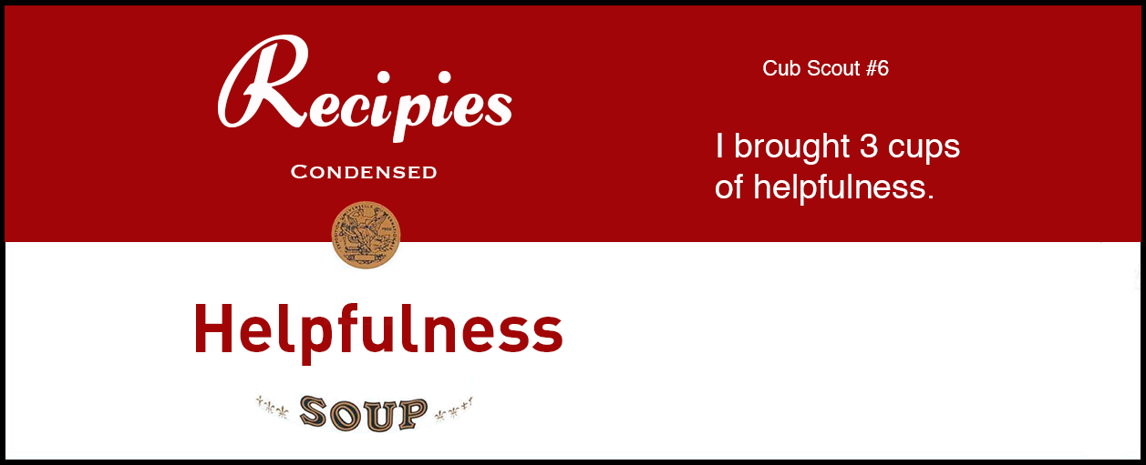

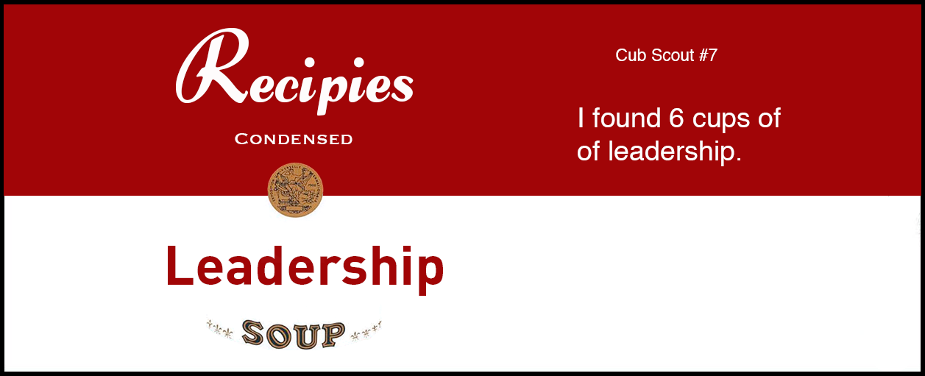

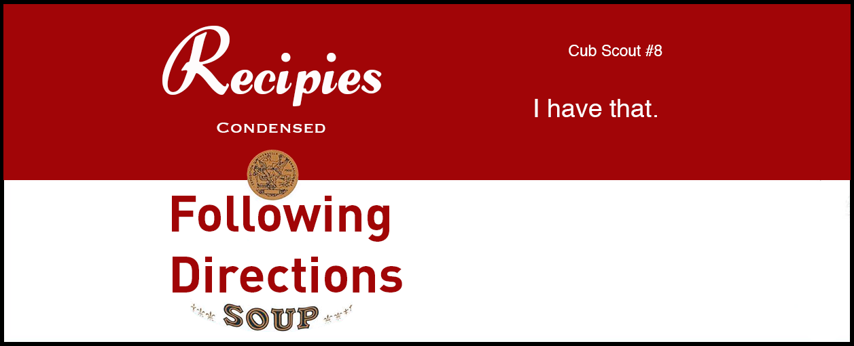

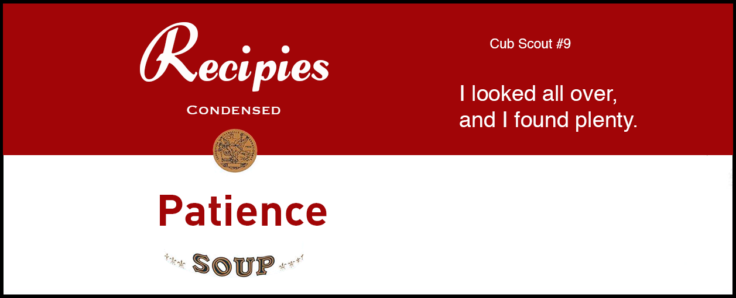

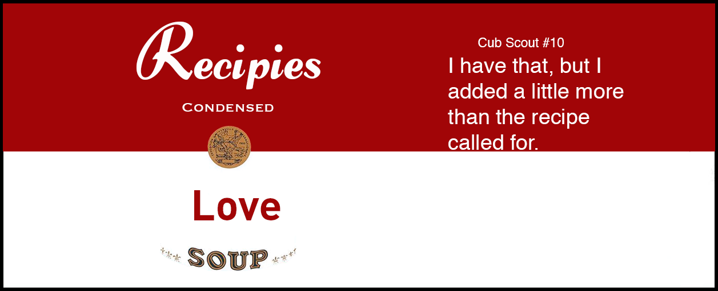

 | Pack 72 |  |  |  |  | December 2017
I'm Playing in The Snow  Tune: I’m singing in the Rain  I’m playing in the snow.  I’m playing in the snow.  What a glorious feeling  It’s snowing again.  Making snowman tonight  For the whole world to see  I’m happy just playing  In the snow |  |  | 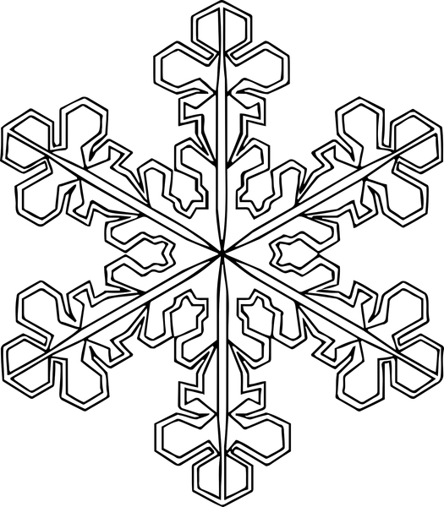 |  |  |  |  |  | January 2019  Jan 10 Den Meeting  Jan 24 Den Meeting  Jan 27 Scouting for Food  (hanger distribution)  Jan 31 Pack Meeting  February 2019  Feb 3 Scouting for Food  (food pick up)  Feb 7 Den Meeting  Feb 21 Den Meeting  Feb 23 Derby car check-in  Feb 24 Pinewood Derby and potluck lunch  Feb 28 Pack Meeting  March 2019  Mar 7 Den Meeting  March 24-25 Family Campout  Mar 28 Den Meeting  April 2019  April 4 Den Meeting  April 14 Scout Fair  April 18 Den Meeting  April 25 Pack Meeting  May 2019  May 2 Den Meeting  May 19 Banquet / Pack Meeting  June 2019  June 5-8 Day Camp: www.orion.shac.org/day-camp
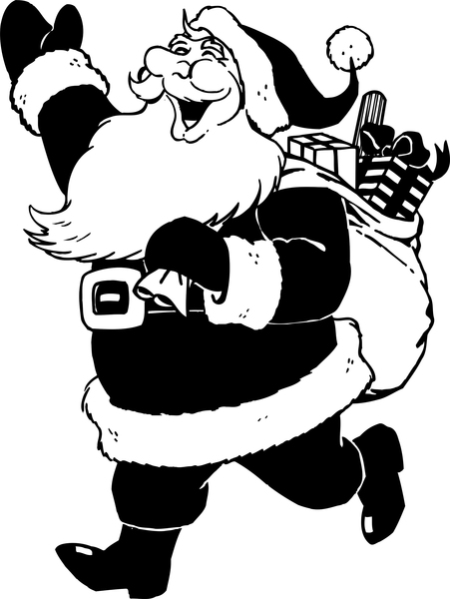 |  | S-A-N-T-A  Tune: BINGO  Every Cub Scout has a friend  And Santa is his name-o  S-A-N-T-A,  S-A-N-T-A  S-A-N-T-A  And Santa is his name-o.
Winter Pokey  Tune: The Hokey Pokey  You put your right mitten in,  You take your right mitten out  You put your right mitten in,  And you shake it all about.  You do the winter pokey (shiver)  And you turn yourself around.  That's what it's all about!  Additional verses:  left mitten, right boot, left boot, long scarf, warm cap, snowsuit |  |  |  | 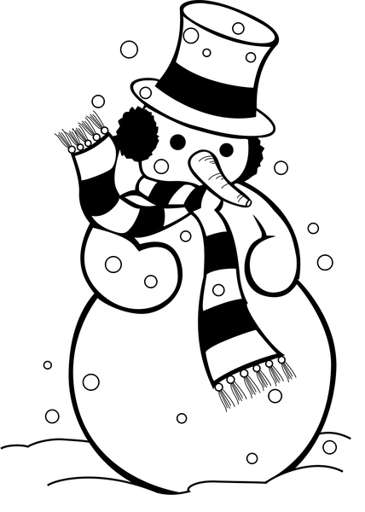
Announcements |  |  |  |  |  |  | Pack 72  facebook.com/pack72tomball  pack72tomball.scoutlander.com  Orion District  www.orion.shac.org  facebook.com/orionbsa  Sam Houston Area Council  www.shac.org  facebook.com/shac.bsa

Christmas House Maze
Find your way from the bedroom to the Christmas Tree.

